**Readings In the Philippine History With Indigenous People's Studies**

***Chapter 1***

**Meaning and relevance of history, geography and natural resources**

* Geography and Its Setting
* Topography of the Philippines
* Natural Resources

**Geography of the Philippines**

**Geography and its setting**

* The Philippines is an Island country on the Western Pacific Ocean, which is part of the Southeast Asia Continent.
* The map shows that The Philippines are a group of islands surrounded by the South China Sea in the West, the Philippine Sea in the East, Celebes Sea in the South, Sulu Sea in the Southwest, and in the North, the island of Luzon (and The Philippines) and the country of Taiwan are separated by the Luzon Strait.

**Geography and its setting (cont’d)**

The Philippines is part of the Southeast Asian Region of the Asian Continent. It’s neighbouring countries are:

* Brunei
* Malaysia
* Indonesia
* Vietnam
* Singapore
* East Timor
* Cambodia
* Vietnam
* Thailand
* Laos
* Myanmar

Likewise, the Philippine Archipelago consists of more than 7,500 islands, which are broadly characterized into three (3) main geographical divisions:

* ***Luzon***, the 15th largest island in the world by land area, is the largest and most populous island in the Philippines.
* ***Mindanao***, the second-largest island in the Philippines after Luzon, and the 7th most populous island in the world.
* ***Visayas****,* (Visayan Islands).

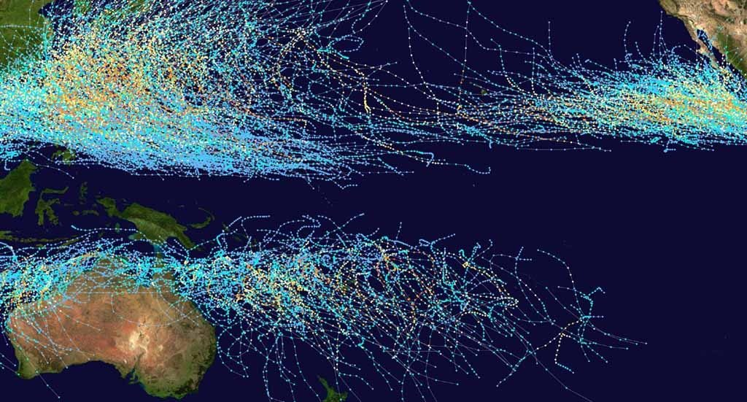

* The Philippines straddles, or sits, on the typhoon belt, an area in the western Pacific Ocean where nearly 1/3 of the world’s tropical cycles form. This area is not only the most active in the world, but also has the most intense storms globally. Approximately, 19 typhoons enter the Philippines each year, around 6-9 of them make landfall.

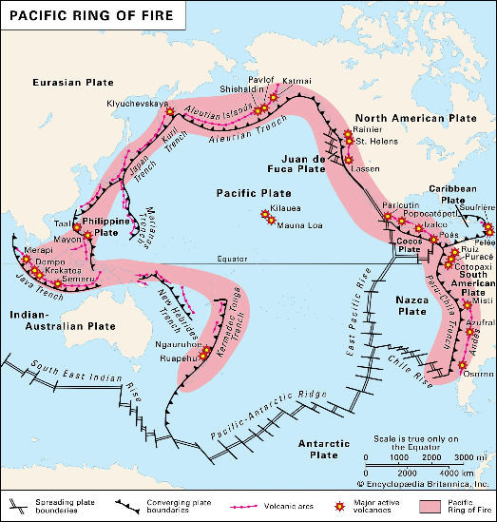

* Philippines is also situated in the Pacific Ring of Fire, making it vulnerable to frequent earthquakes and volcanic eruptions.

**Topography of the Philippines**

* The topography is extremely varied, with volcanic mountain masses forming the cores of most of the larger islands. The range culminates in Mt. Pulag (2,928 metres above sea level/9,606 ft) in Luzon, and in Mt. Apo, the highest point in the Philippines, with an elevation of 2,954 meters above sea level (9,692 ft) in Mindanao.

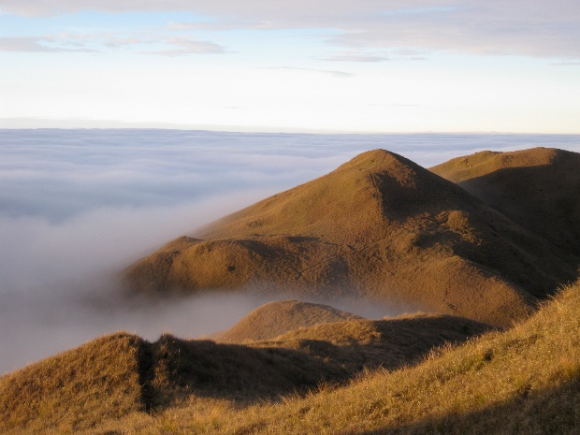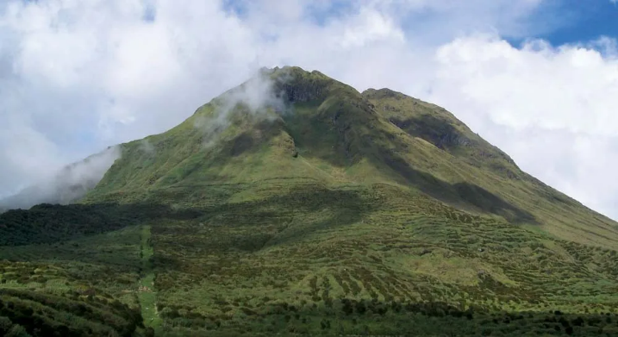

The ***Philippine Trench*,** has a length of approximately 1,320 kilometres (820 miles). At its deepest point, the trench reaches 10,540 meters (34,580 ft) or (5,760 fathoms).

The ***Galathea Deep,*** is the portion of the 10,540-metre-deep (34,580 ft) Philippine Trench exceeding 6000-metre (20,000 ft) depths in the south-western Pacific Ocean.

**Significance**

The strategic location of the Philippines has affected its history.

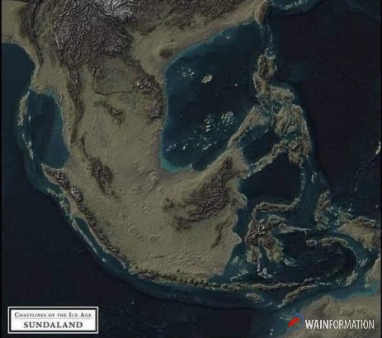

1. Its nearness to mainland Asia has led to the migration of Negritos, Indonesian and Malays. The Negritos travelled to the Philippines by means of land bridges that connected to Asia while the Indonesians and Malays crossed the seas to get to our shores.

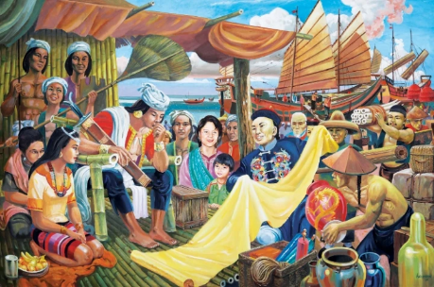

1. Because of the proximity of the Philippines to other Asian countries, the Ancient Filipinos were able to establish trade contacts with the Chinese, Indians, Japanese and Arabs. These trade contacts were economically, as well as culturally beneficial, to Filipinos.

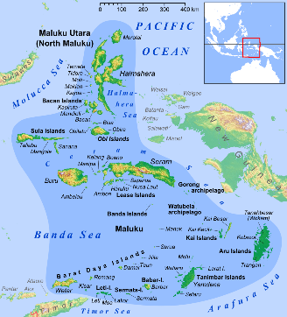

1. The proximity of the country to the Spice Islands or Moluccas resulted in the coming of the Spaniards to the Philippines. This event led to the Hispanization and Christianization of the country.

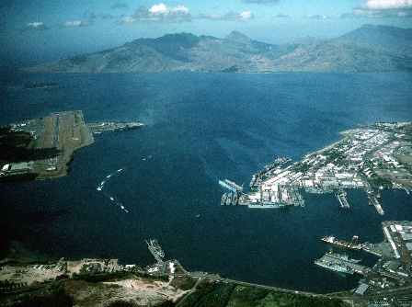

1. The strategic location of the country in SEA lead the United States to acquire the Philippines from Spain and colonize it. This enabled the United States to exert a powerful influence in the region with the installation of military bases in our country.

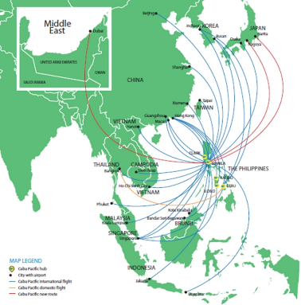

1. Because of its strategic position in the SEA region, it has become an important part of trade and travel in Asia. International airlines and ships stopover in the Philippines on their way to Australia and other Asian countries.

***Chapter 2***

**The Filipino People**

What we'll discuss

* + Origin and Folklore
  + Migration Theories
  + Early Community
  + Customs and traditions

Origin And Folklore of the Filipino People

School of Thought About How Filipino People originated

1. Based on Bible and Religious Beliefs
2. Based on Legends and Myths
3. Migration Theory
4. Core Population Theory

1. Based on Bible and Religious Beliefs

* From the book of genesis, it is said that God created people on the sixth day.
* From these, the maritime people spreads out into different counties including the Philippines

2. Based on Legends and Myths

- A woman and a man appeared in the bamboo name Malakas and Maganda who became the ancestor of the people in the Philippines.

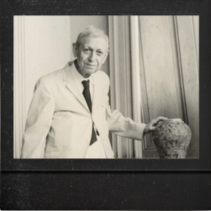3. Migration Theory

Filipino People are mixture of the three different races who arrived to the Philippines

-H. Otley Beyer

**Negritos**

-Most ancient civilization in the country (8,000BCE or more than 25,000 years ago)

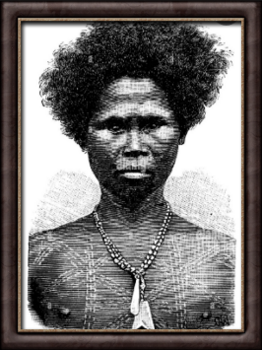-Hunter- Gartherer

They Live in Caves and Mountainside

Appearance :

- Small Body

- Dark Skin

- Curled Hair

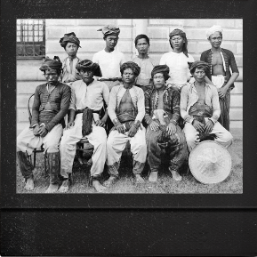Indones

-Second group of people who came through boats after the great ice age about 3000BC or 6000 years ago

-More Advance than Negrito.

-hunting using a bow, Fishing and Farming

-There are two group of Indones who came to the Philippines

First Group

-They came from Southeast Asia.

Appearance:

- Slender and tall body

-White Skin

-Long Nose

-Thin Lips

Second Group

-They came from Indo-China and Central Asia,

Appearance:

-Small body size

-Dark Skin

-Flat Nose

Malay

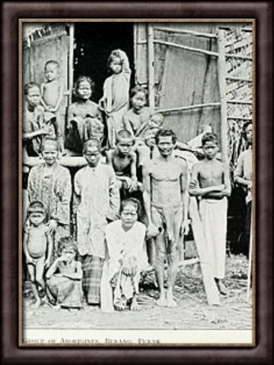-They came after indones about 2000 years ago. They also arrived using boats from southeast Asia.

-Most Advance Among the 3 races

-Way of Living :Agriculture, fishing, trading and mining.

-They Live in Larger Village and had a Government.

Appearance:

Medium Height, Brown Skin, Dark Eyes, flat nose and straight Black Hair.

Core Population Theory

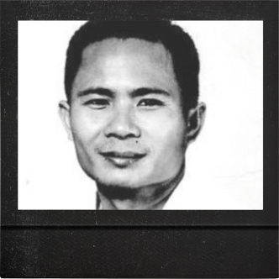Anthropologist from University of the Philippines named Filipe Landa Jocano proposed that The Filipinos are product of long process of cultural evolution and mass movement of people.

Evidence of Core Population Theory

In 1962, a skullcap and a portion of a jaw-presumed to be a human origin-were found in the Tabon Caves of Palawan by archaeologist Robert Fox and Manuel Santiago

This proves that Tabon man came earlier to the Philippines than to the Negrito, Indones, and Malay since the same fossils were also discovered in Southeast Asia and ranged from 200,000 to 250,000 years of age.

**Migration Theories in the Philippines**

Wave Migration Theory

Henry Otley Beyer`s theory about how humans came to live in the Philippines was arguably the most well-known, it tells that the peopling of the archipelago was caused by big “waves” of migrants that crossed over on different time periods.

Dawn Man

-Resembled Peking man, Java man and other Asian homo sapiens. They did not have knowledge in agriculture, they live by hunting and fishing.

-They crossed over land bridges that was formed during the last ice age or glacial period 250,000 years ago.

Pygmies

-They are dark-skinned pygmies called “Aetas” or “Negritos”, good hunters and fishers that utilized spears and small splint stone weapons. Due to the disappearance of land bridges, they was forced to stay in the Philippines.

-They crossed through land bridges as well 25,000 – 30,000 years ago.

Indonesians

-They came to the Philippines in boats. They wielded tools made out of stone and steel; have knowledge in agriculture and mining; wore clothing and body ornaments.

-First seafaring migrants that entered the archipelago 5,000 – 6,000 years ago.

Malays

-Also came to the Philippines in boats. They are capable of making weaved products, pots and jewelries, they also brought the Iron Age culture and the innovative idea in agriculture to the archipelago called “irrigation system”.

-Last to migrate to the Philippines about 2,300 years ago.

Core Population Theory

The theory proposed by Felipe Landa Jocano that disputed Wave Migration theory, it states that there were no distinct waves of migration happened in the Philippines, but a long and continuous process of evolution and movement of early humans.

According to Jocano, The early humans in the Southeast Asia were of the same population or ethnic group then eventually went their separate ways: some migrated to the Philippines, the others to New Guinea, Java and Borneo.

"Out of Taiwan" Theory

A theory presented by archaeologist Peter Bellwood states that the Austronesian-speaking people was originated from Taiwan and had further migrated due to the continual growth of population.

Austronesian people began to blend with Australo-Melanesians, who are thought to have inhabited the islands around 23,000 years earlier.

Over the next 1,000 years, they spread to the rest of the Philippines and continued to migrate further to other countries.

Early Community of Filipinos

Before the Spaniards, there were archeological records of early Chinese and some Muslim scholars narrating the existence of civilization in the archipelago even before Magellan landed.

The Barangays were well-organized independent villages, which functioned much like a city-state. The Barangay was the dominant organizational pattern among indigenous communities in the Philippine archipelago. The name barangay originated from balangay, a Malay word meaning "sailboat'.

The early Filipinos chooses the place to build their community based of economic opportunities wherein access the land and the water for their everyday routine of life.

The first barangays started as relatively small communities of around 50 to 100 families and have the population that varies from 100 to 500 persons. The Datu or Raja ruled the Barangay.

Raja or Datu It was the title of the leader in the Barangay. In tagalog, it is called Lakan.

'The Rajah or Datu is shown the highest respect. He makes important decisions in the community and is regarded as savior.

Early Barangay Qualifications for their leader:

1. Age

2. Physically Fit

3. Inheritance

4. Extent of Knowledge

Social Classes in the Barangay

A social class or division is a basic classification method whereby a community ranks one another as superior or inferior.

1. Datu or Raja - the chieftain of the whole barangay and is the wealthiest person in the community.

2. Maharlika (The Noble People) - this class of people does not pay taxes in the community; they are relatives of the Raja or the Datu (the aristocrats).

3. Timawa (The Free Man) These classes of people were free commoners. They could own their own land and from time to time, they can be obliged to work on a datu's land and help in community projects and events.

4. Alipin / Oripun - those who are unable to pay their debts, punished criminals and illegitimate children.

a.) Aliping Namamahay - those who had their own quarters.

b.) Alipin sa Gigilid - the real slaves, they were homeless, lives with their master, had no property, and could not marry without master's consent, they could be use as a payment for debt.

Early Filipino Education

In the ancient Philippines, children were given the rudiments of education.The father trained his sons to be warriors, hunters, fishermen, miners, lumbermen, and shipbuilders. The mother on her part trained her daughters in cooking, gardening, serving, and other household arts.

It is said that in ancient Panay, there was a barangay school called Bothoan under the charge of the teacher usually an old man. The subjects taught to the children in this barangay school were reading, writing, arithmetic, use of weapons, and lubus (acquiring kinaadman or amulets).

Philippine indigenous communities recognize a woman (or man) as a Babaylan, someone who has the ability to mediate with the spirit world, has her own spirit guides, and is given gifts of healing, foretelling, and insight. She may also have knowledge of healing therapies such as hilot, arbularyo.

**CUSTOMS AND TRADITIONS OF THE EARLY FILIPINO PEOPLE**

PRE-COLONIAL DWELLINGS

* The early Filipinos used caves for their housing until they learned to build houses outside using wood or bamboo and nipa leaves or cogon grass for their roofing that suits tropical climate and that’s how Bahay Kubo were made.

*Later on, they were evolved into Bahay na Bato upon the arrivals of the Spaniards.

CLOTHING AND ORNAMENTS

*According to Pigafettas chronicle, when they arrived here in the Philippines, men and women were barefoot and have no upper clothing. Bahag for men and a piece of clothing around their waist for women. Some of the traditional clothing of the early Filipinos were Kangan and Putong.

*Men and women wear ornaments like bracelets, necklaces and rings. They also have tattoos around their bodies to symbolize beauty and bravery.

EARLY RELIGIONS

*Early Filipinos do not have specific religions since Christianity was introduced to them when the Spaniards colonized the country. But in most part of Mindanao, Islam was already a religion because it was introduced by an Arabian trader in 1380.

*But they do believe that there is a powerful being from the sky and that they called God. The names of their gods varied from places to places in the archipelago. In Katagalogan, they called God as ‘Bathala’ or ‘Maycapal’. In the Mountain Province, they called it Kabunyian or sometimes anito.

Different Gods

1.Bathala

2.Anito or spirits of departing ancestors

3.Priest or Babaylan

COURTSHIP AND MARRIAGE

*Almost all courtship practices were done in the girl’s home. The man, seeking her hand in marriage with offers of gifts to the family.

*A lot of times, marriage in the pre-colonial era wasn’t primarily for love. It was arranged by the parents for economic, social and/or political reasons, particularly for the Datu.

*The Bridal dowry or bridal price was given by the groom’s family to ensure a harmonious marriage.

Gador- it is a wedding gift given by the groom or the groom’s family to indicate the groom’s capacity to provide for the family. It can also become an heirloom.

*In Badjao’s custom, a man took the name of a woman if she came from a family of higher ranking. Also, divorce was commonly practiced and the bridal wealth will be paid to the husband or kept by the wife, depending on whoever was proven at fault for failed marriage.

*Heirlooms were also equally distributed among children regardless of gender.

BURIAL

*Early Filipinos value burial or funeral practices. Some ancestors were buried through the use of jars. Some were buried in trees or in tree trunk, hang the dead by the side of the mountain and other burial practices.

*Mourning period- relatives, family wore white and refrained from eating meat or drinking wine to show their deep sorrows. They also hired professional mourners to chant the good deeds of the dead.

*When a Datu died, mourning rites called LARAO were accorded to him by the people.

ARTS AND MUSIC

* A traditional music and dance are the reflection of life and culture of people of one place. These performing arts depict the events or practices from the past.

Kudyapi 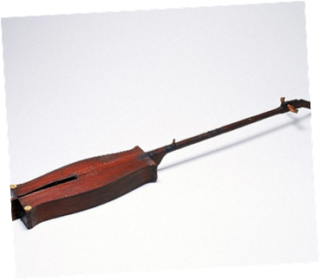 Kubing  Kalaleng 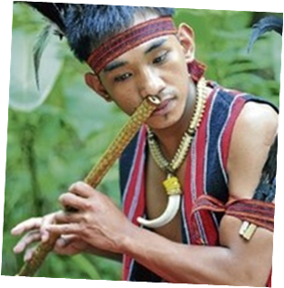

* They also expressed their culture through singing and dancing. Filipinos sing according to what they feel and what they’re doing. Some Pre-Hispanic songs were called Kundiman, Kumintang o Tagumpay, Ang Dalit o Imno at Oyayi o Hele.

* The primitive dances of the early Filipinos were linked with rituals and to their daily lives. Dance movements tell a story, sometimes relate to animals or to their occupation.

Examples of Pre-Colonial Dances

1.Dugso Dance from Bukidnon

2.Salip from Kalinga, Mountain Province

3.Idaw from Cordillera

4.Binaylan Banog from Misamis Oriental

5. Banga from Ifugao

6. Singkil from Mindanao

7. Kadahal Taho from South Cotabato

*Other native dances like tinikling, itik-itik, maglalatik, and palu-palo.

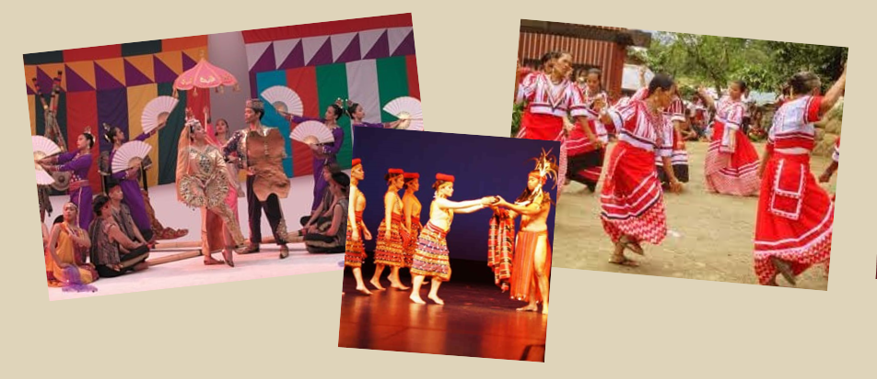

WRITINGS

*Baybayin is one of the precolonial writing systems used by early Filipinos.

*The alphabet called Alibata was composed of 17 letters, 3 vowels and 14 consonants.

*Early Filipinos used sharp-pointed instruments or metals for pens and wrote on the banana leaves, tree barks and bamboo tubes.

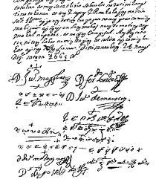 A 1665 document from Naujan, Mindoro

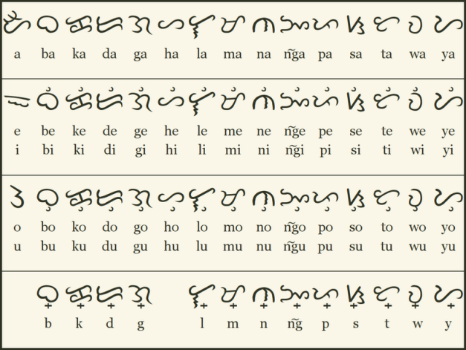 Baybayin

LITERATURE

*Ancient Literature has two kinds: oral literature and written literature.

ORAL LITERATURE

-This includes bugtong, songs, epics such as Darangan the Marangos, Biag ni Lam-Ang of the Ilocanos Region and Hudhud at Alim of the Ifugaos.

* Because paper was not invented yet, many of these tales were not preserved and have vanished from local knowledge. Most of what have been transcribed now are taken from oral literature.

LIVELIHOOD

*Agriculture

- Kaingin Method

- Wet Method

*Hunting

*Boat-making

*Trading

*Other livelihood of Early Filipinos includes handicraft, basket weaving, cloth weaving, pottery,etc.

Group 2

***Chapter 3***

## Topic: Period of Colonization

# Spanish Colonization

## By sailing westward over the Atlantic Ocean, Ferdinand Magellan started out on a journey in 1521 to reach South-East Asia. Magellan sought a path to the Indonesian Spice Islands. Since then, the Spanish Empire has sent ships to colonize the Philippines. Our history has been greatly influenced by the Spanish colonization.

## Born February 4, 1480

## was a Portuguese explorer and a subject of the Hispanic Monarchy from 1518.

## His parents were novelty in Portugal.

## Magellan went to King Manuel of Portugal to ask for his assistance in planning a westward expedition to the Spice Islands. The king consistently turned down his request. A disgruntled Magellan resigned his Portuguese citizenship and moved to Spain in 1517 in order to seek royal support for his expedition.

# Rajah Humabon

## The rajah of Cebu

## According to legend, Magellan participated in the Battle of Mactan in order to win the trust of Rajah Humabon by aiding him in defeating his adversary Lapulapu, the datu of Mactan.

## He is later baptized as Don Carlos.

# Lapu-Lapu

## The chieftain of Mactan

## He is best known for the Battle of Mactan that happened at dawn on April 27, 1521, where he and his warriors defeated the Spanish forces led by Portuguese explorer Ferdinand Magellan and his native allies Rajah Humabon and Datu Zula.

## Modern Philippine society regards him as the first Filipino hero because of his resistance to imperial Spanish colonization.

# The Battle of Mactan

## On April 27, 1521, a bloody battle known as the Battle of Mactan took place in the Philippine archipelago. A Spanish troop fighting for Rajah Humabon of Cebu was defeated by the warriors of Lapulapu, one of the Datus of Mactan, and Lapu Lapu, a Portuguese explorer who was killed in the conflict, led the force. The Spanish crew was forced to leave the Philippine archipelago as a result of the battle's conclusion.

# The Philippine Archipelago

## Southeast Asia's Philippines are a group of about 7,107 islands situated between the South China Sea and the Pacific Ocean. Two-thirds of the total land area is made up of the two major islands, Luzon and Mindanao.

# *THE GALLEON TRADE*

## A

# SPAIN POLICIES IN THE COLONY

# When Philippine archipelago became official colony of Spain, they introduced some policies to control the people in the archipelago.

# This policy was formulated in the Caribbean Island in 1503. They built a town or *pueblo* and forcibly obliged everyone and families to move in the town they created.

# It was a system of a forced labor to the natives of the colony. It was similar to *Polo y servicio* or a *Tributo* (Tribute). The natives were obliged to provide the basic needs of Spaniards (the *conquistadores*).

# *Polo y Servicio –* It was a forced labor to all Filipino male aging 18-60 years old and must complete a 40 days’ work. They called the worker as Polistas. If they were absent within the duration of their Polo, they will be obliged to pay the corresponding amount of the daily rates of a worker to the government for being absent. They called it Falla.

# *Tributo* (Tribute) – Early Filipinos were compelled to pay taxes for the King of Spain. The system was based in *Recopilacion del Reyes de los Reynos de las Indias* which means the King of Spain funded the Expeditions for the Philippines and in return of his effort and gratitude the Filipinos will pay through *Tributo.*

# Friars convinced Filipinos to embrace Catholicism as their religion and after they were immediately baptized, they would be given a Spanish name.

# THE SIX CATHOLIC CONGREGATIONS WHO CAME HERE IN THE PHILIPPINES

# THE AUGUSTINIANS

# THE FRANCISCANS

# THE JESUITS

# THE DOMINICANS

# THE RECOLLECTS

# THE BENEDICTINES

# Structure of the Spanish Government

## Numerous changes occurred in the early Filipinos over the 333-year span of Spanish colonization of the Philippine archipelago. They abandoned the semi-monarchical way of life and society and established their own kind of governance instead. At that point, the Filipinos lost their independence and freedom. Spain established a centralized colonial government in the Philippines that was composed of a national government and the local governments that administered provinces, cities, towns and municipalities.

# The National Government

## The King of Spain is the highest authority. The Viceroy of Mexico governs the nations that were once under Spanish colonial rule with the assistance of his Council of Indies. Spain established a Central Government in Manila's Intramuros.

# GOVERNOR

# RESIDENCIA

# THE VISITA

# THE ROYAL AUDIENCIA

# ALACADIAS

# CORREGIMENTOS

# AYUNTAMIENTO

# Municipal or Pueblo de Indios

# Municipl or Pueblo de Indios

# Invasion Attempts During the Spanish Time in the Philippines

# Chinese Invasion through Limahong

# (The Chinese Pirate)

# Chinese Invasion through Limahong (The Chinese Pirate)

## On November 29, 1574, Limahong attacked Manila where he killed Martin De Goiti - founder of the City of Manila. Goiti also joined Miguel Lopez de Legazpi and Juan de Salcedo in their conquest in the Philippines in 1565. Limahong also tried to attacked Parañaque but he was stopped by Don Galo and with the help of Juan de Salcedo, Limahong was defeated and he retreated to Pangasinan.

# Dutch Invasion

# Dutch Invasion

## In 1646 a series of Naval Battles happened in the Philippine waters between the Spanish fleet and the Dutch Naval Squadron that attacked and tried to invade the Philippines. Spanish and some Filipinos attributed the victory over the Dutch to the Our Lady of La Naval de Manila on April 9, 1652. The event was called The Battle of La Naval de Manila.

# British Invasion

# British Invasion

## In history there was what they called "The Seven Years War" between England and France. The King of Spain, King Charles II felt threatened when France nearly lost the said war against England. On January 4, 1762, England (Britain) declared war against Spain. Immediately after, Spain also made their declaration of war against Britain on January 18 of the same year. The King of Spain and France made a truce in fighting their rival Britain; they called it the Family Compact which was signed on August 15, 1761.

# British Invasion

## On 24 September 1762, a British sailed into Manila Bay from Madras. The expedition was led by Brigadier-General William Draper and Rear Admiral Samuel Cornish and they captured Manila.

## The Philippines was under British for twenty (20) months between 1762-1764. On February 10, 1763 a peace talk occurred between Spain, France and Britain and signed a peace agreement ending the war. After Manila was properly turned over again to Spain, the British forces embarked from Manila and Cavite area on the first week of April 1764.

# Portuguese Invasion

# Portuguese Invasion

## Portugal tried to invade the Philippines because of Spain's violation of the treaty: when Spain colonized the Philippines, because it was supposedly a Portuguese territory according to the Papal Bull (Spain will sail westward and Portugal will go Eastward). Philippine location is in the South East of Asia. According to the Papal Bull all discoveries in the east must be turned over to Portugal. All discoveries in the west, must be turned over to Spain. Spain didn't turn over the Philippines to Portugal, but instead they colonized it.

# Portuguese Invasion

## In October 21, 1568, the Portuguese fleet under captain-general Gonzalo Pereira blockaded Cebu in an effort to starve and expel the Spanish. However, the Spanish colony proved to be resistant to the blockade and the Portuguese fleet eventually suffered from typhoid fever. Pereira then decided to lift the blockade and sail the fleet to the Maluku Islands.

**The Katipunan**

**Establishment of the Katipunan**

**Propaganda movement** – movement organized by the Filipino Ilustrados in Spain as a means to establish reforms in the Philippines.

**La Solidaridad** – A newspaper created by the Propaganda movement as a means to achieve their goals and objectives.

• The Filipinos in Spain headed by Marcelo H. Del Pilar, Jose Rizal, Graciano Lopez Jaena, Mariano Ponce and others desired for reforms in the Philippines, thus they organized the Propaganda Movement.

• Why did I say that? It is because the Propaganda Movement is one of the inspiration of the people who established the Katipunan.

• However, the differences between Del Pilar and Rizal made the organization weaker, despite the efforts exerted by Del Pilar to keep the movement active. This was aggravated by the problem of lack of funds which caused the death of the La Solidaridad, which is the mouthpiece of the Propaganda.

**Establishment of the Katipunan**

La Liga Filipina – Established by Rizal when he returned to the Philippines, on July 3, 1892, at the house of Doroteo Onjungco.

Objectives:

1. Unite the entire archipelago into a compact and homogenous body;

2. Protection for all;

3. Defense against abuses and injustice;

4. Reform in education, agriculture and industry;

5. Study and implementation of reforms.

• Meanwhile, the “anak ng bayan” in the archipelago started to strengthen themselves into a solid group to put an end to the abuses of the colonizers. When Rizal returned to the Philippines, he organized the La Liga Filipina on July 3, 1892, during the gathering of Filipinos in the house of Doroteo Onjungco, where Rizal explained his objectives in organizing the Liga.

• The objectives of the La Liga placed strong emphasis on the importance of education, agriculture, industry, and justice for all, areas which were important to the Filipinos which maybe the reason why there was a strong link between the La Liga and the founders of the Katipunan. When Rizal was arrested and deported on July 7, 1892, the Kataastaasang, Kagalang-galangang Katipunan ng mga Anak ng Bayan was formally organized.

• The objectives of the Liga although socio-civic in character and legitimate and moral, in a way had political implications specifically in a society where social discrimination existed. In the Philippine colonial society, the natives were deprived of their rights. It was not surprising therefore, that despite its socio-civic character and its means of obtaining reforms was through peaceful means, it could resort to alternative means to obtain what it aimed for.

• It could awaken the minds of the people for them to rise and fight the colonizers. It could be the means in which the natives, the ilustrados, the mestizos and the Spaniards born in the Philippines who were also subjected to unfair treatment and injustice, could join and unite to fight the colonizers. They joined forces to ask for reforms – the middle class and the working intellectual class like Bonifacio were the original members of the La Liga. The likes of Bonifacio served as a link of the association to the natives, the “anak ng bayan” who belong to the lowest class of colonial society.

**Establishment of the Katipunan**

Officers of the Liga:

* President: Ambrosio Salvador
* Fiscal: Agustin de la Rosa
* Treasurer: Bonifacio Arevalo
* Secretary: Deodato Arellano

• When Rizal organized the Liga, he was already of the belief that the Philippines would be separated from Spain. He was not keen on the use of revolution as a means to separate from Spain but he believed that it could happen. Rizal, served as the inspiration of the educated Filipinos. He was as well accepted by the “anak ng bayan” as their messiah who like Jesus Christ, redeemed the people from sin in order to obtain a life that was free from Physical and emotional abuses.

• The organization of the Liga was made more significant by the presence of Andres Bonifacio, Apolinario Mabini, Isidro Francisco, Juan Zulueta and Timoteo Pelaez.

**Establishment of the Katipunan**

7 July 1892 – Establishment of Katipunan

House on Azcarraga St. (now Recto Avenue)

Objectives:

to develop a strong alliance with each and every Katipunero

to unite Filipinos into one solid nation;

to win Philippine independence by means of an armed conflict (or revolution);

to establish a republic after independence.

• The La Liga, however, failed in its objectives. It was revealed to the Spanish colonial authorities that there was a difference of opinion among members of La Liga. One group insisted on La Liga's principle of a peaceful reformation while the other espoused armed revolution. Thus, Bonifacio, Valentin Diaz and Deodato Arellano organized the Katipunan. Arellano was chosen to be the head of the Supreme Council while Bonifacio was tasked to recruit members. Since the Katipunan was a secret society, it was difficult to recruit members.

• On July 7, 1892, writer Jose Rizal was banished and exiled to Dapitan in Mindanao. That night Bonifacio, a member of the La Liga Filipina; with Plata, Diwa, Diaz, Arellano, and Dizon, founded the Katipunan in a house on Azcarraga St. (now Recto Avenue) near Elcano Street in San Nicolas, Manila. They established the Katipunan when anti-Spanish Filipinos had realized that societies such as the La Liga Filipina would be suppressed by colonial authorities. Despite their reservations about the peaceable reformation that Rizal espoused, they named Rizal as honorary president, without his knowledge. The Katipunan, established as a secret brotherhood organization, was known as the Kataas-taasang, Kagalang-galangang Katipunan ng mga Anak ng Bayan.

• The rise of the Katipunan signaled the end of the crusade to secure reforms from Spain by means of a peaceful campaign. The Propaganda Movement led by Rizal, del Pilar, Jaena and others had failed its mission; hence, Bonifacio started the militant movement for independence.

**Katipunan as a Political Organization**

Recruitment system

Triangular system

Two-tier sanggunian structure

Members and ranking

Katipon - First degree members. Other symbols: Black hood, revolver and/or bolo.

Kawal - Second degree members. Other symbols: green ribboned-medallion with Malayan K inscription.

Bayani - Third degree members. Other symbols: Red hood and sash, with green borders.

• In accepting members, the Katipunan used rituals and symbols which showed the importance it gave to popular traditions. In initiating the members, they were blindfolded, brought into a dark area where their determination and courage would be put to a test. They would be made to answer the following questions: What the condition of the “Inang Bayan” before, the coming of the Spaniards; what its present condition is and what would be its and its sons’ future would be.

• Katipon could graduate to Kawal class by bringing several new members into the society. A Kawal could become a Bayani upon being elected an officer of the society.

**Recruitment Methods**

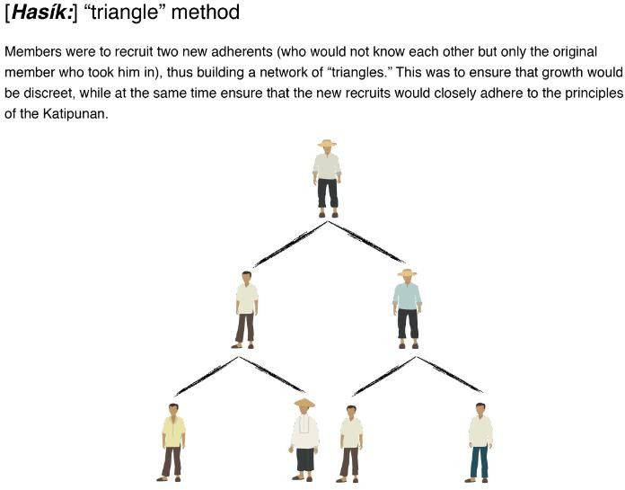

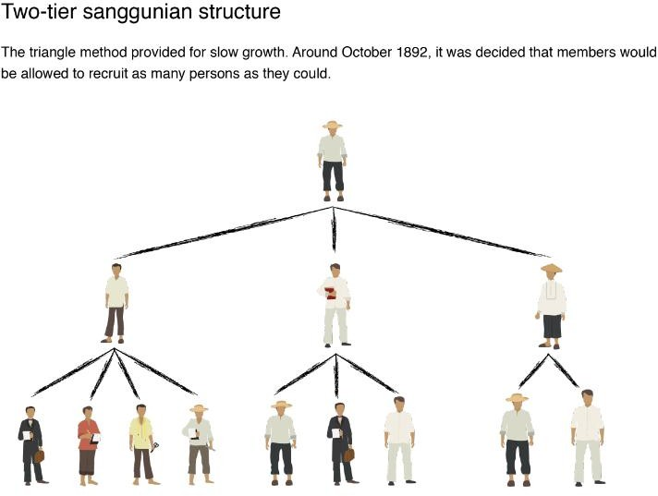

**Members and Ranking**

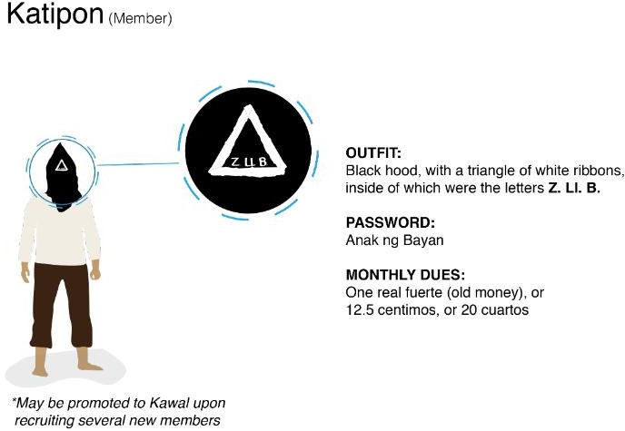

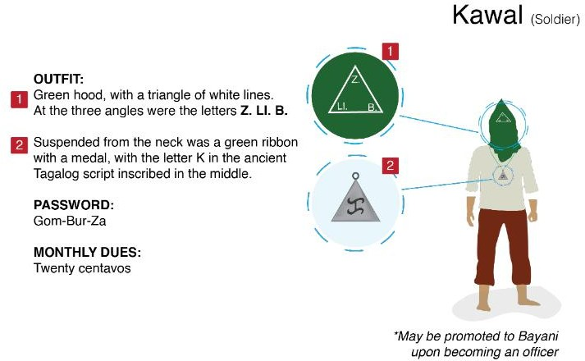

When the Katipuneros had expanded to more than a hundred members, Bonifacio divided the members into three grades: the Katipon which is the lowest rank, the Kawal, and the Bayani. In the meeting of the society, Katipon wore a black hood with a triangle of white ribbon having the letters "Z. Ll. B.", corresponding to the roman "A. N. B.", meaning Anak ng̃ Bayan. Kawal wore a green hood with a triangle having white lines and the letters "Z. LL. B." at the three angles of the triangle, and also wore a green ribbon with a medal with the letter Baybayin Ka (ka) in Baybayin script above a depiction of a crossed sword and flag. The password was Gom-Bur-Za, taken from the names of the three martyrs Mariano Gomez, Jose Burgos and Jacinto Zamora.

**Members and Ranking**

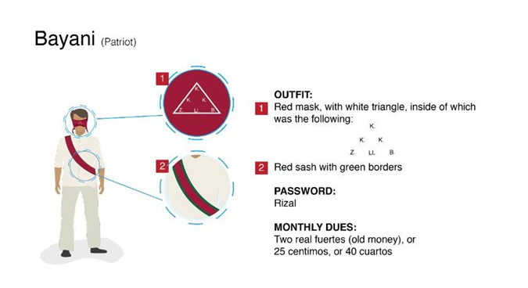

• Bayani (Hero) wore a red mask and a sash with green borders, symbolizing courage and hope. The front of the mask had white borders that formed a triangle with three Ks arranged as if occupying the angles of a triangle within a triangle, and with the letters "Z. Ll. B." below. Another password was Rizal. Countersigns enabled members to recognize one another on the street. A member meeting another member placed the palm of his right hand on his breast and, as he passed the other member, he closed the hands to bring the right index finger and thumb together.

**Katipunan as a Political Organization**

* National Organization
* Katipunan was the result of the collective aspiration of the people and was not the vehicle which united them
* Religious and Polical organization
* Lleto – Katipunan as a combined religious and political organization.
* Teodoro Kalaw – The aim of the Katipunan was to awaken a national sentiment to deliver the Filipino race from the abuses of Spain.

The Katipunan as a national organization was born, grew and supported by the people. It mirrored the point of view, aspirations and experiences of those who brought themselves into the organization. From a logical point of view, the Katipunan was the result of the collective aspiration of the people and was not the vehicle which united them. Setting aside this point of view, it could not be denied that the Katipunan was the pillar of the aspirations and sentiments of the people.

Lleto looked at the Katipunan, as a combined religious and politcal organization. As stated earlier, the organization was born and grew from the people. Its members – the religious-political groups – turned their backs on the colonial order and continued their old tradition. The support it got from the people proved that it was well accepted by them.

As a political organization, the objectives and direction of the Katipunan could be considered national. According to Teodoro Kalaw, the aim of the Katipunan was to awaken a national sentiment to deliver the Filipino race from the abuses of Spain. Even Emilio Jacinto believed that the aim of the Katipunan was for the entire archipelago, stating that the Tagalog language referred to all natives of the archipelago.

**Katipunan as a Political Organization**

* **Objectives** – Isabelo de los Reyes
* Political
* Social
* Moral
* **Structure**

1. Supreme Council (Kataas-taasang Sanggunian) – headed by a president/supremo with officials like fiscal, secretary, and seretary of the treasury;
2. Sangguniang Bayan; and
3. Sangguniang Balangay

• From the point of view of Isabelo de los Reyes, Katipunan had three different but interconnected objectives – political, social and moral.

• The Katipunan was founded to be free from the Spaniards through a revolution. Thus, it was clear that Bonifacio wanted to form a government that would take care of the people after Spain was toppled down. As mentioned earlier, the aim of the Katipunan was national as shown in the structure of the government Bonifacio formed, which was divided into three

• Comparing this structure to the present structure of government, the Supreme Council is the national government; the Sangguninang Bayan is the provincial government and the Sangguniang Balangay, the municipal government. 11/4/20

**Katipunan as a Political Organization**

* Kalayaan – Publication of the Katipunan
* Officers:
  + Supremo: Andres Bonifacio
  + State Secretary: Emilio Jacinto
  + Secretary of War: Teodora Plata
  + Secretary of Justice: Briccio Pantas
  + Secretary of the Interior: Aguedo del Rosario
  + Secretary of Finance: Enrique Pacheco
* La Illustracion Americana (Feb 8, 1897) – recognized the national status of the Katipunan.
* Katipunan – Republika ng Katagalugan
* Bonifacio - Titulado Presidente de la Republica Tagala

• The Katipunan’s national direction was manifested by its strenghening of the local councils in different parts of the archipelago Members like Francisco del Castillo and Candido Iban were from Kalibo, Capiz in the Visayas. These two members of the Katipunan provided the money used in the purchase of machine for the printing of the Kalayaan, the organ of the association

• The La Ilustracion Espanola Americana published on February 8, 1897, recognized the national status of the Katipunan. In this issue, the Katipunan government was referred to as the Republika ng Katagalugan. It also had Bonifacio’s picture which was labelled as Titulado Presidente de la Republica Tagala.

• As to the participation to the revolution of other areas in the archipelago, the people responded eagerly – from Batanes to Mindanao – to the revolution started in Manila and Luzon by their fellow Filipinos, thus the Revolution of 1896 was able to satisfy the geographical dimension for it to be considered a national uprising.

• Clearly, considering the objectives, the composition, and the structure of the Katipunan, this organization spearheaded a national endeavor for regaining the freedom that once was enjoyed by the natives.

**PHILIPPINE WAR HISTORY AND BECOMING FIRST REPUBLIC OF ASIA**

**READINGS IN PHILIPPINE HISTORY WITH INDIGENOUS PEOPLE'S STUDIES**

**PHILIPPINE WAR HISTORY AND BECOMING FIRST REPUBLIC OF ASIA**

**A. PREPARATION FOR THE WAR**

**B. THE BATTLE OF MANILA BAY**

**C. THE RETURN OF AGUINALDO AND THE DECLARATION OF THE PHILIPPINE INDEPENDENCE**

**D. THE PHILIPPINE INDEPENDENCE; FREEDOM AT LAST**

**E. THE FILIPINO- AMERICAN WAR**

**F. THE PHILIPPINE COMMONWEALTH**

**G. THE PHILIPPINE CONSTITUTION**

**H. THE JAPANESE OCCUPATION**

**Preparation for the War**

**The Philippine Islands gained semi- autonomous status in 1935 with the creation of a Philippine Commonwealth and the election of Manuel L. Quezon as president of the newly formed government.**

**MacArthur in Manilla, Philippines, 1945, smoking a corncob pipe**

**One of the most pressing concerns and new responsibilities was the creation of a new military force capable of defending the islands. With this in mind, Douglas MacArthur, then the chief of staff of the U.S. Army, was chosen by President Quezon to be part of the Office of the Military Advisor to the Commonwealth Government. His new job as Field Marshall of the Philippines was to create a new national army complete with its own small off-shore naval patrol force and air contingent over a conservative 10 year period.**

**The Battle of Manila Bay**

**The Battle of Manila Bay**

**On April 30, Dewey's American Asiatic Squadron slipped by the defensive guns of Corregidor Island and into Manila Bay. After dawn, when they located the Spanish fleet, a group of out of date warships anchored off the Cavite naval station (made of wood). The U.S. fleet, in comparison, was well armed and well-staffed, largely due to the efforts of the energetic assistant secretary of the Navy, Theodore Roosevelt, who had also selected Dewey for the command of the Asiatic squadron.**

**At around 5:40 A.M. on May 1, 1898, Dewey turned to the captain of his flagship, the Olympia, and said, "You may fire when ready, Gridley." Two hours later, the Spanish fleet was destroyed, and Dewey ordered a pause in the fighting**

**Battle of Manila Bay: Aftermath**

**Dewey’s decisive victory cleared the way for the U.S. occupation of Manila in August and the eventual transfer of the Philippines from Spanish to American control. In Cuba, Spanish forces likewise crumbled in the face of superior U.S. forces, and on August 12 an armistice was signed between Spain and the United States.**

**Trivia:**

**Roxas Boulevard, originally called Cavite Boulevard, was renamed Dewey Boulevard in honor of the American Admiral George Dewey, whose forces defeated the Spanish navy in the Battle of Manila Bay in 1898.**

**THE RETURN OF AGUINALDO AND THE DECLARATION OF INDEPENDENCE**

**AGUINALDO RETURNS**

**Aguinaldo accepted the Junta's decision, for he had faith and confidence in its members. They were all very highly educated and patriotic Filipinos. The members of the Junta, among others, were Felipe Agoncillo as president with Doroteo Lopez as secretary; Teodoro Sandico, Anastacio Francisco, Mariano Llanera, Miguel Malvar, Andres Garchitorena, Severo Buenaventura, Maximo Kabigting, Faustino Lichauco, and Antonio Montenegro.**

**On May 17, 1898, Aguinaldo boarded the American revenue cutter McCulloch, which was bound for Manila. The ship arrived in Manila Bay two days later. Immediately, he was transferred to Dewey's flagship, the Olympia, where he was given honors due a general of an army.**

**According to Aguinaldo, while he was aboard the Olympia, Dewey assured him that the United States did not need colonies. Dewey, who had been promoted to Rear Admiral, assured him that the United States would recognize the independence of the Philippines. Dewey would later deny having made any promise to Aguinaldo and that his relations with the Filipino leader was purely personal, not official.**

**THE STRUGGLE CONTINUES...**

**When Aguinaldo had finished disembarking the war equipment which were purchased in Hongkong, Filipino rebels came to pay him a visit. He handed them copies of proclamations that he had prepared on the way to the Philippines.**

**The news of Aguinaldo's return spread far and wide. Many Filipinos in the Spanish army defected to Aguinaldo's forces. Some army were given to the Filipinos by the American officers of the Navy. On May 21, Aguinaldo issued a proclamation saying that, "Everything appears favorable for attaining independence... I urge that we strive to unite efforts, and let us fire our hearts with the idea of vindicating our country. Many nations are on our side."**

* **By the end of May, Aguinaldo's armed forces had captured abou 5,000 prisoners.**
* **Town after town, in Cavite and Morong, fell into the hands of the Filipino rebels.**
* **In Pampanga, Laguna, Batangas, Bulacan Nueva Ecija, Tayabas, Bataan, and Camarines, the people were up in arms against Spain. By June 1898, practically the whole of Luzon, with the exception of the Port of Cavite, which was in American hands, and the City of Manila, which was under the Spaniards, was in the hands of the Filipino rebels.**
* **On June 12, 1898, Aguinaldo signed the Proclamation of Philippine Independence in Kawit, Cavite.**
* **This last desperate effort by the governor-general proved useless.**
* **The Filipinos did not cooperate with the Spaniards. Instead, the Filipino rebels besieged Manila, which was then called Intramuros ar the Walled City.**
* **Aguinaldo ordered his forces to lay siege to the city to starve its Spanish population and make them helpless Tondo, Santa Cruz, San Juan, and even as far as Caloocan, were filled with Filipino rebels that surrounded the city.**
* **Then he demanded the surrender of the Spanish forces inside the city, but Governor Augustin, thinking of Spanish honor, refused to surrender.**

**THE SECRET AGREEMENT**

**Dewey did not besiege the city because he did not have enough forces to do it. In June and July, however, American troops arrived in Manila Bay. They landed in Parañaque and encamped south of Pasay. With this force, the American military commanders, among them General Arthur MacArthur, believed that they could fight the Spaniards.**

**But Dewey thought that he could make the Spaniards surrender without a fight. He sent the Belgian consul to Governor Augustin to negotiate with him. The governor was ready to surrender to the Americans, but the Government of Spain did not like this. He was relieved of his duty and was succeeded by General Fermin Jaudenes.**

**Jaudenes believed that the Spanish position was very weak, but he could not surrender without losing face. So he entered into a secret agreement with Dewey and General Wesley Merritt. As agreed, both sides would stage a mock battle to lead to Spanish surrender. It was also agreed upon that the Filipino rebels should not be allowed by their American allies to enter the city. This secret agreement was known only to Jaudenes, Merritt, and Dewey.**

**THE MOCK BATTLE OF MANILA**

**Aguinaldo's generals suspected that the Americans were not being faithful to them. Questions lingered in their minds about the true intentions of the Americans. General Merritt ordered General Francis V. Greene to stop the Filipinos. Greene did as he was ordered and warned Aguinaldo not to his soldiers to enter the Walled City. American soldiers entered the city as the victor of a mock battle.**

**THE AMERICAN TERMS**

**On August 12, Washington time, President William McKinley of the United States issued a proclamation ordering "all military operations against the enemy be suspended". The proclamation was cabled to General Merritt in Manila. It did not reach him in time because Dewey cut the cable linking Manila with the outside world after the battle of Manila Bay. On August 13, the Spanish governor general agreed to sign the surrender document for the city of Manila.**

**FREEDOM AND INDEPENDENCE (1898-1899)**

**The circumstances surrounding the declaration of Philippine independence, its constitution and form of government, were certainly not ideal. The U.S. take-over of Intramuros on August 13, 1898, to the exclusion of the Filipino forces who had earlier laid siege to the city, muddled the issue of who were the real victors of the battle. General Emilio Aguinaldo, together with Apolinario Mabini, were faced with the difficult task of uniting the educated and rich with the majority who were poor and uneducated.**

**THE DICTATORIAL GOVERNMENT**

**When Aguinaldo was in Hongkong, he asked Mariano Ponce to prepare a constitution that provided for a republican form of governmen When Aguinaldo returned to the Philippines, he realized that it was time to organize a government, as what Consul Wildman had earlier advised He was to establish a dictatorial form of government because such a government was very effective in a critical period such as what the country was experiencing.**

**On May 24, 1898 Aguinaldo, upon the advice of Bautista, formally established the Dictatorial Government "to be administered by decrees promulgated under my [Aguinaldo's] sole responsibility." Hereafter, all decrees issued in the name of the Biak-na-Bato Republic were declared null and void. Aguinaldo made it clear that this form of government was temporary in nature and that in the future the people may modify it.**

**MABINI ENTERS THE SCENE**

**While Aguinaldo was in Hongkong, Felipe Agoncillo advised him to look for a certain Apolinario Mabini of Tanawan, Batangas. The General ordered his men to fetch the man and bring him to Kawit, Cavite. He was thin and obviously sick and had been paralyzed from the waist down to his lower limbs. Despite this, there was a strange light in the man's eyes that he could not explain. This meeting was the beginning of a friendship that, unfortunately, lasted only one year.**

**THE DECLARATION OF INDEPENDENCE**

**Aguinaldo proclaimed the independence of the Philippines from his home in Kawit on June 12. He asked a musician to compose a march which would be played during the independence day ceremonies. After June 12, he faded from the picture and Apolinario Mabini stepped in as Aguinaldo's topmost adviser. The Declaration of Independence was signed by ninety-eight persons.**

**PHILIPPINE INDEPENDENCE;**

**Freedom at Last**

* **June 12, 1898- The Philippine Declaration of Independence in Cavite el Viejo**
* **1896: The Philippine revolution began. Eventually, the Spanish signed an agreement with the revolutionaries.**
* **Independence was proclaimed on June 12, 1898 between four and five in the afternoon in Cavite at the ancestral home of General Emilio Aguinaldo.**
* **The event saw the unfurling of the national flag of the Philippines, made in Hong Kong by Marcela Agoncillio, Lorenza Agoncillo, and Delfina Heroza.**
* **And the performance of the Marcha Filipina magdalo as the national anthem now know as lupang hinirang**
* **The Act of the declaration of the independence was prepared , written, and read by ambrosia rianzares bautista in Spanish.**
* **The declaration was not recognized by the U.S. nor Spain and Spain later sold the Philippines to the United States in the 1898 Treaty of Paris ended the Spanish-American War.**
* **Philippine-American War - The Philippine Revolutionary Government did not recognize the treaty or American sovereignty, and subsequently fought and lost a conflict with United States.**
* **The end came when Emilio Aguinaldo was captured by U.S. forces and issued a statement acknowledging and accepting the sovereignty of the United States over the Philippines.**
* **Following World War II, the US granted independence to the Philippines on July 4, 1946 via the Treaty of Manila.**
* **In 1964, President Diosdado Macapagal signed into law Republic Act No. 4166, designating June 12 as the country's Independence Day.**

**THE FILIPINO-AMERICANWAR**

**Also known as the Philippine War of Independence or The Philippine Insurrection**

**Referred as the second phase of the Philippine Revolution**

**The Philippine-American War was an armed conflict fought from February 4, 1899 to July 2, 1902 between forces of the United States and Filipino revolutionaries led by President Emilio Aguinaldo.**

**HOW AND WHY DID AMERICA COME TO THE PHILLIPPINES?**

**From Hong Kong, General Emilio Aguinaldo, accompanied by Colonel Gregorio del Pilar and a certain Mr. J. Leyba, sailed to Singapore for an important meeting with his old friend, Mr. Howard W. Bray, an English man. The purpose of their visit was to consult with their friend about the status of the Philippines and themselves as exiled in Hong Kong. He would also take the opportunity to gather news about the possibilities of the war between America and Spain. They would support and cooperate with America to fight Spain, should America recognize the Philippine Independence afterward.**

**After Aguinaldo returned to the Philippines from Hong Kong on May 19, 1898, on board an American cutter from the fleet of Admiral George Dewey, who on May 1, 1898, had defeated the Spanish forces in the Battle of Manila Bay. The United States had declared war on Spain (over Cuba) in April 1898 and Dewey was sent to Manila to destroy the Spanish navy.**

**WHO IS GENERAL**

**GREGORIO DEL PILAR?**

* **He was born on November 14, 1875 in Bulacan. He was the nephew of propagandist Marcelo H. del Pilar and Toribio H. del Pilar, who was exiled in Guam for his involvement in the 1872 Cavite Mutiny.**
* **He is also known as “Goyong.” At the age of 20, when the Philippine Revolution against Spanish rule broke out in August under the leadership of Andres Bonifacio, del Pilar joined the insurgency. He distinguished himself as a field commander while fighting Spanish garrisons in Bulacan.**
* **On December 28, 1896, he also participated in the attack in Kakarong de Sili-Pandi, Bulacan in the town unfriendly to the Katipunan. On January 1, 1897, he was one among the defenders when a Spanish counterattack recaptured the town.**

**THE TREATY OF PARIS (BETRAYAL OF ALLIANCE)**

**Commissioners from the United States and Spain met in Paris on October 1, 1898 to produce a treaty that would bring an end to the war after six months of hostilities.**

**Signed on December 10, 1898, the Treaty of Paris ended the Spanish-American War and allowed the United States to purchase the Philippines from Spain for $20 million.**

**Before signing the Treaty of Paris, President McKinley said he did not know what to do with the Philippines. But he was surrounded by men who had interest in making the Philippines an American colony. These men representing the Pressure Groups were:**

* **The American Businessman**
* **The American and Naval Pressure Group**
* **The Religious Pressure Group**

**THE FORMATION OF MALOLOS CONGRESS**

**After proclaiming the Philippine Independence on June 12, 1898, President Emilio Aguinaldo with Apolinario Mabini then ordered the convening of a revolutionary congress at Malolos, Bulacan.**

**The revolutionary government of Emilio Aguinaldo attempted to prevent the American conquest, through establishing a formal government.**

**The Malolos Congress or finally known as the “National Assembly” of representatives was the constituent assembly of the First Philippine Republic, held in Barasoain Church in Malolos Bulacan.**

**The Congress was a show of force to the foreign correspondents that we Filipinos are civilized and the Church itself became the seat of Government.**

**The election of Malolos Congress was held between the month of June 23 and September 10, 1898. On September 15, 1898, Pedro Paterno was elected president and Gregorio S. Araneta as vice president.**

**The resulting Malolos Constitution was ratified onNovember 29, 1898, signed into law on December 23,1898 and was approved on January 20, 1899, sanctioned by President Emilio Aguinaldo on January 21, and promulgated on January 22, 1899.**

**The document stated that the people have exclusive sovereignty and basic civic rights, separated the church from the state, and called for the creation of an Assembly of Representatives (National Assembly) which would act as the legislature. It also called for a parliamentary republic as the form of government with the president elected for a term of four years by a majority of the Assembly.**

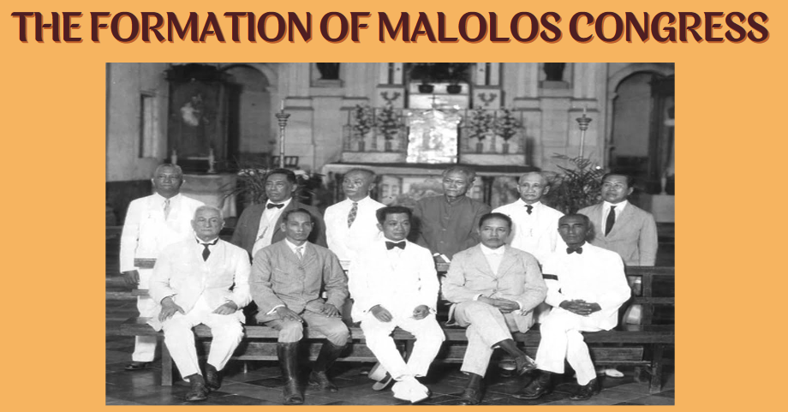

**MEMBERS OR REPRESENTATIVES OF MALOLOS CONGRESS**

**Asserted that among the 85 delegates who convened in Malolos there were 43 lawyers, 17 doctors, five pharmacists, three educators, seven businessmen, four painters, three military men, a priest and four farmers. Five of the 85 delegates did not have a college degree.**

**THE BENEVOLENT ASSIMILATION PROCLAMATION**

**After signing the Treaty of Paris, President McKinley issued the so- called “Benevolent Assimilation” Proclamation. General Elwell Otis delayed its publication until January 4, 1899, then publishing an amended version edited so as not to convey the meanings of the terms “sovereignty”, “protection”, and “right of cessation” which were present in the unabridged version.**

**FILIPINO''S REACTION TO THE PROCLAMATION**

**General Marcus P. Miller, who was in Iloilo, published the original text of the proclamation. Copies of this unchanged version fell into the hands of Filipinos. Antonio Luna, editor of La Independencia, attacked the proclamation severely and said it was a trick to make the Filipino people quiet. On January 5, 1899, Aguinaldo issued strongly worded proclamation saying that “my government is disposed to open hostilities if the American troops attempt to take forcible possession of the Visayan Islands.”**

**The initial enthusiasm for American support of the Revolution against Spain turned increasingly sour as the Filipino revolutionaries became convinced that the United States was preparing to take over sovereignty over the Philippines from Spain.**

**HOW THE FILIPINO-AMERICAN WAR STARTED IN THE PHILIPPINE SOIL?**

**It started with a gun fired by Private William W. Grayson, of the American sentry Volunteer Infantry Regiment, at the corner of Sociego and Silencio Street near the San Juan River Bridge in Sta. Mesa. The American sentry shouted, "Halt!" upon seeing the Filipino soldiers. Grayson killed a Filipino lieutenant and another Filipino soldier. This marked the beginning of the Filipino-American War.**

**HOW WAS TH E WAR WAGED?**

* **The following day after the incident, General Isidoro Torres delivered a message to General Otis of the American army from President Emilio Aguinaldo, informing that the shooting had begun accidentally, he desired the conflict to stop immediately, Aguinaldo also proposed to have a neutral zone for the two fighting forces.**
* **General Ellwel Otis dismissed these proposals, and replied that the “fighting, having begun, must go on to the grim end.” On the day of February 5, 1899, General Arthur McArthur ordered his troops to advance against Filipino troops, beginning a full-scale armed clash. What turned out to be the bloodiest battle of the war ended late on February 5 with a decisive American victory.**

**THE FALL OF MABINI CABINET: WHO IS APOLINARIO MABINI?**

* **He was born on July 23, 1864 in Talaga, Tanauwan, Batangas.**
* **"Utak ng Himagsikan" or "Brain of the Revolution" at "Dakilang Lumpo"**
* **The most powerful man behind Emilio Aguinaldo**
* **His detractors called him the “Dark Chamber of the President” while his admirers named him “the Sublime Paralytic”**
* **Mabini wrote most of Aguinaldo’s presidential decrees**
* **He was the President of the Cabinet, First Prime Minister, and Secretary of Foreign Affairs.**

**THE FALL OF THE MABINI CABINET**

* **Americans tried to win over the Filipinos by promising freedom and autonomy**
* **Mabini stood for the Independence of the Filipinos.**
* **Cabinet members of the Malolos Government**
  + **Pedro A. Paterno**
  + **Ambrosio Rianzares Bautista**
  + **Felipe Buencamino**
* **They passed a resolution asking Aguinaldo to repudiate Mabini’s independent stand and relieve him as a President of the Cabinet.**
* **May 7, 1898**
* **Aguinaldo wrote a letter to Mabini notifying him**
* **Formation a new cabinet under Pedro A. Paterno**
* **Mabini sent his resignation**

**THE ASSASSINATION OF LUNA:**

**WHO IS ANTONIO LUNA?**

* **Antonio Novicio Luna was born on October 29, 1866 in Manila but he was an Ilocano.**
* **The Luna brothers, Juan Luna and Antonio Luna, participated in the struggle for Philippine Independence.**
* **He displayed his writing prowess by writing in La Solidaridad with “Taga-Ilog” as his pen name.**
* **Most brilliant among the Filipino military officers**
* **He organized professional guerilla soldiers known as “Luna Sharpshooters” and the “Black Guard”**
* **He was called “Heneral Artikulo Uno”**

**THE ASSASSINATION OF LUNA**

* **On June 2, 1899, Luna received telegram sent by Aguinaldo himself, ordered him to go to the new capital at Cabanatuan, Nueva Ecija to form a new cabinet. Upon arriving at Cabanatuan on June 5, along with Francisco Roman and Eduardo Rusca, Luna proceeded to the headquarters, alone, to communicate with the President. As he went up the stairs, he ran into an officer whom he had previously disarmed for insubordination: Captain Pedro Janolino, commander of the Kawit Battalion and an old enemy whom he had once threatened with arrest for favoring American autonomy. Captain Janolino was accompanied by Felipe Buencamino, the Minister of Foreign Affairs and a member of the Cabinet.**
* **Both exchanged heated words as he was about to depart. In the Plaza Lucero fronting the church of Cabanatuan, a rifle shot rang out. Still outraged and furious, Luna rushed down the stairs and met Janolino, accompanied by some elements of the Kawit Battalion. Janolino swung his bolo at Luna, wounding him in the head. Janolino's men fired at Luna, while others started stabbing him, even as he tried to fire his revolver at one of his attackers. He staggered out into the plaza where Román and Rusca were rushing to his aid, but as he lay dying, they too were set upon and shot, with Román being killed and Rusca being severely wounded. Luna received more than 30 wounds.**
* **Despite his commitment to discipline the army and serve the Republic which attracted the admiration of people, his temper caused some to hate him. Unfortunately, the brave General died in the hand of his fellow Filipino soldiers, like the fate of Andres Bonifacio. He was the first Filipino soldier whose coffin was wrapped in our Philippine Flag at the time of his burial.**
* **After General Antonio Luna and Francisco Roman died in Plaza Lucero, Pedro Janolino stated that everything that happened was just a matter of self-defense. One version of the story says there was a conspiracy that happened in May 1899 before Luna's Assassination. There was a meeting that happened between Emilio Aguinaldo, Pedro Paterno, and Felipe Buencamino in Cabanatuan, but no one can tell what the meeting was about.**
* **The first confirmation was from Apolinario Mabini himself, who stated in his La Revolucion Filipina that only Emilio Aguinaldo should be blamed for what happened to General Luna and Francisco Roman because of his craving for power.**

**BALANGIGA MASSACRE**

* **Balangiga is a place in Eastern Samar, where a memorable incident happened between the Filipino militants and members of the 9th US Infantry Regiment.**
* **Early morning of September, the bell of Balangiga Church sounded. The American Infantry get confused with the sound of the bell not knowing it was already the signal for the Filipino Militants to conduct their surprise attack against the Americans. After they took control of the place, they took the rifles and ammunition of the American Infantry.**
* **General Jacob Smith out of anger, ordered that Samar be turned into a “howling wilderness.” All Filipino male above ten years age who were capable of bearing guns and rifles be shot. They burned the Church and another sad part was they robbed the three church bells and brought it with them back to America as their war trophy.**

**THE CAPTURE OF EMILIO AGUINALDO (MARCH 23, 1901)**

* **On November 12, 1899, with General Aguinaldo conventional forces shattered; he ordered a shift to guerilla warfare, because he knew that this kind of method is unpredictable. Because of that, Americans concluded that the resistance would never be broken until their leader General Aguinaldo was killed or captured. However, their problem was they did not know his whereabouts.**
* **On February 1901, Brigadier General Frederick Funston made as his headquarters the house and office of General Aguinaldo when he moved from Malolos to San Isidro, Nueva Ecija. It was owned by Crispulo Sideco, also known as “Kapitang Pulong”**
* **When San Isidro was under the Americans, the town mayor, Francisco Villajuan, had convinced the worn-out men to give up their resistance. The group was led by Cecilio Segismundo, an Ilocano and General Aguinaldo’s messenger, and carried some important communication.**
* **Cecilio was forced to pinpoint the location of General Aguinaldo in the village of Palanan, Isabela. He also told the Americans the number of Aguinaldo’s guards with him.**
* **The Americans recovered from him a coded message made by General Aguinaldo under the alias of Pastor and Colon de Magdalo. Americans accessed Lazaro Segovia to decode messages. Segovia was a former Spanish army officer who had defected to the Philippine army and then switched allegiance to the American side; he understood English, Spanish, and the Tagalog dialect. The most important decoded message was an order to General Baldomero Aguinaldo instructing him to send reinforcement troops to Palanan, Isabela.**

**MACABEBE SCOUTS ARE THE KEY TO GENERAL AGUINALDO''S CAPTURE**

* **In relation to the decoded message of Aguinaldo recovered from Cecilio Segismundo, General Funston disguised the Macabebe scouts and sent them to Palanan, pretending that they were the men requested by General Aguinaldo, while General Funston and four other American officers, disguised as prisoners of war. Aside from Segismundo, Funston included in the line Hilario Tal Placido, Lazaro Segovia, Dionisio Bato, and Gregorio Cadhit. Placido had been a Lieutenant Colonel in the Philippine army and they knew General Emilio Aguinaldo personally.**
* **Another thing which was in the possession of General Funston that time was Official Seal of General Urbano Lacuna and some official letters and memos with the signature of the General. General Lacuna’s signature was copied by Roman Roque, a native of San Isidro, Nueva Ecija. He had the skill of an expert penman and also a former officer in the Philippine army who had surrendered to the Americans, and later he was employed by the US army as interpreter and clerk.**
* **When General Funston and the Macabebe group reached the place of General Aguinaldo in Palanan, Isabela, at around 3:00 p.m., they immediately executed their plan. They went and talked to General Aguinaldo. After fifteen to twenty minutes, perhaps, Aguinaldo was already convinced. At the time when they were all inside the vicinity of General Aguinaldo’s Camp, Captain Segovia went out quickly and gave his signal to assault. Macabebe scout started to shoot and General Aguinaldo thought that the shots he heard was just a welcome noise for the re-enforcement which came, and not suspecting anything against him. The general went to his window to stop them; he shouted several time, “Ceasefire.” While shouting he observed that rifle and their bullets were aimed to him.**
* **One of his men Dr. Barcelona held him by a tight embrace with his two arms got locked, while crying to him by saying “Do not sacrifice yourself; the country needs your life.” Unfortunately, together with his other men General Emilio Aguinaldo was declared as Prisoners of War (POW).**
* **On March 25, 1901, from his camp General Aguinaldo with his three men together with General Funston and some American Soldiers took a 10- kilometer walk to the shoreline of Palanan, Isabela, and when they reach the area, they boarded the U.S.S Vicksburg bound to Manila.**
* **On April 1, 1901, General Emilio Aguinaldo swore allegiance to the United States of America. General MacArthur has notified the War Department that Aguinaldo has taken the “oath of allegiance.”**
* **On April 19, he issued a Proclamation of Formal Surrender to the United States, telling his followers to lay down their weapons and give up the fight.**

**WHO IS GENERAL MIGUEL MALVAR?**

* **He was born in Santo Tomas, Batangas on September 27, 1865 and a fellow revolutionary of Apolinario Mabini and became classmates in Batangas.**
* **Malvar and his family had a friendship with Jose Rizal and his family.**
* **Like Macario Sakay, Malvar was an original Katipunan. He joined the Katipunan before the Philippine Revolution. When the Revolution began by August 1896, he was the military commander of Batangas. He once fought alongside General Edilberto Evangelista, Malvar’s senior officer at the time, at the Battle of Zapote Bridge, where the former died in battle. Malvar had set up his own headquarter in Indang, Cavite where he stayed until the Tejeros Convention.**
* **The capture of Aguinaldo dealt a severe blow to the Filipino cause, but not as much as the Americans had hoped. General Miguel Malvar took over the leadership of the Filipino government. He originally had taken a defensive stance against the Americans, but now launched all-out offensive against the American- held towns in the Batangas region. General Vicente Lukbán in Samar, and other army officers, continued the war in their respective areas.**
* **General J. Franklin Bell relentlessly pursued Malvar and his men, forcing the surrender of many of the Filipino soldiers. Finally, Malvar surrendered, along with his sick wife and children and some of his officers, on April 13, 1902, to put an end to the sufferings of his countrymen. By the end of the month nearly 3,000 of Malvar's men had also surrendered. With the surrender of Malvar, the Filipino war effort began to dwindle even further.**
* **After the war, he refused any position offered to him in the American colonial government. He died in Manila on October 13, 1911 due to liver failure. He was buried in his hometown, Santo Tomas, Batangas on October 15.**
* **He was the forgotten president of the Philippines.**

**WHO IS MARIANO SAKAY?**

* **One of the forces that remained at large and continued fighting when General Emilio Aguinaldo was captured was led by Mariano Sakay.**
* **There was no exact date when Mariano Sakay was born but their idea was year 1869 or 1878 along Tabora Street, Tondo, Manila.**
* **He was one among those original members of the Katipunan movement. In 1899, he continued the fight for Philippine independence against the United States.**
* **Mariano Sakay was one of the founders of the Partido Nacionalista that aimed to achieve the Philippine Independence through legal means. They appealed to the Philippine Commission, but the Commission passed the Sedition Law, which prohibited any form of propaganda advocating independence of the Philippines.**
* **When General Emilio Aguinaldo was captured, Mariano Sakay established a Tagalog Republic somewhere in the mountains of Rizal. In his military circular No. 7, dated June 19, 1903, the government of the Tagalog Republic (called the “Republic of the Philippines) affirmed the formation of an organized army.**
* **In 1905, a certain Filipino with the name of Dominador Gomez was given authority by the American Governor- General Henry Clay Ide to negotiate for the surrender of Sakay and his men. Gomez met with Sakay at camp and discussed about the concern of the American government to the Filipinos, what Sakay’s group wanted and the first step toward Filipino Independence.**
* **After the thorough explanations on both sides, Sakay agreed to end his resistance on the condition that a general amnesty will be granted to him and to his men. They were permitted to carry firearms, and that he and his officers were permitted to leave the country.**
* **Sakay believed that the struggle had now shifted to constitutional and legal means, and that the establishment of the assembly was a means to winning independence. He surrendered on July 20, 1906, down from the mountains on the promise of an amnesty for him and his officials, and the formation of a Philippine Assembly composed of Filipinos that would serve as the “Gate of Freedom”**
* **Mariano Sakay was accused of “bandolerismo" under the Brigandage Act of Nov. 12, 1902, which interpreted all acts of resistance to American rule, is considered banditry.” Mariano Sakay was sentenced to death, hanged on September 13, 1907. Mariano Sakay was buried at Manila North Cemetery later that day.**

**CASUALTIES AND ATROCITIES**

* **While relatively short compared to past and future wars, the Philippine-American War was especially bloody and brutal. An estimated 20,000 Filipino revolutionaries and 4,200 American soldiers died in combat. Also, as many as 200,000 Filipino civilians died from starvation or disease or were killed as “collateral damage” during battles. Other estimates placed total deaths as high as 6,000 Americans and 300,000 Filipinos.**
* **Especially during the latter stages of the fighting, the war was marked by reports of torture and other atrocities committed by both sides. While Filipino guerillas tortured captured American soldiers and terrorized Filipino civilians who sided with the Americans, U.S. forces tortured suspected guerrillas, torched villages, and forced villagers into concentration camps originally built by Spain.**

**THE FIRST PHILIPPINE COMMISSION**

**(SCHURMAN COMMISSION)**

* **On January 20, 1899, President McKinley appointed Dr. Jacob Gould Schurman to chair a commission (known as Schurman Commission), with Dean C. Worcester, Charles H. Denby, Admiral Dewey, and General Otis as members. It was to investigate conditions on the islands and make recommendations. President McKinley instructed the First Philippine Commission to order the use of the Philippine languages as well as English for instructional purposes and to replace Spanish.**
* **In the report that they issued to the president the following year, the commissioners acknowledged Filipino aspirations for independence; they declared, however, that the Philippines was not ready for it. Specific recommendations included the establishment of civilian government as rapidly as possible (the American chief executive in the islands at that time was the military governor), including establishment of a bicameral legislature, autonomous governments on the provincial and municipal levels, and a system of free public elementary schools.**

**THE SECOND PHILIPPINE COMMISSION**

**(TAFT COMMISSION)**

**After the Schurman Commission, the Second Philippine Commission, appointed by McKinley on March 16, 1900, and headed by William Howard Taft, was granted legislative as well as limited executive powers.**

**Between September 1900 and August 1902, it issued 499 laws. A judicial system was established, including a Supreme Court, and a legal code was drawn up to replace antiquated Spanish ordinances. A civil service was organized. The 1901 municipal code provided for popularly elected presidents, vice presidents, and councilors to serve on municipal boards.**

**On July 4, President William McKinley was assassinated and Theodore Roosevelt succeeded the Presidency. 4th of July was declared as the ending date of the Philippine- American War.**

**On April 9, 2002, Philippine President Gloria Macapagal Arroyo proclaimed that the Philippine–American War had ended on April 16, 1902, with the surrender of General Miguel Malvar. She declared the centennial anniversary of that date as a national working holiday and as a special non-working holiday in the province of Batangas, Lipa and Tanauan.**

**TAFT AS FIRST AMERICAN CIVILIAN**

**GOVERNOR IN THE PHILIPPINES**

**On 4 July 1901, Taft became governor of a civil administration for the Philippines. This regime, called the Insular Government, administered the country until 1935. Taft made many reforms in the Philippines since he started his duty as an American civilian governor by uplifting and developing Filipinos to be more civilized. He was a federal circuit judge in Cincinnati before his move here in the Philippines when President McKinley asked him to lead the second commission. He was one among the Americans who opposed annexation of colonies.**

**WHEN LAND REFORM PROGRAM STARTED IN THE PHILIPPINES**

* **During the American occupation in the Philippines they issued the Philippines Bill of 1902, which set ceiling on the hectares that private individuals and corporation may acquire: 16 hectares for private individuals and 1,024 hectares for corporations.**
* **Land Registration Act of 1902 (Act No. 496) – provided for a comprehensive registration of land titles under the Torrens System.**
* **Public Land Act of 1903 – introduced the farm system in the Philippines.**
* **Tenancy Act of 1933 (Act No. 4054 and 4113) – regulated relationships between landowners and tenants of rice (50-50 sharing) and sugar cane lands.**
* **Torrens system – is a system of land registration invented by Sir Robert Torrens in the 19th century, in which the government is the keeper of all land and title records, and a land title will serve as a certificate of full, unvoided, and valid ownership.**

**THE CIVIL SERVICE ACT**

* **The first major legislation passed by the commission on September 19, 1900 was Act No. 5, known as the Civil Service Act., From the passage of this act until the departure of Taft from the Philippines, the number of Americans and Filipinos applying to serve the government continued to increase.**

**THE EDUCATION ACT OF 1901**

* **On September 1, 1898, General Elwell Otis made an initiative to establish a public school system, organizing seven schools in Manila. While war was raging, American soldiers took time out to organize schools, and to teach classes. When General MacArthur assumed command, he continued the public education project and increased its budget. When the Taft Commission arrived in Manila, the Army had organized 39 schools in Manila with a daily attendance of between 4,500 and 5,000 students.**

**THE PHILIPPINE COMMONONWEALTH**

**Preparation for the Philippine Commonwealth**

**IN RELATIONTO THE PLAN OF PRESIDENT WILLIAM MCKINLEY, HE ESTABLISHED TWO COMMISSIONS ( THE SCHURMAN AND TAFT COMMISSION) AS PREPARATION FOR THE PHILIPPINE COMMONWEALTH, AN AMERICAN- SPONSORED GOVERNMENT .**

**The Cooper Act or the Philippine**

**Organic Act of 1902**

**Congressman Henry A. Cooper authored the Philippine Organic Act of 1902, the approval of the act concurred with the official end of the Philippine – American War. (It is also known as Philippine Bill of 1902).**

**The Philippine Organic Act provided for the creation of an elected Philippine Assembly after the following conditions were met:**

**The cessation of the existing insurrection in the Philippine Islands**

**Completion and publication of a census**

**Two years of continued peace and recognition of the authority of the United States of America after the publication of the census**

**The first census in the Philippines was in 1591, Spanish time. I t was based on tributes collected and generated about 666,712people in the islands. In the year 1799, Filipino population was estimated 1,502,574. However, the first official census in the Philippines was carried out by the Spanish government pursuant to a royal decree calling fine the counting of persons living as of the midnight of December 31, 1877; a count of 6.984,727 has been recorded.**

**The first census conducted by the U. S. military forces took place in 1903 to fulfill Public Act 467 which was approved by the United States Philippine Commission on October 6, 1902. A total of 7,635 , 426 Filipinos were recorded as inhabitants of the Philippines.**

**THE JONES LAW**

**Congressman William Jones authored the bill which replaced the Philippine Organic Act of 1902 .**

**The Jones Law (also known as the Philippine Autonomy Act of 1916) was another Organic Act passed by the United States Congress. The said law acted as a constitution of the Philippines from its enactment until the Tydings Mc Duffie Act was passed in 1934. The Jones Law created the first fully elected Philippine legislature.**

**Hare-Hawes-Cutting Law**

**The Hare- Hawes- Cutting Act was enacted on January 17, 1933. (246) I t was the first US l aw passed that set a process and a date for the Philippines to gain independence from the United States. This l aw was the result of the OsRox Mission led by Sergio Osmeña and Manuel Roxas.**

**The law stated the following:**

1. **America will give the Philippine independence after 10 years.**
2. **They will establish several military and naval bases for the United States.**
3. **There will be impositions of tariffs and quotas on Philippine imports.**

**The Hare- Hawes- Cutting Act was authored by South Carolina Representative Butler Hare, Missouri Senator Harry Bartow Hawes and New Mexico Senator Bronson M. Cutting. It was passed by the United States Congress in December 1932, but was vetoed by U. S. President Herbert Hoover. Congress overrode the veto on January 17, 1933. The Philippine Senate was required to ratify the l aw. With leaders such like Manuel L. Quezon opposing the bill, the Philippine Senate rejected the bill.**

**Resident Commissioners**

**Benito Legarda and Pablo Ocampo were the first two Filipino Resident Commissioners sent to Washington. Other Filipinos who occupied this position included Manuel Quezon, Jaime de Veyra, Teodoro Yangco, Isaro Gabaldon, and Camilo Osias.**

**Tydings Mcduffie Law**

**The Tydings- Mc Duffie Act, officially the Philippine Independence Act was enacted on March 24, 1934, authored by the two members of Democrats, Senator Millard E. Tydings of Maryland and Representative John Mc Duffie of Alabama, and signed into law by President Franklin D. Roosevelt.**

**The act mandated the following:**

1. **U. S. recognition of independence of the Philippine Islands as a separate and self- governing nation after a ten-year transition period.**
2. **The act allowed the U. S to maintain military forces in the Philippines and to call all military forces of the Philippine government into U. S. military service.**
3. **The act empowered the U. S. President, within two years following independence, to negotiate matters relating to U. S. naval reservations and fueling stations of in the Philippine Islands.**
4. **The act reclassified all Filipinos, including those who were living in the United States, as aliens for the purposes of immigration to America. A quota of 50 immigrants per year was established.**
5. **Before this act, Filipinos were classified as United States nationals, but not United States citizens, and while they were allowed to migrate relatively freely, they were denied naturalization rights within the US, unless they were citizens by birth in the mainland America.**

**Senate President Manuel L. Quezon headed the “Philippine Independence mission” to Washington, D.C. in 1934, after the OsRox Mission and successfully lobbied in the US Congress and secured the passage of law.**

**In 1935, as the result of Tydings-McDuffie Law, the 1935 Constitution of the Philippines was drafted and became law, establishing the Commonwealth of the Philippines with an elected executive, the President of the Philippines**

**The Nacionalista Party**

**The Nacionalista Party had a dilemma between their two candidates as to who can be their party standard bearer for the Presidency and for Vice Presidency. Both had the intention to run as President. A Party Convention was made for official selection for Manuel L. Quezon, The Senate President from Tayabas and Sergio Osmeña, the Senate Pro- tempore from Cebu.**

**The National Socialist Party**

**Prior to the incoming election, General Emilio Aguinaldo founded the National Socialist Party in 1934. He announced his candidacy for President on June 2, 1935 with his running mate Raymundo Melliza. Mr. Meliza was a former governor of Iloilo. Their candidacy was also supported by the organization Veteranos de la Revolucion, formed during the administration of Governor- General Leonard Wood by remaining Filipino veterans of the Philippine Revolution and the Philippine- American War.**

**The Republican Party**

**On June 19, 1935, Bishop Greogrio Aglipay announced his candidacy for the Presidency of the Philippines. He revived the Republican Party only for his intention to run for the 1935 election. His political party was organized since 1904 but collapsed in 1907. His running mate was Roberto Nabong from Partido Komunista ng Pilipinas.**

**Independent Candidate**

**Pascual B. Racuyal, a mechanic in profession was a Filipino weird and aspirant for the Philippine presidency. According to some historians there were questions as to Racuyal' s mental stability. Among his promises include that should if he be elected to the presidency, he will construct roads out of plastic to prevent their further deterioration. He filed his candidacy on the 1935 election. On the 1953 election, he invited Manila Mayor Arsenio Lacson as his running mate, until 1986, to the Marcos- Aquino snap election. But he was disqualified in 1986 and was declared a nuisance candidate.**

**RESULTS OF THE PRESIDENTIAL ELECTION: SUMMARY OF THE SEPTEMBER 16, 1935 PHILIPPINE PRESIDENTIAL ELECTION RESULTS**

|  |  |  |  |
| --- | --- | --- | --- |
| CANDIDATES | PARTIES | VOTES | % |
| Manuel L. Quezon | Nacionalista Party | 695,332 | 67.99% |
| Emilio Aguinaldo | National Socialist Party | 179,349 | 17.54% |
| Gregorio Aglipay | Republican Party | 148,010 | 14.47% |
| Pascual Racuyal | Independent | 158 | 0.00% |
| TOTAL |  | **1,021,445** | **100%** |

**RESULTS OF THE VICE PRESIDENTIAL ELECTION: SUMMARY OF THE SEPTEMBER 16, 1935 PHILIPPINE VICE-PRESIDENTIAL ELECTION RESULTS**

|  |  |  |  |
| --- | --- | --- | --- |
| CANDIDATES | PARTIES | VOTES | % |
| Sergio Osmenia | Nacionalista Party | 812,352 | 86.93% |
| Raymundo Melliza | National Socialist Party | 70,899 | 7.59% |
| Norberto Nabong | Republican Party | 51,433 | 5.50% |
| TOTAL |  | **934,128** | **100%** |

**The Philippine Commonwealth Government**

**The Philippine Commonwealth Government was for a ten- year transitional period in the Philippines from 1935 - 1945 in preparation for the independence from the United States.**

**The Commonwealth Government was a turning point in Philippine history. To the Filipino people, it was a realization of their efforts to manage themselves and plan their own destiny as people. The Philippines became a self- governing commonwealth in 1935**

**Among the provisions was the election in 1934 of a Constitutional Convention to draft the constitution of the incoming commonwealth government. It was presided over by Claro M. Recto with 202 elected Filipino delegates who decided that the constitution to be written would cover not only the transitional Commonwealth, but would apply to the Republic as well. The convention finished its work on February 8, 1935 and submitted it to the President of the United States for certification that its provisions complied with the Philippine Independence Act. It was certified on March 25, 1935 and it was subsequently ratified by the Filipino people in a plebiscite on May 14, 1935.**

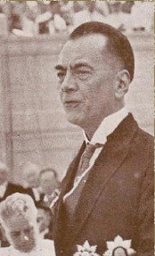**On November 15, 1935, the inauguration of the Philippine Commonwealth Government happened. Manuel L. Quezon was elected president and tasked with preparing the country for full independence after a ten-year transition period. With Sergio Osmeña as Vice-president, they took their path in the ceremony.**

**The primary concerns in the transition period were:**

1. **National Security and National Defense**
2. **Social Justice of the Country**
3. **Education**
4. **Language**
5. **Economic Development**

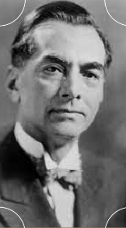**MANUEL L. QUEZON**

**He was born on August 19, 1878 and died on August 1, 1944. Manuel Luis Quezon was a Filipino statesman, soldier, and politician who served as the first president of the Commonwealth of the Philippines from 1935 to 1944. He was the first Filipino to head a government of the entire Philippines, and is considered to have been the second president of the Philippines after Emilio Aguinaldo (1899 - 1901) .**

**AchÚevements of Quezon AdmÚnÚstŨatÚon UndeŨ the Commonwealth GoveŨnment**

**Reorganization of the government by creating offices, including**

**Department of National Defense, Institute of National Language and the National Council of Education, Filipinization of the judiciary f rom**

**Supreme Court to the municipal courts. Granting of women' s suffrage.**

**Creation of new chartered cities - Cebu, I loilo, Bacolod, Davao, Zamboanga, San Pablo, Quezon City, Cavite and Tagaytay.**

**The adoption of a national l anguage, based on Tagalog.**

**Promotion of Social Justice, as shown by the Eight Hour Labor Act enacted by the National Assembly and the appointment of public defenders**

**Compulsory military training of able- bodied Filipino youths, under the supervision of Gen. Douglas Mac Arthur.**

**Taking of the 1939 Official Census of the Philippines.**

**The improvement of the Philippine economy, as revealed by the growth of agriculture.**

**Commerce and industries.**

**Creation of Joint Preparatory Committee on Philippine Affairs ( JPCPA).**

**Passing of three amendments of the 1935 Phil. Constitution.**

**1. . Tenure of the President and Vice- President was four years with reelection for another term**

**2. . Establishment of a Bicameral Congress of the Philippines 3 . Creation of an Independent Commission on Elections**

**composed of three members to supervise**

**PŨesÚdent Quezon ReÚnfoŨcement to Land RefoŨm**

**PŨogŨam**

**President Manuel L . Quezon adopted the " Social Justice" program to arrest the increasing social unrest in Central Luzon.**

**SÚgnÚfÚcant LegÚslatÚon Enacted DuŨÚng Commonwealth PeŨÚod:**

**1935 Constitution - " The promotion of social justice to ensure the**

**well- being and economic security of al l people should be the concern of the State."**

**Commonwealth Act No. 178 ( An Amendment to Rice Tenancy Act No. 4045 ) , Nov. 13 , 1936 - I t provided for certain control in the l andlord- tenant relationships.**

**National Rice and Corn Corporation ( NARIC), 1936 - Established the price of rice and corn thereby help the poor tenants as well as**

**consumers.**

**Commonwealth Act. No. 461 , 1937 Specified reasons for the dismissal of tenants and only with the**

**approval of the Tenancy Division of the Department of Justice.**

**Rural Program Administration, created on March 2 ,**

**1939 - Provided the purchase and lease of haciendas and their sale and lease to the tenants.**

**Commonwealth Act No. 441 , enacted on June 3 , 1939 Created the National Settlement Administration with a capital stock of P 20 , 000 , 000 .**

**ClaŨo M. Recto CMS**

**He was born in Tiaong on February 8 , 1890 , and died on Oct. 2 , 1960 in Rome, I taly. He was a statesman and leader of the " Filipino- f i rst" movement that**

**attacked U. S . " neo- colonialism" in the Philippines. Recto was a l awyer who**

**graduated f rom the University of Santo Tomas in 1913 . He was elected in 1919 to the Philippine House of Representatives and served for three terms as a minority**

**f loor leader.**

**He became a Senator in 1931 ; he switched his al legiance two years l ater to the Nacionalista Party. He was a member of a mission to Washington, D. C., led by Manuel Quezon, which secured passage by Congress of the Philippine Independence and Commonwealth Act ( 1934 ; Tydings Mc Duffie Act). Recto was appointed president of the convention charged with drafting a constitution for the new Commonwealth government.**

**The Second Commonwealth**

**In the midst of the Filipino- American War, sad news reached the Philippines, when President**

**Manuel L . Quezon died in New York, at morning of August 1 , 1 Below was the communication sent by**

**Vice President Osmena informing, the government of the Philippines and the letter informing the**

**Commonwealth government that Sergio Osmena already took his oath of office as President of the Philippine commonwealth to Justice Robert H.**

**Jackson of the United States Supreme Court in the offices of Secretary Harold L . Ickes, Department of**

**Interior, Washington, D. C.**

**It is with a deep sense of sorrow and personal loss that I must give the sad news of the passing away of President Manuel L. Quezon of the Philippines. He died in Saranac Lake, NY. at 10:00 this morning, with Mrs. Quezon and his three children at his bedside.**

**President Quezon's death is a great loss to the freedom loving world. No champion of liberty fought for such a noble cause with more determination and against greater odds. His whole life was dedicated to the achievement of his people's freedom, and it is one of the sad paradoxes of fate that with the forces of victory fast approaching the Philippines, he should pass away now and be deprived of seeing the culmination of his labors-the freedom of his people.**

**To the Filipinos, President Quezon's demise is a severe blow. No man has received more tokens of a people's love and confidence than did Manuel L. Quezon at the hands of the Filipino people. His death will be taken in the Philippines as another terrible ordeal visited upon a nation already so sorely tried by a brutal invasion, and only Filipino courage and fortitude can blunt the poignant sorrow of so irreparable a loss.**

**Manuel L. Quezon was my dear and beloved friend. Our friendship has stood the test of all political differences and has remained throughout whole and unimpaired. My attachment to him was rooted in that genuine friendship that has mellowed with the years into a real and abiding affection. He has gone to his reward, a valiant leader who will live forever in the hearts of his people. His memory will help me face the tasks that are ahead with the same patriotism with which he led us in our fight for freedom, and with the same devotion to the masses of our people which has characterized his administration as President of the Philippines.**

**SeŨgÚo Osmeña**

**He was born September 9 , 1878 and died on October 19 , 1961 . Osmeña was a Filipino politician who served as the third President of the Philippines f rom 1944 to 1946 .**

**Prior to his succession upon the sudden death of President Quezon in New York, he f i rst became governor of Cebu in the year 1906 to 1907 and**

**became member of the House of Representatives f rom 1907 to 1922 as a Speaker of the House. He also served as Senator and as a Senate Pro-**

**Tempore before he won as a Vice President in the 1935 election as a running mate of the l ate**

**President Manuel L . Quezon.**

**In the early history of Philippine politics, he was the oldest to hold the office of the President at the age of 65 , until the election of 2016 when Rodrigo Roa Duterte won the Presidency at the age of 71 .**

**Osmeña was the f i rst Visayan to become President**

**of the Philippines.**

**THE PHILIPPINE CONSTITUTION**

**THE PHILIPPINE CONSTITUTION**

**Right after the signing of the Treaty of Paris in Washington**

**D.C in 1898 that ceded the Philippines to the US paying the amount of $20, 000, 000 to Spain in the process, and the**

**eruption of Filipino-American War in 1899, our country was placed under a military government until 1901 with the passing of the Spooner Amendment, putting an end to the military rule in the Philippines and replacing it with a civil government with William H. Taft as the first civil governor.**

**This was accepted by the Philippine Legislature on May 1, 1934. Delegates to the convention were subsequently elected in 1934. In the first meeting held on July 30 at the session of the House of**

**Representatives, Claro M. Recto was unanimously elected as its President. Salient features of the 1935 Constitution include the following: a bicameral legislature composed of a senate and House of Representatives.**

**The President is to be elected to a four-year term together with the Vice- President without re-election; rights of suffrage by male citizens of the Philippines who are twenty-one years of age or over and are able to read and write; extension of the right of suffrage to women within two years after the adoption of the constitution.**

**The draft of the constitution was approved by the convention on February 8, 1935 and ratified by Pres.**

**Roosevelt in Washington D.C on March 25, 1935.**

**Elections were held in September 1935, Manuel L. Quezon was elected as the president of the Commonwealth.**

**The 1935 Constitution provided the legal basis of the Commonwealth Government which was considered a transition government before the granting of the Philippine independence with American-inspired constitution; the Philippine government would eventually pattern its government system after American government.**

**It has been said that the 1935 Constitution was the best-written Philippine**

**charter ever.**

**THE JAPANESE OCCUPATION**

**THE WAR IN PACIFIC**

**The preparations of the Commonwealth for an independen Philippines was interrupted when the war in the Pacific broke out in 1941. The fear of Filipino political leaders, especially Claro M. Recto, that Japan was a menace to the security of the Philippines, came true. On December 7, 1941, Hawaiian time, Japanese bombers attacked the American fleet in Pearl Harbor, Hawaii.**

**Provoked by the attack, true President Franklin D. Roosevelt spoke before the joint session of the American Congress and urged it to declare war against Japan. "Yesterday Roosevelt said, "December 7, 1941, ... the United States was suddenly and deliberately attacked by naval and air forces of the empire of Japan. Immediately, the Congress declared war against Japan. On December 8, British time, England also declared war against Japan and the war in the Pacific was on.**

**THE OCCUPATION OF MANILA**

**Japanese naval, military, and air forces took the offensive against the United States, Britain, and Holland. Their colonies in Asia were attacked-the Philippines, Malaya, and Indonesia. In order to save Manila from destruction, General Douglas MacArthur declared it an open city. All guns and other defenses were withdrawn from Manila. But the Japanese continued bombing it, resulting in the destruction of properties and buildings.**

**THE FALL OF BATAAN AND CORREGIDOR**

**President Quezon took his oath of office in Corregidor on December 30, 1900.**

**President Roosevelt ordered Quezon to be transferred to Australia. In March, he also ordered General MacArthur to fly to Australia, from where he would direct military operations against Japan. With Manila and other parts of Luzon in the hands of the Japanese, Bataan and Corregido began to take heavy beating from the enemy.**

**GOVERNMENT**

**REORGANIZATION**

**During World War Two, General Masaharu Homma, the Japanese commander-**

**in-chief, ordered the reorganization of the central government. This was renamed Central Administrative Organization composed of six executive departments — Interior, Finance, Justice, Agriculture and Commerce, Education, Health and Public Welfare, Public Works and Communications. In each department, Japanese "advisers" were installed. The advisers were actually spies or agents of the Japanese military. On the provincial and municipal levels, however, nothing was changed.**

**EDUCATIONAL POLICY OF THE JAPANESE**

**Japanese educational policy was based on the spiritual rejuvenation of the Filipinos and the propagation of Filipino culture. Enrollment in the schools throughout the Philippines did not exceed 300,000. The uncertainty of war conditions discouraged schooling and other activities. Many scho children remained in their homes or on their farms.**

**THE SECOND REPUBLIC**

**In September 1943, the Japanese authorities in Japan decided that the Philippines should be given its independence. The real intention of the Japanese was to show the Filipinos that they were better than the Americans. Consequently, a commission created for the purpose of framing a constitution was headed by Jose P. Laurel as president. In his inaugural speech, Laurel said: "...I am sure our people will rise as one to meet the challenge".**

**THE GUERILLA WARFARE**

**The guerrillas harassed Japanese army units, ambushed, and killed them. Their guerrilla warfare tactics made the Japanese conquest of the Philippines very difficult. Among the most famous guerrilla leaders were Governor Tomas Confesor of Iloilo, Colonel Macario Peralta, of Panay, Colonel Ruperto Kangleon of Leyte, and Wendell Fertig of Mindanao.**

**THE GOVERNMENT-IN-EXILE**

**Quezon and his party left Corregidor in February 1942 for Australia and the United States. It was in the U.S. that Quezon reorganized the Commonwealth government. Quezon was very sick, and on August 1, 1944 he died at Saranac Lake, New York.**

**He was succeeded by Vice President Sergio Osmeña.**

**THE RETURN OF MACARTHUR**

**In 1944, the United States began its offensive against Japan.**

**Island after island in the Pacific, which the Japanese had captured early in the war, fell into the hands of the Americans.**

**In several encounters, the Japanese navy was defeated by elements of the American navy which guarded Leyte. As the Japanese military forces weakened, MacArthur landed in Lingayen, Pangasinan on January 9, 1945.**

**THE GUERILLA WARFARE**

**The guerrillas harassed Japanese army units, ambushed, and killed them. Their guerrilla warfare tactics made the Japanese conquest of the Philippines very difficult. Among the most famous guerrilla leaders were Governor Tomas Confesor of Iloilo, Colonel Macario Peralta, of Panay, Colonel Ruperto Kangleon of Leyte, and Wendell Fertig of Mindanao.**

**THE END OF THE WAR**

**With the Japanese defeated in the Philippines, MacArthur now proposed to carry the war to Japan itself. Hundreds of huge bombers, called Superfortresses, bombed Japan, particularly Tokyo, Nagoya, Osaka, and other Japanese cities.**

**President Harry S. Truman, who had succeeded Roosevelt after his death, and Prime Minister Winston Churchill of England demanded for Japan to surrender unconditionally. At first Japan refused to surrender. The Americans then dropped atomic bombs on the cities of Hiroshima and Nagasaki. Faced with threats of annihilation, Japan surrendered unconditionally. On September 2, 1945, Japan signed the terms of surrender on board the battleship USS Missouri at Tokyo Bay.**

**The war in the Pacific was finally over.**

**THANK YOU!!**

**REFERENCES**

**https://drive.google.com/drive/folders/1 zdZM5nCmmtieKrhhUfYvmaYY0U3VJ0qY https://www.officialgazette.gov.ph/cons titutions/1987-constitution/ https://www.officialgazette.gov.ph/cons titutions/constitution-day/ https://nhcp.gov.ph/the-constitution-of- the-philippine-commonwealth/ https://www.philippine- history.org/philippine- commonwealth.htm**

**REPORTERS**

**Anthril Embalsado Paulo Raphael Josafat John Andrei Miole Ronnie Ropero**

**Ayen Damari Sayson**

**Chapter 8**

1. **MODIFIED TRUE OR FALSE.** Write T/True if the underlined word is true and if False, write the correct answer on the space provided.
2. The last issue of the newspaper *La Independencia* was on November 11, 1901.

* False/November 11, 1900

1. The pen name of Graciano Lopez Jaena in *La Solidaridad* was “*Taga-Ilog*.”

* False/none OR False/Diego Laura

1. The day they founded the *Katipunan*, there were not more than 300 members.

* T

1. Francisco Calvo funded the *Diariong Tagalog*.

* T

1. The *La Liga Filipina* was initially planned in Hong Kong by Dr. Jose Rizal in his second homecoming to the Philippines.

* T

1. Miguel Morayta’s friendship with Filipino Colonials led to the group of an all-Filipino Lodge in Madrid.

* False/Barcelona

1. The Circulo Hispano-Filipino was established in the year 1882 by a group of Filipino students led by Juan Atayde.

* T

1. Juan Luna was born in Badoc, Ilocos Norte on October 13, 1857. He was a well-known artist and a political activist during the Spanish colonization of the Philippines.

* T

1. Pascual Poblete was the Editor of the Tagalog section while Marcelo del Pilar handles the Spanish section in *Diariong Tagalog*.

* T

1. Dr. Jose Rizal was he President of the organization *La Liga Filipina*.

* False/Founder

1. **Identification.** Write the correct answer on the space provided.
2. This newspaper published not only articles and essays about the economic, cultural, political, and social conditions of the country, but also current news, both local and foreign, and speeches of prominent Spanish leaders about the Philippines.

* La Solidaridad

1. How many copies of the newspaper *Kalayaan* were printed by the Katipunan publication?

* 2000

1. Some of his works were *Efemerides Filipinas*, a column on historical events in the Philippines which appeared in *La Oceania Española* (1892-1893) and *El Ideal* (1911-1912). He also wrote *Ang Wika at Lahi* (1917), a discussion on the importance of national language.

* Mariano Ponce

1. He was born on February 21, 1855 in Binondo, Manila, and died in March 13, 1913. He was an artist and known as one of the great Filipino painters of the late 19th century, and significant to the Philippine History for having been an associate and inspiration for members of the Philippine reform movement which included Jose Rizal, Marcelo H. del Pilar, Mariano Ponce and Graciano Lopez Jaena.

* Felix Hidalgo/Felix Resurrection Hidalgo

1. He was dubbed as the *“Father of Diariong Tagalog”.*

* Pascual Poblete

1. He was born in Cupang, Bulacan on August 30, 1850. A writer, lawyer, journalist, and a freemason. His pen-name was *Plaridel.*

* Marcelo H. Del Pilar

1. It was the newspaper founded by General Antonio Luna. It came out on September 3, 1898.

* La Independencia

1. The title of one of the articles of Dr. Jose Rizal in *Diariong Tagalog,* that in English means “Beloved Homeland”.

* Amor Patrio

1. A newspaper that was published on June 20, 1898 by Clemente Jose Zulueta.

* La Libertad

1. He used pen names in his articles like “Tikbalang”, “Kalipulako” and “Naning”.

* Mariano Ponce

Chapter 9

1. **IDENTIFICATION.** Identify the correct answer. Write the answer on the space provided.
2. She was known as the *Lakambini of the Katipunan*.

* Gregoria de Jesus

1. The judge advocate who led the investigation of the Bonifacio brothers.

* Colonel Pedro Lipana

1. The name of the *Katipunan’s* women’s auxiliary section.

* La Semilla

1. The date when Supremo Andres Bonifacio and his brother, Procopio, were executed by a firing squad on Mount Nagpatong.

* May 10, 1897

1. The place where the members of *Magdalo* and *Magdiwang* assembled to form a revolutionary government.

* Tejeros, Cavite/Tejeros Convention

1. He fired a shot to Andres Bonifacio using his revolver and wounded the Supremo into his upper left arm.

* Colonel Agapito Bonson

1. The Presiding Judge of the council of war who trialed the Bonifacio brothers.

* Gen. Mariano Noriel

1. The Magdiwang faction of *Katipunan* in Cavite was headed by _____?

* Gen. Mariano Alvarez

1. He was a member of the Magdalo faction, stood and questioned the qualifications of Andres Bonifacio as uneducated and unfit for the position as a Director for the Interior.

* Daniel Tirona

1. The date when Baldomero Aguinaldo (Auditor of War) wrote President Emilio Aguinaldo to recommend the approval of the decision made by the tribunal which was Execution for the Bonifacio brothers.

* May 8, 1897

1. **Essay.** (5 points each) Answer the following questions brief and concise.
2. Do you agree that President Aguinaldo shouldn’t be blamed for the execution of the Supremo Andres Bonifacio?
3. Do you agree that what happened between the Magdiwang and Magdalo was a political struggle of elites and ordinary people in the society?
4. Do you believe about the charges they made against Andres Bonifacio when he was in Cavite? Explain your answer.

Chapter 10

1. **Multiple Choices.**
2. On _____ , the Spaniards reinforced their line to crush General Aguinaldo’s Forces in Cavite.
3. May 24, 1898
4. June 14, 1897
5. ***February 15, 1897***
6. July 2, 1899
7. To formalize the Biak na Bato Government, General Aguinaldo and his group conducted another election and elected __________ as Secretary.
8. Baldomero Aguinaldo
9. Pedro Paterno
10. Mariano Trias
11. ***Antonio Montenegro***
12. He was commissioned by Gen. Aguinaldo to look for a place to retreat, and he found Biak-Na-Bato in San Miguel, Bulacan.
13. Mariano Trias
14. Pablo Tecson
15. ***Mamerto Alejandrino Natividad, Jr.***
16. Mariano Llanera
17. The General who replaced General Camilo Polavieja as the Governor-General in the Philippines.
18. ***Primo de Rivera***
19. Ramon Blanco
20. Francisco Despujol
21. Martin Izquierdo
22. The date of ratification of the Biak na Bato constitution.
23. ***November 1, 1897***
24. August 2, 1898
25. December 3, 1896
26. September 23, 1897

**CHAPTER 2**

**Some Conflicting Views in Philippine History**

According to the paper of Francisco Jayme Paolo A. Guiang, in studying Philippine history, it is important to note the various historical accounts that exist in order to explain and expound the complexities of the past. Historians create their narratives through a survey and analysis of primary sources available in the archives, libraries or the antique collections of document enthusiasts. The output can be a wide range of accounts that explain a nation's history. But there are events and accounts in our history that present conflicting views by some historians.

* + - 1. **Site of the first Mass in the Philippines**

There was a controversy regarding where the site of the first mass was held in the Philippines when Ferdinand Magellan reached our archipelago - in (Masao) Butuan or Limasawa (Leyte)?

***Masao Butuan***

During the 17th century, two Jesuit historians accounted for Magellan's voyage in the Philippines. Father Francisco Collins, S.J. (1592-1660) in his work, Labor Evangelica, published in 1663 (three years after his death), recounted the events when Magellan first landed on the local shore. The work was republished 240 years later in three volumes with annotations of Father Pastells, S.J. in Madrid in 1903.

The following is the account of Collins regarding the arrival of Magellan and the first mass.

"At the end of three month' and twelve days during which they traverse 4,000 leagues, having crossed the equator a second time, they climbed up to 15 degrees North Latitude where they came upon two islands which they named Las Velas (The Sails). At twelve degrees north they came upon the Ladrones Islands. A few days later they saw the island of Ibabao (Samar) in this Archipelago. But the first island they •touched at was Humunu, a small uninhabited island near Guiuan Point...To that and other islets they gave the name Buenas Senas (Good Omens) but to the entire archipelago they gave the name San Lazaro being the Saturday of saint Lazarus' Sunday in Lent of the year 1521. On Easter Day, in the territory of Butuan, the first mass ever offered in these parts was celebrated and a cross planted. Magellan then took formal possession of the islands in the name of the Emperor and of the crown of Castille. The man who gave the most signal service to our men was the chief of Dimasaua, relative of the chief of Butuan and of that of Zebu, wither he lead the Armada, which entered that harbor at noon on the 7th of April, the Octave of Easter. "

Collins seemed familiar and precise with the accounts of Magellan voyage and for his narration of Magellans Landing in Homonhon Island which they spelled Humunu as also written in Pigafetta's Chronicle.

The second Jesuit writer was Father Francisco Combes SJ. (1620 - 1665). He and Collins both lived and worked as missionaries here in the Philippines. Like Collins, his book (History of Mindanao) was also printed and published in Madrid in 1667, two years after his death. Combes' work was edited by Wenceslao Retana and Father Pastells. It was re-issued after 230 years.

Combes' version on the account of Magellan voyage:

"The first time that the royal standards of the faith were seen to fly in this island (of Mindanao) was then the archipelago was first discovered by the Admiral Alonzo de Magallanes. He followed a new and diffcult route (across the Pacific), entering by the strait of Siargao, formed by the island and that of Leyte, and landing at the island of Limasaua which is the entrance of that strait. Amazed by the novelty and strangeness of the Spanish nation and the ships, the barbarians of that island welcomed them and gave them good refreshments.

While at Limasaua, enjoying rest and good treatment, they heard of the river Butuan, whose chieftain was more powerful. His reputation attracted our men tither to see for, themselves or be disillusioned, their curiosity sharpened by the fact that the place was nearby. The barbarian (chief) lived up to our men's expectations providing them with the food they needed... Magellan contented himself with having them do reverence to the cross which is erected upon a Hillock as a sign to future generations of their alliance... the solemnity with which the cross was erected and the deep piety shown by the Spaniards, and by the natives following the examples of the Spaniards, engendered great respect for the cross.

Not finding in Butuan the facilities required by the ships, they returned to Limasaua to seek further advice in planning their future route. The Prince of Limasaua told them of the three most powerful nations among pintados (Visayans), namely of those of Caraga, samar and Zebu, the facilities of its port and the more developed structures (being more monarchial) aroused everyone's desire to go tither, thus guided by the chief of Limasaua passing beteween Bool and Leyte and close to the Camotes island, they entered the harbor of Zebu by the Mandawe entrance on the 7th of April 1521, having departed from Limasaua on the first day of that month. "

According to this account, Combes explained that Magellan landed in Butuan and he put the cross in a solemn ceremony, but he did not mention about the first mass held.

**Two contradicting versions of the two Jesuits historian:**

1. **Combes** — Magelan went first to Limasaua then to Butuan and went back to Liamasua before sailing to Cebu.
2. **Collin** — Magellan went first to Butuan then to Limasaua before sailing to Cebu.

Among the arguments presented by many historians on the early days, many believe that the Limasawa opinion has been generally accepted since then. Although, today there are still groups who are determined to manifest the authenticity of Butuan as the place where the first mass held.

**Evidence that Show Limasawa as the Place Where the First Mass was Held**

* + - 1. **Albo's Ig Book**

Albo was part of Magellan Expedition. He was the pilot (called contra maestre) in Magellan's flagship Trinidad. He was one among those eighteen (18) survivors of the expedition who returned to Spain with Sebastian Elcano on the ship Victoria. Albo kept his own diary by a "log book" during their voyage.

* + - 1. **Pigafetta's Chronicle**

Antonio Pigafetta was the official chronicler of Ferdinand Magellan; he recorded everything he observed during their voyages. They used Pigafetta's records like:

1. Pigafetta's testimony regarding the route
2. Pigafetta's drawn Map
3. The two native kings as stated in Pigafetta's chronicle
4. The seven day-stay in the place called "mazaua"
   * + 1. **Summary of Albo and Pigafetta Testimony**
       2. **Confirmatory Evidence from Izgazpi expedition**

In relation to this issue a law was passed in congress even though it is still under debate, Republic Act 2733 declares Limasawa Island in the province of Leyte as the place where the first Mass in the Philippines was held.

* + - 1. **Cavite Mutiny**

The 12th of June of every year since 1898 is a very important event for all the Filipinos. On this particular day, the entire Filipino nation as well as Filipino communities all over the world gather to celebrate the Philippine Independence Day. 1898 came to be a very significant year for all of us— it is as equally important as 1896—the year when the Philippine Revolution broke out owing to the Filipinos' desire to be free from the abuses of the Spanish colonial regime. But we should be reminded that another year is as historic as the two—1872.

Two major events happened in 1872 — first was the 1872 Cavite Mutiny and the other was the martyrdom of the three martyr priests in the persons of Fathers Mariano Gomes, Jose Burgos and Jacinto Zamora (GOMBURZA). However, not all of us know that there were different accounts in reference to the said event. All Filipinos must know the different sides of the story—since this event led to another tragic yet meaningful part of our history—the execution of GOMBURZA which in effect a major factor in the awakening of nationalism among the Filipinos (Pugay, 2012).

***Spanish Viewpoint of the Mutiny***

The two Spaniards, Jose Montero y Vidal, a prolific Spanish historian and Gov. Gen. Rafael Izquierdo deemed that the event of 1872 was planned earlier and was thought of as a big conspiracy among educated leaders, mestizos, abogadillos or native lawyers, residents of Manila and Cavite and the native clergy. They insinuated that the conspirators of Manila and Cavite planned to liquidate high-ranking Spanish officers to be followed by the massacre of the friars.

According to Vidal and Izquierdo, on the day of January 20, 1872, Sampaloc, Manila celebrated the feast of the Virgin of Loreto, as a tradition during feast; they celebrated the occasion with the usual fireworks displays. Apparently, those in Cavite misidentified the fireworks as the sign for the attack, and just like what was agreed upon, the 200-men contingent headed by Sergeant Lamadrid launched an attack targeting Spanish officers at sight and seized the arsenal in Fort San Felipe.

When the news reached Gov. General Izquierdo, he ordered the reinforcement of the Spanish forces in Cavite to suppress the revolt. The "revolution" was easily crushed when the anticipated support from Manila did not come ashore. Main leaders including Sergeant Lamadrid were killed in the battle, while the GOMBURZA were tried by a court-martial and were condemned to die by strangling (Garote). Patriots like Joaquin Pardo de Tavera, Antonio Ma. Regidor, Jose and Pio Basa and other abogadillos were suspended by the Audencia (High Court) from the practice of law, arrested and-were sentenced with life imprisonment at the Marianas Island. Furthermore, Gov. Izquierdo dissolved the native regiments of artillery and ordered the formation of artillery force to be composed exclusively of the Peninsulares (Spanish-born Spaniard or mainland Spaniard residing in newly colonized countries).

***Filipino Viewpoint of the Mutiny***

A filipino scholar and researcher, Dr, Trinidad Pardo de Tavera, wrote the Filipino version of the incident in Cavite. From his point of view, the event was an ordinary mutiny by the native Filipino soldiers and laborers of the Cavite arsenal who turned out to be frustrated with the end of their privileges. Ultimately, Tavera pointed Gov. Izquierdo responsible for cold-blooded policies such as the abolition of privileges of the workers and native army members of the arsenal and the exclusion of the creation of school of arts and trades for the Filipinos, which the general believed as a cover-up for the organization of a political club.

On January 20, 1872, headed by Sergeant La Madrid, about 200 men comprised of soldiers, laborers of the arsenal, and residents of Cavite, rose in arms and killed the commanding officer and Spanish officers in scene. The rebels were expecting support from the majority of the army unfortunately, it didn't happen. This, report of mutiny reached the authorities in Manila and Gov. Gen. Izquierdo instantly ordered the reinforcement of Spanish troops in Cavite. After two days, the mutiny was officially declared restrained.

Tavera that time believed that the Spanish friars and Gov. Ge.Izquierdo used the Cavite Mutiny as a powerful control by amplifying it as a full-blown conspiracy concerning not only the native army but also involved residents of Cavite and Manila, and essentially the native clergy to take over the Spanish government in the Philippines. It is important that during the time, the Central Government in Madrid announced its intention to remove the friars of all the powers of involvement in matters of civil government and the course and organization of educational institutions. This gathering of events was, believed by Tavera, urged the friars to do something severe in their awful aspiration to maintain power in the Philippines.

* + - 1. **Retraction of Jose Rizal**

Some historians believed that Jose Rizal retracted his Anti-Catholic ideas through a document before he was executed, which stated: **"I retract with all my heart whatever in my words, writings, publications and conduct has been contrary to my character as a son of the Catholic Church."** However, there are suspicions of its truthfulness given that there is no certificate of Rizal's Catholic marriage to Josephine Bracken.

The said retraction document was discovered in 1935. After analyzing six major documents of Rizal, Mr.Ricardo Pascual determined that the retraction document was not in Rizal's handwriting. Former Senator Rafael Palma, a former President of the University of the Philippines and a prominent Mason, disputed that the retraction is not in keeping with Rizal's personality and matured beliefs. He named the retraction story a "pious fraud." Mr.Frank Laubach, a Protestant minister; Mr. Austin Coates, a British writer; and Mr. Ricardo Manapat, Director of the National Archives also denied the authenticity of the written retraction.

Mr. Nick Joaquin, Nicolas Zafra of UP Leön Maria Guerrero Ill, Gregorio Zaide, Guillermo Gömez Rivera, Ambeth Ocampo, John Schumacher, Antonio Molina, Paul Dumol and Austin Craig, all known historians, affirmed the authenticity of Rizal's Retraction, the document was judged as such by a foremost expert on the writings of Rizal, Teodoro Kalaw (a 33rd degree Mason) and "handwriting experts... recognized and renowned in our courts of justice," H. Otley Beyer and Dr. José I. Del Rosario, both from University of the Philippines.

The original text was discovered by Father Manuel Garcia. C.M. on May 18, 1935.

*Me declaro catolica y en esta Religion en que naci y me eduque quiero vivir y morir.*

*Me retracto de todo Corazon de cuanto en mis palabras, escritos, inpresos y conducta ha* Habido contrario a mi cualidad de hijo de la Iglesia Catolica. Creo y profeso cuanto ella ensefia y me somento a cuanto ella manda. Abomino dela Masonaria. Como enigma que es de la Iglesia y como sociedad prohibida por la Iglesia. Puede el Prelado Diocesano, como Autoridad Superior Eclesiastica hacer publica esta manifastacion espontanea mia para reparar el escandalo que mis actos hayan podido causar y para que Dios y los hombers me perdonen.

*Manila 29 de Deciembre de 1896*

*Jose Rizal*

*English Translation:*

I declare myself a catholic and in this Religion in which I was born and educated I wish to live and die.

I retract with all my heart whatever in my words, writings, publications and conduct has been contrary to my character as son of the Catholic Church. I believe and I confess whatever she teaches and I submit to whatever she demands. I abominate Masonry, as the enemy which is of the Church and as a Society prohibited by the Church. The Diocesan Prelate may, as the Superior Ecclesiastical Authority, make public this spontaneous manifestation of mine in order to repair the scandal which my acts may have caused and so that God and People may pardon me.

Manila 29 of December of 1896

Jose Rizal

* + - 1. **Cry of Balintawak or Pugad Lawin**

Are the "Cry of Balintawak and Pugad Lawin" the same? Did Andres Bonifacio really make an outcry in Balintawak or Pugad Lawin? Why do they called it "Cry of Balintawak?"

It all started when the secret society of the Filipinos, known to be the Katipunan, was discovered by the Spaniards. When the news spread all over Manila and neighboring areas, immediately' the Governor General rendered the arrest of all the members of the said Katipunan.

The Supremo Andres Bonifacio vigilantly instructed his messengers to inform all the Katipunan leaders to attend a general assembly to be held on the 24th day of August in Caloocan. Their agenda was to discuss the situation and the possible steps for them to do about the problem.

On the evening of August 19, Andres Bonifacio and his brother Procopio together with Teodoro Plata, Emilio Jacinto (Brain of Katipunan) and Aguedo Del Rosario slipped through the cordon of Spanish patrols and reached the meeting place before midnight. Dr. Pio Valenzuela followed them the next day.

On the day of the called assembly, Andres Bonifacio asked his men whether they were willing to fight to the bitter end. Despite the objection of his brother-in-law, Teodoro Plata, almost all assembled members agreed to fight to the last. "And because of that, "The Supremo shouted, "bring out your cedulas and tear them to pieces to symbolize our willpower to take up arms!" The Katipuneros obediently showed up their cedulas and tored into pieces, while shouting "Long live the Philippines!" This event marked the so-called "Cry of Balintawak," which others said actually happened in Pugadlawin. (Both places were located in Caloocan.)

* + - 1. **The First President of the Philippines**

Emilio Aguinaldo was the first Philippine president, according to history books. The justifications of Aguinaldo's Presidency include:

1. He won in Tejeros Convention over Bonifacio and became the President.
2. He was, the President of the Biak-na-Bato Government established in San Miguel Bulacan.
3. After his exile in Hong Kong, he established dictatorial form of government preceding the Declaration of Philippine Independence on June 12, 1898, and he was still the President.
4. Gen. EmilioAguinaIdo and Apolinario Mabini formed the Malolos Convention in Bulacan to establish a new Philippine Government which is a Republic and once again Emilio Aguinaldo was elected as President of the first Philippine Republic.

Other Filipino historians, even today, struggle to considerate the Supremo Andres Bonifacio as the Philippine first President. their justifications are as follows:

1. President of the Supreme Council
2. Supreme President
3. President of the Sovereign Nation of Katagalugan / Sovereign Tagalog Nation
4. President of the Sovereign Nation, Founder of the Katipunan, Initiator of the Revolution
5. Office of the Supreme President, Government of the Revolution

One issue of the Spanish newspaper La Ilustraciön Espanola y Americana published in February 1897 addressed "Andrés Bonifacio - Titulado "Presidente" de la Repüblica Tagala." Another name for Bonifacio's government was Repüblika ng Katagalugan (another form of "Tagalog Republic"). They said that it was a justification for Andres Bonifacio, as even the Spaniards acknowledged the title of President of the Republic.

**CHAPTER 3**

**Before the Conquest**

Philippine History writing started during Spanish time when Ferdinand Magellan landed in the Philippine archipelago in the year 1521, followed by Filipinos like Dr. Jose Rizal who annotated Antonio Morga's Book "*Succesos De las Islas Filipinas*" (Events of the Philippine Islands) and Americans.

But before the Spaniards, there were archeological records of early Chinese and some Muslim scholars narrating the existence of civilization in the archipelago even before Magellan landed.

**Early Dwellers in the Philippine Archipelago**

***Tabon Man***

The Tabon Man skull cap was discovered by Dr. Robert Fox an American Anthropologist in the Tabon cave in Palawan in 1962. According to research this Man lived on the early days called Stone Age and inside the cave. He also found evidence that these early human already knew how to make and use tools. Experts said skeletal remains found in Tabon was not a Negrito.

***Negrito***

Heny Otley Beyer; a known anthropologist, introduced the "***Theory of Migration***" that the first Human who came to the Philippine Archipelago through the Land Bridges were Negritos, the ancestors of the Aetas, but many anthropologist and experts opposed and disproved this belief.

***Callao Man***

Dr. Armand Mijares of University of the Philippines led the team of Archeologist in 2007. They found a foot bone inside the Callao Cave in Cagayan. They said this' man existed 20,000 years older than the Tabon man. They needed to consume almost three years =to determine the age of the bone. They used a method called Uranium Series Dating conducted in France. However, their team is still planning to conduct more site excavations and study to re-enforce their findings and theories.

***Laguna Copperplate Inscription (LCI)***

The oldest written documents in Philippine History was found in Lumbang River in the Province of Laguna by a sand worker in the said river. He later sold the LCI artifact to National Museum.

According to the story, a Dutch anthropologist named Antoon Postma who died last October 2016 translated the Inscription. The translation shows the chief of Tondo the debt of Namwaran. The LCI names several places in the Philippines and also in Indonesia.

This copperplate discloses the influence of Hindu culture in the Philippines before 900 A.D. Some believe that cultural -contact was more likely through Hindu Empire in Indonesia or India.

It proves that Manila was already populated and civilized before the Arrival Muslims in the year 1100k to 1200's. It also indicates the interaction of the early Filipinos to its neighboring Asian countries before Ferdinand Magellan.

**The Early Philippine Society**

The early Filipinos started building their communities along the mouth of the river or coastal areas. They choose the place because of economic opportunities wherein they access the land and the water for their everyday routine of life. Their community was a Barangay setup with 50 or 2000 people as residents.

The barangay originated from the story of the Ten Bornean Datus who were to have sailed in the direction of the Philippines using their boat called Balangay to escape the cruelty of Sultan Makatunaw of Borneo, with their family and other people onboard. When the group of the Bornean Datus reached the Philippine Island they settled in various places. Those Datus who sailed were Datu Puti, Datu Sumakwel, Datu Bangkaya, Datu Paiburong, Datu Paduhinogan, Datu Dumangsol, Datu Libay, Datu Daumangsil, Datu Dumalogdog and Datu Balensuela. At the time of their arrival there were already inhabitants in the archipelago — the Aeta with their chief Marikudo. Datu Puti and Marikudo entered to a trade alliance by purchasing the Panay Island for a golden salakot and since then, the Aetas left the land to the Datus and they settled in the forest. However, this story according to the recent studies revealed some irregularities because the story does not have any written evidences, but only verbal or spoken historical account which became part of Filipino culture:

**Traditional Filipino Communities**

The Raja or Datu ruled the Barangay. His duty is to look over to the people and maintain peace within the community and lead them if there are intruders who would. like to conquer their place and hurt them. After the historic sandugo of Miguel Lopez de Legazpi and Datu Sikatuna of Bohol, some tribal leaders adopted the said symbolic ceremony and preservation of friendship between the two tribes.

Another way to solve the dispute of the two tribes or Barangay during the early days was the arrange marriage of their children. This will give way to the merging of the two former rival kingdoms and become a larger, strong and more powerful tribe.

**How Do the Early Barangay Choose their Ieader as Raja or Datu**

Early Barangay also sets qualifications for their leader:

1. Age — Their leader must be at around 30 years old and above.
2. Physically Fit — Leader is expected to be physically strong to lead the Barangay in maintaining peace and order and a protector from outside aggressors.
3. Inheritance - Based on blood line relations to the former Raja or Datu. (First born son, daughter or an immediate relative)
4. Extent of Knowledge — Had enough knowledge about the customs and the traditions of Barangay.

The Raja or Datu is the head of the Barangay. He possess an extensive power over his people. He makes and implements laws according to their customs and traditions. He also serves as judge over conflict between two or more individuals of his constituents. In respect the community also serves their leader by helping him in his household works, fishing, farming, harvesting, travel and during war. The Datu has a council of elders serving as his advisers — their job is to review, remind and agrees to the decision of the Raja or Datu in relation to their existing law. The barangay messenger or announcer of messages is known as *umalohokan*.

**Social Classes in the Barangay**

A social class or division is a basic Classification method whereby a community ranks one another as superior or inferior. Although there are many factors that contribute the social segregation of people but majorly this ranking and evaluation is done on the basis of authority, wealth, status and social influence.

**Raja or Datu**

It was the title of the leader in the Barangay during Pre-Hispanic time. In tagalog, it is called Inkan. The Rajah or Datu is shown the highest respect. He makes important decisions in the community and is regarded as savior.

**Maharlika (The Noble People)**

This class of people does not pay taxes in the community, they are relatives of the Raja or the Datu (the aristocrats).

**Timawa (The Free Man)**

These classes of people were free commoners. They could own their own land and from time to time, they can be obliged to work on a datu's land and help in community projects and events. They were free to change their allegiance to another datu if they married into another community or if they decided to move.

**Alipin (The Slave)**

*There are two types of Alipin:*

**Aliping namamahay**—was typically an alipin who had received a piece of land from his master. In return, he was obliged to hand over a portion of what the land produced as a compliment and to his master's land.

**Alipin sa gigilid** - In pre-colonial times the gilid was the area behind and below the house where the toilet was located. These alipins were single men and women who worked in their master's home. They were completely reliant for food and shelter, but if they could make some money on the side, they were allowed to keep some of it, and if they managed to save enough, they could buy their status to *namamahay* or even *timawa status*. If a man desired to get married, the master would usually set him up as an aliping namamahay with his own home and an area of land; however, this was rarely done for women.

**Pre-Colonial Dwellings**

The early Filipinos used caves for their housing until they learned to build houses outside using wood or bamboo and nipa leaves or cogon grass for their roofing suited for our tropical climate. Later on, they called it Bahay Kubo.

There were places in the Philippines particularly in the mountainous areas where people make their houses at the top of the tree (tree house). This is to protect them from wild animals that can hurt them. For those people residing beside the sea like the Badjao or sea gypsies, their boats already serve as their houses.

**Clothing and Ornaments**

According to Pigafettas chronicle, the day they landed in the Philippine Archipelago, they saw that early Filipinos in all classes - men and women — were barefoot and they were not wearing upper clothing, only G-string or *bahag* for men (a strip of cloth wrapped around the waist and passing down between the legs), while women wore a piece of cloth wrapped around their waist. But they had necklaces, armlets made of gold, copper, shells, animal tooth.

Their way of dressing started to change when the Spaniards went here and women were obliged to wear upper clothing. They said that it was improper for women to talk and face Spaniards especially friars without an upper clothing. It was a rule given to Raja and Datu by the early Spanish authority.

**Early Religion**

Early Filipinos did not have religion, but they believed that there is a powerful being from the sky and that they called God. The name of their gods varied from places to places in the archipelago. In Katagalogan, they called God as **Bathala** or Maycapal In the Mountain Province, they called it Kabunyian, sometimes anito. But for most part of Mindanao, religion was already Islam even before the Spaniards arrived. (Islam was introduced in the Philippines in 1380 by Karim ult Makhdum the Arabian trader who came to the Philippine Archipelago while Christianism was only introduced 1521 upon the arrival of Ferdinand Magellan).

**Superstitious Beliefs**

Even prior to the coming of the Spaniards, Filipinos were already believers of supertitious beliefs. Among them include:

1. Aswang (witch)
2. Kapre (a tall big black muscular creature with a hairy feature with a strong and smell that can get human attention and smoking a large tobacco while resting at the tree).
3. Dwende (a tiny creature with pointed ears like human feature)
4. Tiyanak (a baby like a monster that sucks human blood)
5. Tikbalang (a half-man and a half-horse creature)

**Early Philippine Writing**

The Baybayin or the Alibata was the pre-Hispanic writing system in the Philippines. Filipinos believed that this system originated from Kawi a Javanese old script with a large numbers of loanwords from Sanskrit. (Java is a place in Indonesia and a Sanskrit is a classical language of India) (48)

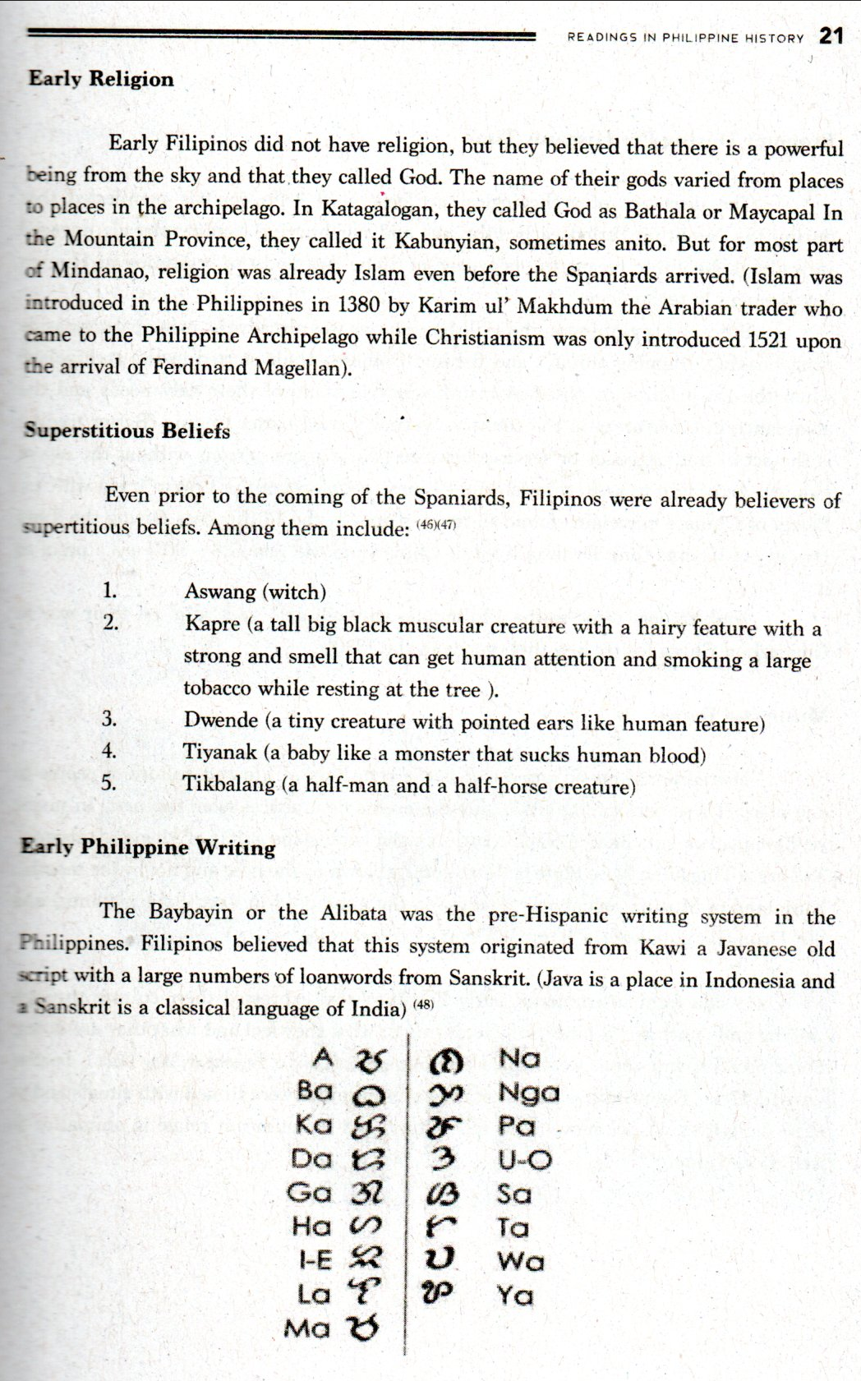

**Economy During Pre-Hispanic Time**

The discovery of archeological artifacts in the Philippines manifested that during the Neolithic Period early Filipinos and neighboring country already engaged in trading). Neolithic means the last stage of Stone Age and the beginning of Human development in technology).

Since the beginning in the Philippines, rice was already the principal crop aside from hunting, trapping animals and fishing. Domestic trade started in the archipelago when the early Filipinos observed insufficiency in some of their daily needs and the abundance in other areas in the country. So they started barter trading (Barter trading is the act of trading goods or services between two or more persons without the use of money). According to archaeologist, the Chinese people were the first to trade with us. Pieces of Chinese porcelains found in many places in the Philippines during the Tang Dynasty of China (Tang Dynasty lived in China from the year 618 — 907) are a proof to it.

Arab traders came to the Philippines through Jolo and Sulu, on their way to Guangzhou China for trading their goods in the 1380's.

**Music and Dance**

A traditional music and dance is the reflection of life and culture of people of one place. These performing arts depict the events or practices from the past. In music we have instruments like kudyapi (a two-stringed boat-shape guitar of Maguindanaoans), *Kalaleng*, a Tingguian Nose Flute (a flute literally blown by the nose and not by the mouth), Kulintang (a Muslim xylophone); Gangsa (a flat gong used in Cordillera province) and Slit Drum(Batikok-kok) (a Bamboo Drums in Ilocandia).

Aside from instruments, early Filipinos also expressed their culture through singing and dancing. Filipinos sing according to what they feel and what they are doing. Some pre-Hispanic songs were called *Kundiman, Kumintang o Tagumpay, Ang Dalit o Imno* at *Oyayi o Hele*. The primitive dances of the early Filipinos were linked with rituals and to their daily lives. Dance movements tell a story, and sometimes it relate to animal or to their occupation.

**Examples of pre-Colonial Dances**

* + - 1. Dugso Dance from Bukidnon
      2. Salip from Kalinga, Mountain Province
      3. Idaw from Cordillera
      4. Binaylan Banog from Misamis Oriental
      5. Banga from Ifugao
      6. Singkil from Mindanao; and
      7. Kadahal Taho from South Cotabato

**CHAPTER 4**

**Colonization of the Philippines**

It all started when the two powerful countries - Portugal and Spain - had a cold rivalry in conquering lands to expand their empire and to look for spices as one of the most valuable goods which is equivalent to gold. To pacify the situation, the Pope in Vatican, Pope Alexander VI mediated between the two to avoid further conflict (Portugal and Spain are both Catholic Nations).

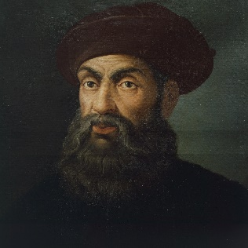The pope issued a Papal Bull in May 4, 1493 to imaginarily divide the world into two. A line about 555.6 kilometers westward of the Azores belonged to Spain and the Eastward is was for Portugal. They called it Inter-Caetera. But in June 7, 1494, they settled another agreement known as Treaty of Tordisillas. This treaty was agreed upon by the Spanish and the Portuguese to clear up confusion on newly claimed land in the New World.

**Who is Ferdinand Magellan?**

Ferdinand Magellan was born in Portugal in 1480. His parents were both members of nobility. After the death of his parents, he studied in Lisbon and finished his schooling on cartography, astronomy, and celestial navigation. In 1505 he joined the Portuguese fleet that sailed to East Africa. Four years after he experienced being in the battle when they engaged and destroyed Egyptian Ship in the Arabian Sea.

Two years after the Battle, he explored and conquered Malacca and from Malacca he got a native servant named Enrique. In 1513 while in war with the moors in Morocco, he was wounded on his leg that caused him to limp for the rest of his life. After the incident, Magellan was accused of illegal trading with the moors that caused him to be rejected of employment in Portugal as per order of the King.

In 1517, he decided to move to Spain to look for an opportunity to offer his service to the Spanish court. Timely enough, through the Treaty of Tordisillas, King Charles I (later, it became King Charles V) of Spain was convinced about the proposed route plan of Magellan in looking for the spice island and gave his blessing for a voyage under the Crown of Spain. The King gave him a fleet of five ships called the Armada and a rank of commander of the expedition under the Order of Santiago.

After the success of the voyage, the King granted Magellan the following:

1. Monopoly of the discovered route for a period of ten years
2. Their appointment as governors of the lands and islands found, with 5% of the resulting net gains
3. A fifth of the gains of the travel
4. The right to levy one thousand ducats on upcoming trips, paying only 5% on the remainder
5. Granting of an island, apart from the six richest, from which they would receive a fifteenth

The Magellan's Fleet:

1. **The flagship Trinidad** - (110 tons, crew 55), under Magellan's command
2. **San Antonio** - (120 tons; crew 60) commanded by Juan de Cartagena
3. **Concepciön** - (90 tons, crew 45) commanded by Gaspar de Quesada
4. **Santiago** - (75 tons, crew 32) commanded by Joäo Serräo
5. **Victoria** - (85 tons, crew 43), named after the church of Santa Maria de la Victoria deTriana, where Magellan took an oath of allegiance to Charles V; commanded by Luis Mendoza

**Discovery of the Philippine Archipelago**

On August 10, 1519 when Ferdinand Magellan departed from Spain, Antonio Pigafetta, a Venetian scholar and traveller, asked to be on the voyage, accepting the title of “supernumerary” and a modest salary. He became a strict assistant of Magellan and kept an accurate journal. The only other sailor to report the voyage would be Francisco

Albo, who kept a formal logbook. Juan de Cartagena was named Inspector General of the expedition, responsible for its financial and trading operations. In September, 1519 from Sanlücar de Barrameda, Spain, and the Atlantic Ocean, the fleet reached South America. They stopped at Port San Julian because some of the crews of the fleet mutinied against Magellan that was on the day of Easter 1520. Magellan immediately suppressed the uprising, meanwhile, he sent the Santiago for scouting the route but because of the heavy storm the ship got wrecked. The crews were rescued and were distributed to the four ships. On October 21, 1520, Magellan found the straight route of the voyage crossing the Pacific Ocean and named the straight after him (Magellan Straight). Along the way, the San Antonio maneuvered sailing back to Spain because they really didn’t want to be under the leadership of Magellan because he was a Portuguese.

From among the five ships sent by King Charles I, only three left to continue the mission of the expedition, the Trinidad, Concepcion and Victoria. It was the first time for the Europeans to sail in Pacific Ocean. Magellan named it Mar Pacifico for its peace and calm unlike other oceans that they travelled where the waters were extremely rough.

On March 16, 1521 they reached the island of Homonhon at the eastern part of the province of Samar. They landed there to gather foods and also to refresh the crew after their long voyage from the Pacific Ocean. The island was inhabited that time but Rajah Kulambo of Limasawa Island on the Southern Part of the Province saw their arrival. Through Enrique the native servant from Malacca, Magellan communicated to Rajah Kulambo and later they became friends through a blood compact.

It was Rajah Kulambo who guided Ferdinand Magellan to enter to Sugbu (Cebu) and meet the Cebu chief Rajah Humabon.

**Who is Rajah Humabon?**

The diary of Antonio Pigafetta mentioned about Rajah Humabon. He was considered as the wisest and bravest man in the island of Sugbo (Cebu). Under him were eight chieftains of barangays and he served as their Supreme Ruler. Ferdinand Magellan's ship landed adjacent the royal residence (near the shore line of Sugbo). The leaders met face to face. Pigafetta describe Rajah Humabon as short, fat, and brown- skinned, with a broad face having high cheekbones and a flat nose, lots of tattoos in his arms with purple and red symmetrical patterns that stretched to his chest. He wore a yellow silk turban, a scarf embroidered with a needle about his head, and clothing. A necklace of large pearls hung from his neck, two large gold earrings with precious gem decorated his ears, and gold rings fixed his thick fingers.

Aside from the spice island, other missions of Magellan expedition were to circumnavigate the earth and to spread Christianity. When they entered the Archipelago in 1521, their priority was to Christianize all the early Filipinos they would meet. And Rajah Humabon was the first native chieftain who embraced Christianity.

On April 14, 1521, Rajah Humabon along with his wife and others were baptized by Father Valderama. He was named Carlos in honor of King Charles I of Spain and Humabon's wife was named Juana after King’s mother named Johanna. As a gift from Magellan, Juana received the image .of Infant Jesus (now known as the Sto. Niho de Cebu) and the large cross erected In the historical baptismal site (known as the Magellan Cross in Cebu).

**Who is Lapu-Lapu?**

Many of us Filipino do not know Lapu-Lapu well because of lack of information about the said great man of Mactan. Many believed that Lapu-Lapu was born in 1491 but nobody can determine the exact date. He lived in Mactan and later became their Chief. As a leader he helped his people to become independent and led them to fight against those who would like to invade their place. A poet from the 17th century called Lapu-lapu as Cali Pulaco but in the account of Antonio Pigafetta it was Cilapulapu. There is no official description of how Lapu-Lapu looked like because even Pigafetta was not able to have a chance to see the Mactan hero face to face because during the battle, Antonio Pigafetta, was on board the ship which was anchored 200-300 meters from the shore line of Mactan. The ship could not go near because that time, there was low tide. The European leader was killed in Mactan Battle and the victory was attributed to Lapu-Lapu

— the first Filipino to resist foreign invaders.

**What Happened After the Battle of Mactan**

After the Battle in April 28, 1521, when the native chieftain, named Lapu-Lapu, defeated Magellan in Mactan, Rajah Humabon lost faith in the Spaniards and turned into a punisher — the first Filipino to avenge the honor of women. He devised a plan to kill all the Spaniards who remained on the island, to revenge the rape of their women during the entire stay of the Europeans. The Rajah invited the Spaniards to a feast through the collaboration of Enrique who had a personal grudge to Barbosa for the way he was treated, uncaringly. The new fleet commanders Juan Serrano and Duarte Barbosa with some other Spaniards went to the invitation even though they felt a little suspicions and scared during that time.

At the location of the feast, after Rajah Humabon gave the signal, his men immediately came out and attacked Serrano, Barbosa and their men with bolos and spears. All of the Spaniards were killed except Serrano event though he was seriously wounded, he still managed to run and reach the shore. From the distance, the crew of their ships spotted him, but unfortunately they got afraid to rescue him so they decided to leave Serrano to die. Once again, they elected another captain of their ships to replace the two dead leaders.

The three ships (Trinidad, Concepcion and Victoria) had a problem because they were lacking crew for their remaining ships so they decided to abandon and burn the smaller ship which was the Concepcion and divide the crew for the Trinidad under Gonzalo Gomez de Espinosa as the captain and Victoria under the command of Juan Sebastian El Cano.

The Trinidad went back to their previous. route crossing the Pacific but unfortunately they were apprehended and fell in the hands of their rival Portuguese while the Victoria under the leadership of El Cano continued the route of sailing westward but along the way they encountered Portuguese ships and they engaged into battle. Luckily they defeated the Portuguese but from 59 crews, it went down to 18 after the incident. They went around the Cape of Good Hope and entered the Port of San Lucar de Barrameda. On September 7, 1522, the ship Victoria reached its port of origin Seville, Spain; it was the first ship that circumnavigated the world, while the captain Juan Sebastian Elcano was awarded a coat of arms by Charles I of Spain, featuring a globe with the motto: *Primus Circumdedisti me* (in Latin, "You went around me first"), and a lifetime annual pension.

**CHAPTER 5**

**Spanish Era in the Philippines**

After the Magellan voyage through the chronicle of Antonio Pigafetta, the King of Spain sent a series of expeditions to relocate the Philippine Archipelago.

**The five expeditions sent were:**

1. Fray Garcia Jofre de Loaisa (1525)
2. Sebastian Cabot (1526)
3. Alvaro de Saavedra (1527)
4. Ruy Lopez de Villalobos (1542)
5. Miguel Lopez de Legazpi (1564)

Among the expeditions sent, The Legazpi voyage was the most successful as it resulted in the discovery of the *tornaviaje* or return trip to Mexico across the Pacific by Andres de Urdaneta. This discovery started the Manila galleon trade, which lasted two and a half centuries. But it was Villalobos who named of Leyte and Samar Las Islas Filipinas after Philip Il of Spain.

Miguel Lopez de Legazpi's tomb is in San Augustine Church in Manila

**What is Galleon Trade?**

It was the trade monopolized by the Spanish government from 1565 to 1815 using a Galleon Ship with a route of Acapulco Mexico to Manila, Philippines. All traders specially the Chinese who would like to engage business to any Spanish colony needed use the Galleon Ship for transportation of their goods. In Spain they also called it "*La Nao dela China*" (Most of the Cargoes were from China through Manila). They would not allow traders to go in if they would not use their Galleons. The Spanish took taxes from the goods at the same time the transport fee for the galleon ship. These trading lasted for almost 250 years.

**Establishment of Spanish Government in the Philippines**

For 333 years — from 1521 to 1898, the Philippines were under Spain. Manila became their center of government where the Spanish Governor-General was residing. It was called Intramuros (the Walled City) as the seat of their government. Spanish built the said wall in the late 16th century as the protection of the city from other invasion. The form of government they introduced to the early Filipino was called Encomienda. (word encomienda came from the word *encomendar* means to entrust.")

This system of government was formulated by Spain to control the natives behavoir of their colony. The persons who implemented the *Encomienda* were called *Encomienderos* (they were also known as *Adelanto*). The title of Adelanto's was for the Spanish noble men that served their king during the 15th, 16th and 17th century. This gave them right to rule in regions as Governors and Justices.

The encomenderos were required by law to perform the following duties:

* + - 1. To give protection to the natives
      2. To help the missionaries convert the natives to Christianity
      3. To promote education

Encomienderos were given rights by the King to rule and manage their respective areas of responsibilities like in the Philippines. But this system of Spain in governing the enlcoy gave negative impressions and results to the King because most of the *encomienderos* abused the natives in the colony not only by imposing high taxes, but they also confiscate personal things like jewelries, animals, crops if these natives could not pay their taxes.

**Spain Policies in the Colony**

When Philippine archipelago became official colony of Spain, they introduced some policies to control the people in the archipelago.

* + - 1. **Reduccion** - This policy was formulated in the Caribbean Island in 1503.They built a pueblo or town and forcibly obliged everyone and families to move in the town they created. Once they were confined inside the pueblo or town, Spanish authorities built their outpost encircling the town for them to monitor all movement because their numbers were just around 700 to 1000 during their early years in the Philippines and they were sending an additional of 100to 150 re-enforcement every year. The typical physical structure of an early pueblo was a public park or they called it plaza at the center and around it were church, municipal hall or *municipyo*,. *pamilihang* *bayan* and *paradahan* (parking for Caromata — a carriage pulled by horse).
      2. **Repartamiento** — It was a system of a forced labor to the natives of the colony. It was similar to a *Polo y servicio* or a *Tributo* (Tribute). The natives were obliged to provide the basic needs of Spaniards (the *conquistadores*).

**Polo y Servicio** — It was a required forced labor to all Filipino men aging 18 - 60 years old and must complete a 40 days' work. They were assigned in various locations of work like the shipyard for the Galleon Ships, Constructions of churches, roads, and bridges or to the forest to cut trees for logs. They called the worker as Polistas. If they were absent within the duration of their Polo, they will be obliged to pay the corresponding amount of the daily rates of a worker to the government for being absent. They called it Falla.

**Tributo (Tribute)** — Early Filipinos were compelled to pay taxes for the King of Spain. The system was based in *Recopilacion del Reyes de Ios Reynos de las Indias* which means the King of Spain funded the Expeditions for the Philippines and in return of his effort and gratitude the Filipinos will pay it through *Tributo*.

* + - 1. **Instruccion** — Friars convinced Filipinos to embrace Catholicism as their religion and after they were immediately baptized, they would be given a Spanish name. The early education of Filipinos during Spanish period was through religion. It was primarily exclusive for elite Filipinos to go to formal schools operated by friars from different congregations in the first year of their operation. The *Doctrina Christiana* was the first book that has been published in the Philippines and used in School.

**The Six (6) Catholic Congregations Who Came Here in the Philippines**

**Augustinians** — They entered the Philippines together with Miguel Lopez de Legazpi in the year 1565. They were Fray Andres de Urdaneta, Martin de Rada, Fray Diego de Herrera, Fray Andres de Aguirre, Fray Lorenzo jimenez and Fray Pedro de Gamboa.

**Franciscans** — The second religious order to come in the Philippines. They were 15 Franciscans who arrived in the Archipelago in 1578.

**Jesuits** - The first Jesuits in the Philippines were from the Province of Mexico. They arrived in 1581. They were headed by Fr. Antonio Sedeno, and his companions were Fr. Alonso Sanchez, Nicolas Gallardo and Gaspar Suarez de Toledo, but died during their voyage.

**Dominicans** — The first Dominican Friar who arrived in the Philippines was in the year 1587.

**The Recollects** — In the year 1606, Thirteen (13) Recollects arrived in Cebu, but one of them died at sea. They went to Manila and established their church in the Bagumbayan area (Now Rizal Park) but it was demolished twice - first was in 1642 when the Governor General perceived that it was a threat to Intramuros where the Palacio del Governador is located, second was during the British Invasion in .1762.

**Benedictines** — On September 12, 1895, the Order of Benedictine arrived in the Philippines. They started their missionary work in Surigao in 1896. Rev. Jose Deas y Villar, OSB, founded the Benedictine community in Mindanao.

**Spanish Government Structure in the Philippines**

When Spain invaded the Philippine archipelago and controlled it for 333 years, many changes took place in the life of our early Filipinos. The semi Monarchial type of living and society were abolished and they introduced their own government structure. That was the time when the Filipinos lost their freedom and Independence. To rein the country they established a centralized government.

**National Government**

Spain established a Central Government that was located in Intramuros Manila. The King of Spain was the central ruler. The King designated his alter ego — the Viceroy to Mexico which was also under Spain. It's function is to supervise all the colony of Spain with his Council of Indies.

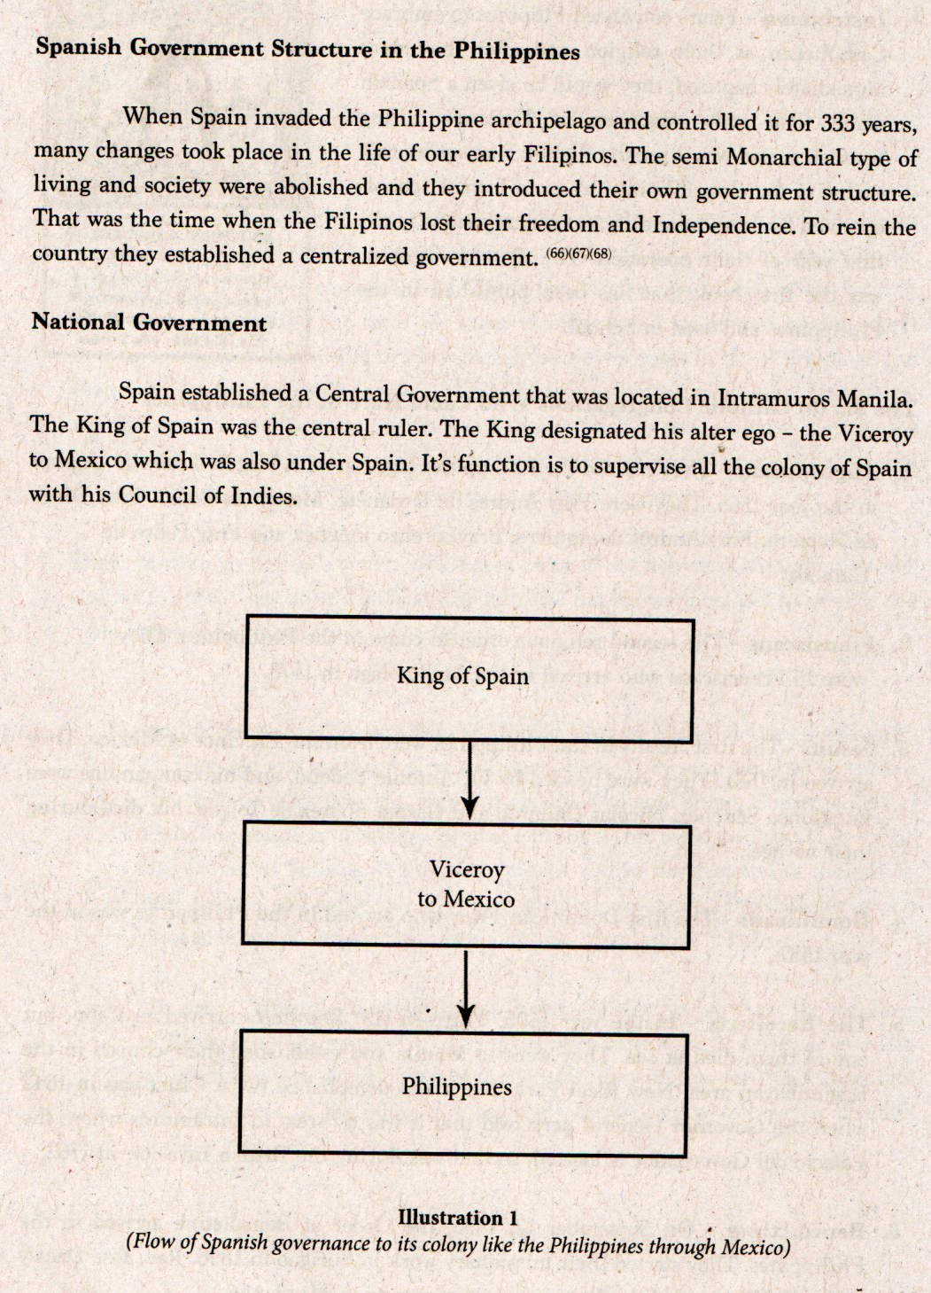

In 1821, Mexico regained its Independence over Spain. Ail remaining colonies went directly under Spain. The King immediately sent its Governor General to govern every colony.

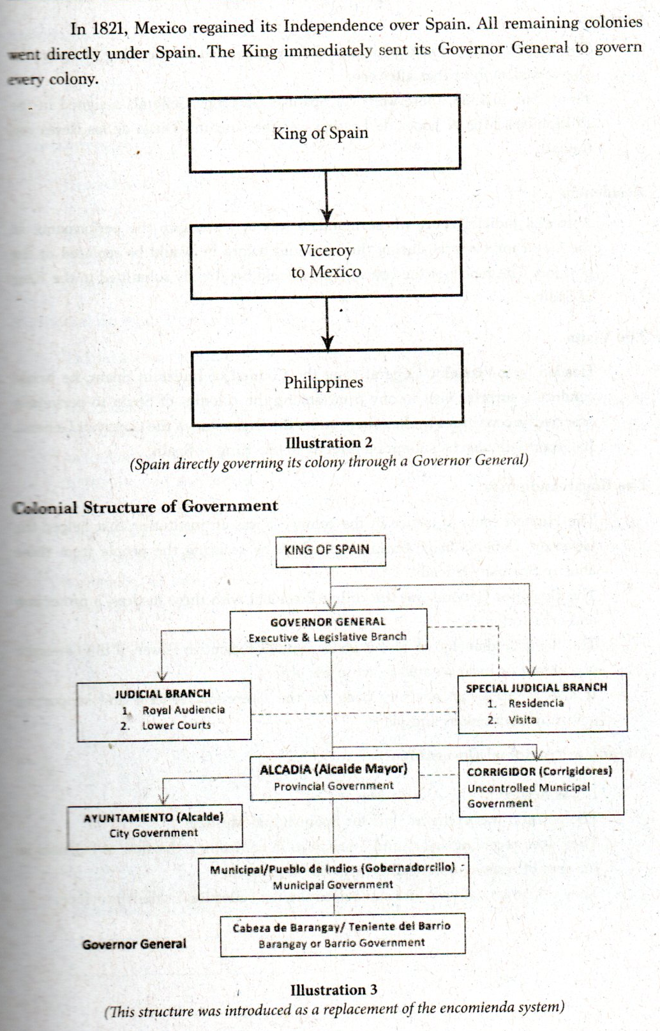

**Colonial Structure of Government**



**Governor**

* The highest ranking official in the Colony appointed by the King of Spain, he also served as the Kings alter ego.
* From 1565 to 1898, there were 115 Spanish Governor Generals assigned in the Philippines. Miguel Lopez de Legazpi was the first and Diego de Ios Reyes was the last.

**Residencia**

* A special judicial court whose mandate was to investigate the performance of the Governor General during the term and before he would be replaced in the position. The report of the investigation would be directly submitted to the King of Spain.

**The Visita**

* Headed by a Visitador General from the Council of Indies in Spain, he would conduct a surprise visit to any from among the colonies of Spain to personally observe the conditions in the colony under the leadership of the Governor General. Its report will also be submitted directly to the King of Spain.

**The Royal Audiencia**

* The Highest court of justice in the colony. •It was an institution that helped the Governor General in governing the colony by securing the people from those abusive Spanish Officials.
* The Governor General was the ruling President with three justices, a prosecutor and other officials.
* The Royal Audiencia can also exercise limited Executive Power, if the Governor was absent or incapacitated to act in his office.
* It also serves as an advisory body for the Governor General and supporting government decisions and plans.

**Alacadias (Provincial Government)**

* It was headed by the Alcalde Mayor.
* The position was exclusive only for Spanish and Mestizos.
* They were receiving salary and a privilege in controlling the flow of business in his area of responsibility called as *Indulto de Comercio*.
* They implemented laws and supervised the tax collection in their province.

**Corregimentos (Uncontrolled Provinces)**

* Headed by designated Army Officers by the Governor-General
* The province they held was not yet totally under their governance, there were resistance from some Filipinos.

**Ayuntamiento (The City Government)**

* Headed by an Alcalde
* It was a former town but when it became the center of trade and commerce, it turned into a City
* It has a City Council; composed of the following headed by the Alcalde, Councilors (Regidores), The Aguacil Mayor (Chief of Police), and Escribando (Secretary).

**Municipal or Pueblo de Indios**

* The leader was called Gobernadorcillo
* The highest political position that Filipinos can have during those times.
* To become a candidate for Gobernadorcillo, they must be a Cabeza de Baranggay and among the Cabezas, they will elect top three to be part of the list that will be submitted to the Governor General or to the Alcalde Mayor. And from the three in the list they will choose one to become the Gobernadorcillo.
* Every Alcadias or Province were divided into a Pueblos or Towns
* They re not receiving salary but they're exempt from paying taxes and excused from rendering Polo with their immediate family member plus their social status as member of Principalia.
* They focus on tax collection and the peace and order within their Pueblo.

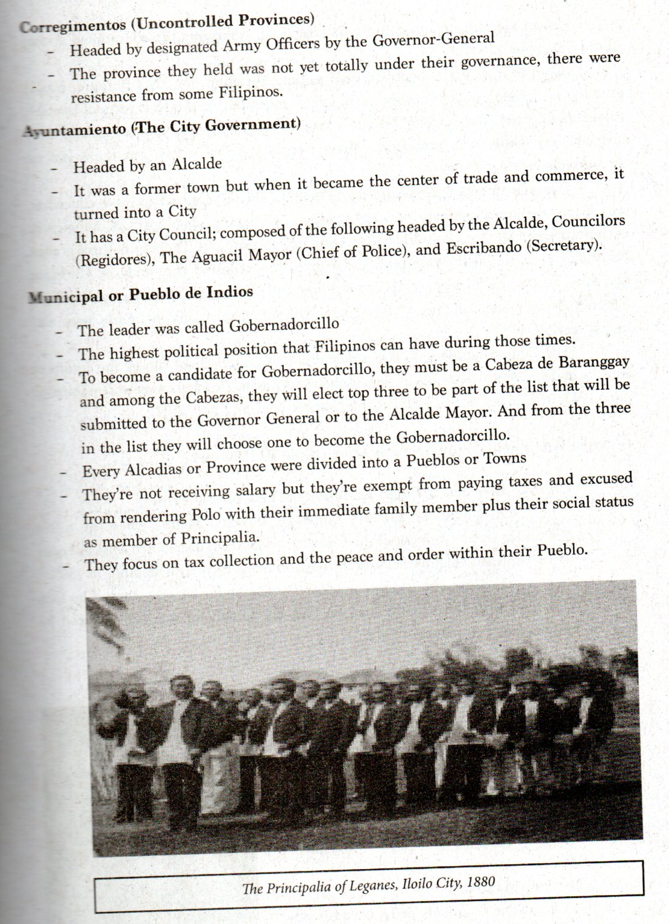

The Principalia of Leganes, Iloilo City, 1880

Spain promulgated an educational decree for reforming the educational system in the Philippines.

During the early Spanish occupation, education for the Filipino people centered on religion and primarily for the elite, especially in the first years of Spanish colonization. Prior to that, early Filipinos taught their children at home, focusing more on vocational skills than academics. There were also tribal tutors, but there was no structured educational system.

The enactment of the Educational Decree of 1863 liberalized access to education, which provided for the establishment of at least one primary school for boys and girls in each town under the responsibility of the municipal government. There were three grades: "entrada," "acenso," and "termino.". The curriculum required the study of Christian doctrine, values and history as well as reading and writing in Spanish, mathematics, agriculture, etiquette, singing, world geography, and Spanish history. Girls were also taught sewing.

The Educational Decree also provided for a normal school run by the Jesuits to educate male teachers in Manila. Normal schools for women teachers were not established until 1875, in Nueva Caceres. (Philippine News Agency archives, 2011)

**Invasion Attempts During Spanish Time in the Philippines**

***Chinese Invasion through Limahong (The Chinese Pirate)***

On November 29, 1574 Limahong attacked Manila where he killed Martin De Goiti - founder of the City of Manila. Goiti also joined Miguel Lopez de Legazpi and Juan de Salcedo in their conquest in the Philippines in 1565.

Limahon also tried to attacked Parafiaque but he wås stopped by Don Galo and with the help of Juan de Salcedo, Limahong was defeated and he retreated to Pangasinan.

***Dutch Invasion***

In 1646 a series of Naval Battles happened in the Philippine waters between the Spanish fleet and the Dutch Naval Squadron that attacked and tried to invade the Philippines. Spanish and some Filipinos attributed the victory over the Dutch to the Our Lady of La Naval de Manila on April 9, 1652. The event was called The Battle of La Naval de Manila. (74)

(The Our Lady of La Naval is now the Patron Saint of our Philippine Navy).

***British Invasion***

In history there was what they called "The Seven Years War" between England and France. The King of Spain, King Charles Il felt threatened when France nearly lost the said war against England. On January 4, 1762, England (Britain) declared war against Spain. Immediately after, Spain also made their declaration of war against Britain on January 18 of the same year. The King of Spain and France made a truce in fighting their rival Britain; they called it the Family Compact which was signed on August 15, 1761.

On 24 September 1762, a British sailed into Manila Bay from Madras. The expedition was led by Brigadier-General William Draper and Rear-Admiral Samuel Cornish and they captured Manila. (75)

The Philippines was under British for twenty (20) months between 1762-1764. On February 10,. 1763 a peace talk occurred between three Spain, France and Britain and signed a peace agreement ending the war. After Manila was properly turned over again to Spain, the British forces embarked from Manila and Cavite area on the first week of April 1764.

***Portuguese Invasion***

Portugal tried to invade the Philippines because of Spain's violation of the treaty: when Spain colonized the Philippines, because it was supposedly a Portuguese territory according to the Papal Bull - (Spain will sail westward and Portugal will go Eastward). Philippine location is in the South East of Asia. According to the Papal Bull all discoveries in the east must be turned over to Portugal. All discoveries in the west, must be turned over to Spain. Spain didn't turn over the Philippines to Portugal, but instead they colonized it.

REPUBLIC ACT NO. 8371

AN ACT TO RECOGNIZE, PROTECT AND PROMOTE THE RIGHTS OF INDIGENOUS CULTURAL COMMUNITIES/INDIGENOUS PEOPLES, CREATING A NATIONAL COMMISSION ON INDIGENOUS PEOPLES, ESTABLISHING IMPLEMENTING MECHANISMS, APPROPRIATING FUNDS THEREFOR, AND FOR OTHER PURPOSES

CHAPTER I

General Provisions

SECTION 1. Short Title. — This Act shall be known as “The Indigenous Peoples’ Rights Act of 1997”.

SECTION 2. Declaration of State Policies. — The State shall recognize and promote all the rights of Indigenous Cultural Communities/Indigenous Peoples (ICCs/IPs) hereunder enumerated within the framework of the Constitution:

a) The State shall recognize and promote the rights of ICCs/IPs within the framework of national unity and development;

b) The State shall protect the rights of ICCs/IPs to their ancestral domains to ensure their economic, social and cultural well being and shall recognize the applicability of customary laws governing property rights or relations in determining the ownership and extent of ancestral domain;

c) The State shall recognize, respect and protect the rights of ICCs/IPs to preserve and develop their cultures, traditions and institutions. It shall consider these rights in the formulation of national laws and policies;

d) The State shall guarantee that members of the ICCs/IPs regardless of sex, shall equally enjoy the full measure of human rights and freedoms without distinction or discrimination;

e) The State shall take measures, with the participation of the ICCs/IPs concerned, to protect their rights and guarantee respect for their cultural integrity, and to ensure that members of the ICCs/IPs benefit on an equal footing from the rights and opportunities which national laws and regulations grant to other members of the population; and

f) The State recognizes its obligations to respond to the strong expression of the ICCs/IPs for cultural integrity by assuring maximum ICC/IP participation in the direction of education, health, as well as other services of ICCs/IPs, in order to render such services more responsive to the needs and desires of these communities.

Towards these ends, the State shall institute and establish the necessary mechanisms to enforce and guarantee the realization of these rights, taking into consideration their customs, traditions, values, beliefs, interests and institutions, and to adopt and implement measures to protect their rights to their ancestral domains.

CHAPTER II

Definition of Terms

SECTION 3. Definition of Terms. — For purposes of this Act, the following terms shall mean:

a) Ancestral Domains — Subject to Section 56 hereof, refer to all areas generally belonging to ICCs/IPs comprising lands, inland waters, coastal areas, and natural resources therein, held under a claim of ownership, occupied or possessed by ICCs/IPs, by themselves or through their ancestors, communally or individually since time immemorial, continuously to the present except when interrupted by war, force majeure or displacement by force, deceit, stealth or as a consequence of government projects or any other voluntary dealings entered into by government and private individuals/corporations, and which are necessary to ensure their economic, social and cultural welfare. It shall include ancestral lands, forests, pasture, residential, agricultural, and other lands individually owned whether alienable and disposable or otherwise, hunting grounds, burial grounds, worship areas, bodies of water, mineral and other natural resources, and lands which may no longer be exclusively occupied by ICCs/IPs but from which they traditionally had access to for their subsistence and traditional activities, particularly the home ranges of ICCs/IPs who are still nomadic and/or shifting cultivators;

b) Ancestral Lands — Subject to Section 56 hereof, refers to land occupied, possessed and utilized by individuals, families and clans who are members of the ICCs/IPs since time immemorial, by themselves or through their predecessors-in-interest, under claims of individual or traditional group ownership, continuously, to the present except when interrupted by war, force majeure or displacement by force, deceit, stealth, or as a consequence of government projects and other voluntary dealings entered into by government and private individuals/corporations, including, but not limited to, residential lots, rice terraces or paddies, private forests, swidden farms and tree lots;

c) Certificate of Ancestral Domain Title — refers to a title formally recognizing the rights of possession and ownership of ICCs/IPs over their ancestral domains identified and delineated in accordance with this law;

d) Certificate of Ancestral Lands Title — refers to a title formally recognizing the rights of ICCs/IPs over their ancestral lands;

e) Communal Claims — refer to claims on land, resources and rights thereon, belonging to the whole community within a defined territory;

f) Customary Laws — refer to a body of written and/or unwritten rules, usages, customs and practices traditionally and continually recognized, accepted and observed by respective ICCs/IPs;

g) Free and Prior Informed Consent — as used in this Act shall mean the consensus of all members of the ICCs/IPs to be determined in accordance with their respective customary laws and practices, free from any external manipulation, interference and coercion, and obtained after fully disclosing the intent and scope of the activity, in a language and process understandable to the community;

h) Indigenous Cultural Communities/Indigenous Peoples — refer to a group of people or homogenous societies identified by self-ascription and ascription by others, who have continuously lived as organized community on communally bounded and defined territory, and who have, under claims of ownership since time immemorial, occupied, possessed and utilized such territories, sharing common bonds of language, customs, traditions and other distinctive cultural traits, or who have, through resistance to political, social and cultural inroads of colonization, non-indigenous religions and cultures, became historically differentiated from the majority of Filipinos. ICCs/IPs shall likewise include peoples who are regarded as indigenous on account of their descent from the populations which inhabited the country, at the time of conquest or colonization, or at the time of inroads of non-indigenous religions and cultures, or the establishment of present state boundaries, who retain some or all of their own social, economic, cultural and political institutions, but who may have been displaced from their traditional domains or who may have resettled outside their ancestral domains;

i) Indigenous Political Structures — refer to organizational and cultural leadership systems, institutions, relationships, patterns and processes for decision-making and participation, identified by ICCs/IPs such as, but not limited to, Council of Elders, Council of Timuays, Bodong Holders, or any other tribunal or body of similar nature;

j) Individual Claims — refer to claims on land and rights thereon which have been devolved to individuals, families and clans including, but not limited to, residential lots, rice terraces or paddies and tree lots;

k) National Commission on Indigenous Peoples (NCIP) — refers to the office created under this Act, which shall be under the Office of the President, and which shall be the primary government agency responsible for the formulation and implementation of policies, plans and programs to recognize, protect and promote the rights of ICCs/IPs;

l) Native Title — refers to pre-conquest rights to lands and domains which, as far back as memory reaches, have been held under a claim of private ownership by ICCs/IPs, have never been public lands and are thus indisputably presumed to have been held that way since before the Spanish Conquest;

m) Nongovernment Organization — refers to a private, nonprofit voluntary organization that has been organized primarily for the delivery of various services to the ICCs/IPs and has an established track record for effectiveness and acceptability in the community where it serves;

n) People’s Organization — refers to a private, nonprofit voluntary organization of members of an ICC/IP which is accepted as representative of such ICCs/IPs;

o) Sustainable Traditional Resource Rights — refer to the rights of ICCs/IPs to sustainably use, manage, protect and conserve a) land, air, water, and minerals; b) plants, animals and other organisms; c) collecting, fishing and hunting grounds; d) sacred sites; and e) other areas of economic, ceremonial and aesthetic value in accordance with their indigenous knowledge, beliefs, systems and practices; and

p) Time Immemorial — refers to a period of time when as far back as memory can go, certain ICCs/IPs are known to have occupied, possessed in the concept of owner, and utilized a defined territory devolved to them, by operation of customary law or inherited from their ancestors, in accordance with their customs and traditions.

CHAPTER III

Rights to Ancestral Domains

SECTION 4. Concept of Ancestral Lands/Domains. — Ancestral lands/domains shall include such concepts of territories which cover not only the physical environment but the total environment including the spiritual and cultural bonds to the areas which the ICCs/IPs possess, occupy and use and to which they have claims of ownership.

SECTION 5. Indigenous Concept of Ownership. — Indigenous concept of ownership sustains the view that ancestral domains and all resources found therein shall serve as the material bases of their cultural integrity. The indigenous concept of ownership generally holds that ancestral domains are the ICC’s/IP’s private but community property which belongs to all generations and therefore cannot be sold, disposed or destroyed. It likewise covers sustainable traditional resource rights.

SECTION 6. Composition of Ancestral Lands/Domains. — Ancestral lands and domains shall consist of all areas generally belonging to ICCs/IPs as referred under Sec. 3, items (a) and (b) of this Act.

SECTION 7. Rights to Ancestral Domains. — The rights of ownership and possession of ICCs/IPs to their ancestral domains shall be recognized and protected. Such rights shall include:

a) Right of Ownership. — The right to claim ownership over lands, bodies of water traditionally and actually occupied by ICCs/IPs, sacred places, traditional hunting and fishing grounds, and all improvements made by them at any time within the domains;

b) Right to Develop Lands and Natural Resources. — Subject to Section 56 hereof, right to develop, control and use lands and territories traditionally occupied, owned, or used; to manage and conserve natural resources within the territories and uphold the responsibilities for future generations; to benefit and share the profits from allocation and utilization of the natural resources found therein; the right to negotiate the terms and conditions for the exploration of natural resources in the areas for the purpose of ensuring ecological, environmental protection and the conservation measures, pursuant to national and customary laws; the right to an informed and intelligent participation in the formulation and implementation of any project, government or private, that will affect or impact upon the ancestral domains and to receive just and fair compensation for any damages which they may sustain as a result of the project; and the right to effective measures by the government to prevent any interference with, alienation and encroachment upon these rights;

c) Right to Stay in the Territories. — The right to stay in the territory and not to be removed therefrom. No ICCs/IPs will be relocated without their free and prior informed consent, nor through any means other than eminent domain. Where relocation is considered necessary as an exceptional measure, such relocation shall take place only with the free and prior informed consent of the ICCs/IPs concerned and whenever possible, they shall be guaranteed the right to return to their ancestral domains, as soon as the grounds for relocation cease to exist. When such return is not possible, as determined by agreement or through appropriate procedures, ICCs/IPs shall be provided in all possible cases with lands of quality and legal status at least equal to that of the land previously occupied by them, suitable to provide for their present needs and future development. Persons thus relocated shall likewise be fully compensated for any resulting loss or injury;

d) Right in Case of Displacement. — In case displacement occurs as a result of natural catastrophes, the State shall endeavor to resettle the displaced ICCs/IPs in suitable areas where they can have temporary life support systems: Provided, That the displaced ICCs/IPs shall have the right to return to their abandoned lands until such time that the normalcy and safety of such lands shall be determined: Provided, further, That should their ancestral domain cease to exist and normalcy and safety of the previous settlements are not possible, displaced ICCs/IPs shall enjoy security of tenure over lands to which they have been resettled: Provided, furthermore, That basic services and livelihood shall be provided to them to ensure that their needs are adequately addressed;

e) Right to Regulate Entry of Migrants. — Right to regulate the entry of migrant settlers and organizations into the domains;

f) Right to Safe and Clean Air and Water. — For this purpose, the ICCs/IPs shall have access to integrated systems for the management of their inland waters and air space;

g) Right to Claim Parts of Reservations. — The right to claim parts of the ancestral domains which have been reserved for various purposes, except those reserved and intended for common public welfare and service; and

h) Right to Resolve Conflict. — Right to resolve land conflicts in accordance with customary laws of the area where the land is located, and only in default thereof shall the complaints be submitted to amicable settlement and to the Courts of Justice whenever necessary.

SECTION 8. Rights to Ancestral Lands. — The right of ownership and possession of the ICCs/IPs to their ancestral lands shall be recognized and protected.

a) Right to transfer land/property. — Such right shall include the right to transfer land or property rights to/among members of the same ICCs/IPs, subject to customary laws and traditions of the community concerned.

b) Right to Redemption. — In cases where it is shown that the transfer of land/property rights by virtue of any agreement or devise, to a non-member of the concerned ICCs/IPs is tainted by the vitiated consent of the ICCs/IPs, or is transferred for an unconscionable consideration or price, the transferor ICC/IP shall have the right to redeem the same within a period not exceeding fifteen (15) years from the date of transfer.

SECTION 9. Responsibilities of ICCs/IPs to their Ancestral Domains. — ICCs/IPs occupying a duly certified ancestral domain shall have the following responsibilities:

a) Maintain Ecological Balance. — To preserve, restore, and maintain a balanced ecology in the ancestral domain by protecting the flora and fauna, watershed areas, and other reserves;

b) Restore Denuded Areas. — To actively initiate, undertake and participate in the reforestation of denuded areas and other development programs and projects subject to just and reasonable remuneration; and

c) Observe Laws. — To observe and comply with the provisions of this Act and the rules and regulations for its effective implementation.

SECTION 10. Unauthorized and Unlawful Intrusion. — Unauthorized and unlawful intrusion upon, or use of any portion of the ancestral domain, or any violation of the rights hereinbefore enumerated, shall be punishable under this law. Furthermore, the Government shall take measures to prevent non-ICCs/IPs from taking advantage of the ICCs/IPs customs or lack of understanding of laws to secure ownership, possession of land belonging to said ICCs/IPs.

SECTION 11. Recognition of Ancestral Domain Rights. — The rights of ICCs/IPs to their ancestral domains by virtue of Native Title shall be recognized and respected. Formal recognition, when solicited by ICCs/IPs concerned, shall be embodied in a Certificate of Ancestral Domain Title (CADT), which shall recognize the title of the concerned ICCs/IPs over the territories identified and delineated.

SECTION 12. Option to Secure Certificate of Title Under Commonwealth Act 141, as amended, or the Land Registration Act 496. — Individual members of cultural communities, with respect to their individually-owned ancestral lands who, by themselves or through their predecessors-in-interest, have been in continuous possession and occupation of the same in the concept of owner since time immemorial or for a period of not less than thirty (30) years immediately preceding the approval of this Act and uncontested by the members of the same ICCs/IPs shall have the option to secure title to their ancestral lands under the provisions of Commonwealth Act 141, as amended, or the Land Registration Act 496.

For this purpose, said individually-owned ancestral lands, which are agricultural in character and actually used for agricultural, residential, pasture, and tree farming purposes, including those with a slope of eighteen percent (18%) or more, are hereby classified as alienable and disposable agricultural lands.

The option granted under this section shall be exercised within twenty (20) years from the approval of this Act.

 CHAPTER IV

Right to Self-Governance and Empowerment

SECTION 13. Self-Governance. — The State recognizes the inherent right of ICCs/IPs to self-governance and self-determination and respects the integrity of their values, practices and institutions. Consequently, the State shall guarantee the right of ICCs/IPs to freely pursue their economic, social and cultural development.

SECTION 14. Support for Autonomous Regions. — The State shall continue to strengthen and support the autonomous regions created under the Constitution as they may require or need. The State shall likewise encourage other ICCs/IPs not included or outside Muslim Mindanao and the Cordilleras to use the form and content of their ways of life as may be compatible with the fundamental rights defined in the Constitution of the Republic of the Philippines and other internationally recognized human rights.

SECTION 15. Justice System, Conflict Resolution Institutions, and Peace Building Processes. — The ICCs/IPs shall have the right to use their own commonly accepted justice systems, conflict resolution institutions, peace building processes or mechanisms and other customary laws and practices within their respective communities and as may be compatible with the national legal system and with internationally recognized human rights.

SECTION 16. Right to Participate in Decision-Making. — ICCs/IPs have the right to participate fully, if they so choose, at all levels of decision-making in matters which may affect their rights, lives and destinies through procedures determined by them as well as to maintain and develop their own indigenous political structures. Consequently, the State shall ensure that the ICCs/IPs shall be given mandatory representation in policy-making bodies and other local legislative councils.

SECTION 17. Right to Determine and Decide Priorities for Development. — The ICCs/IPs shall have the right to determine and decide their own priorities for development affecting their lives, beliefs, institutions, spiritual well-being, and the lands they own, occupy or use. They shall participate in the formulation, implementation and evaluation of policies, plans and programs for national, regional and local development which may directly affect them.

SECTION 18. Tribal Barangays. — The ICCs/IPs living in contiguous areas or communities where they form the predominant population but which are located in municipalities, provinces or cities where they do not constitute the majority of the population, may form or constitute a separate barangay in accordance with the Local Government Code on the creation of tribal barangays.

SECTION 19. Role of Peoples Organizations. — The State shall recognize and respect the role of independent ICCs/IPs organizations to enable the ICCs/IPs to pursue and protect their legitimate and collective interests and aspirations through peaceful and lawful means.

SECTION 20. Means for Development/Empowerment of ICCs/IPs. — The Government shall establish the means for the full development/empowerment of the ICCs/IPs own institutions and initiatives and, where necessary, provide the resources needed therefor.

CHAPTER V

Social Justice and Human Rights

SECTION 21. Equal Protection and Non-discrimination of ICCs/IPs. — Consistent with the equal protection clause of the Constitution of the Republic of the Philippines, the Charter of the United Nations, the Universal Declaration of Human Rights including the Convention on the Elimination of Discrimination Against Women and International Human Rights Law, the State shall, with due recognition of their distinct characteristics and identity, accord to the members of the ICCs/IPs the rights, protections and privileges enjoyed by the rest of the citizenry. It shall extend to them the same employment rights, opportunities, basic services, educational and other rights and privileges available to every member of the society. Accordingly, the State shall likewise ensure that the employment of any form of force or coercion against ICCs/IPs shall be dealt with by law.

The State shall ensure that the fundamental human rights and freedoms as enshrined in the Constitution and relevant international instruments are guaranteed also to indigenous women. Towards this end, no provision in this Act shall be interpreted so as to result in the diminution of rights and privileges already recognized and accorded to women under existing laws of general application.

SECTION 22. Rights During Armed Conflict. — ICCs/IPs have the right to special protection and security in periods of armed conflict. The State shall observe international standards, in particular, the Fourth Geneva Convention of 1949, for the protection of civilian populations in circumstances of emergency and armed conflict, and shall not recruit members of the ICCs/IPs against their will into the armed forces, and in particular, for use against other ICCs/IPs; nor recruit children of ICCs/IPs into the armed forces under any circumstance; nor force indigenous individuals to abandon their lands, territories and means of subsistence, or relocate them in special centers for military purposes under any discriminatory condition.

SECTION 23. Freedom from Discrimination and Right to Equal Opportunity and Treatment. — It shall be the right of the ICCs/IPs to be free from any form of discrimination, with respect to recruitment and conditions of employment, such that they may enjoy equal opportunities for admission to employment, medical and social assistance, safety as well as other occupationally-related benefits, informed of their rights under existing labor legislation and of means available to them for redress, not subject to any coercive recruitment systems, including bonded labor and other forms of debt servitude; and equal treatment in employment for men and women, including the protection from sexual harassment.

Towards this end, the State shall, within the framework of national laws and regulations, and in cooperation with the ICCs/IPs concerned, adopt special measures to ensure the effective protection with regard to the recruitment and conditions of employment of persons belonging to these communities, to the extent that they are not effectively protected by laws applicable to workers in general.

ICCs/IPs shall have the right to association and freedom for all trade union activities and the right to conclude collective bargaining agreements with employers’ organizations. They shall likewise have the right not to be subject to working conditions hazardous to their health, particularly through exposure to pesticides and other toxic substances.

SECTION 24. Unlawful Acts Pertaining to Employment. — It shall be unlawful for any person:

a) To discriminate against any ICC/IP with respect to the terms and conditions of employment on account of their descent. Equal remuneration shall be paid to ICC/IP and non-ICC/IP for work of equal value; and

b) To deny any ICC/IP employee any right or benefit herein provided for or to discharge them for the purpose of preventing them from enjoying any of the rights or benefits provided under this Act.

SECTION 25. Basic Services. — The ICCs/IPs have the right to special measures for the immediate, effective and continuing improvement of their economic and social conditions, including in the areas of employment, vocational training and retraining, housing, sanitation, health and social security. Particular attention shall be paid to the rights and special needs of indigenous women, elderly, youth, children and differently-abled persons. Accordingly, the State shall guarantee the right of ICCs/IPs to government’s basic services which shall include, but not limited to, water and electrical facilities, education, health, and infrastructure.

SECTION 26. Women. — ICC/IP women shall enjoy equal rights and opportunities with men, as regards the social, economic, political and cultural spheres of life. The participation of indigenous women in the decision-making process in all levels, as well as in the development of society, shall be given due respect and recognition.

The State shall provide full access to education, maternal and child care, health and nutrition, and housing services to indigenous women. Vocational, technical, professional and other forms of training shall be provided to enable these women to fully participate in all aspects of social life. As far as possible, the State shall ensure that indigenous women have access to all services in their own languages.

SECTION 27. Children and Youth. — The State shall recognize the vital role of the children and youth of ICCs/IPs in nation-building and shall promote and protect their physical, moral, spiritual, intellectual and social well-being. Towards this end, the State shall support all government programs intended for the development and rearing of the children and youth of ICCs/IPs for civic efficiency and establish such mechanisms as may be necessary for the protection of the rights of the indigenous children and youth.

SECTION 28. Integrated System of Education. — The State shall, through the NCIP, provide a complete, adequate and integrated system of education, relevant to the needs of the children and young people of ICCs/IPs.

CHAPTER VI

Cultural Integrity

SECTION 29. Protection of Indigenous Culture, Traditions and Institutions. — The State shall respect, recognize and protect the right of ICCs/IPs to preserve and protect their culture, traditions and institutions. It shall consider these rights in the formulation and application of national plans and policies.

SECTION 30. Educational Systems. — The State shall provide equal access to various cultural opportunities to the ICCs/IPs through the educational system, public or private cultural entities, scholarships, grants and other incentives without prejudice to their right to establish and control their educational systems and institutions by providing education in their own language, in a manner appropriate to their cultural methods of teaching and learning. Indigenous children/youth shall have the right to all levels and forms of education of the State.

SECTION 31. Recognition of Cultural Diversity. — The State shall endeavor to have the dignity and diversity of the cultures, traditions, histories and aspirations of the ICCs/IPs appropriately reflected in all forms of education, public information and cultural-educational exchange. Consequently, the State shall take effective measures, in consultation with ICCs/IPs concerned, to eliminate prejudice and discrimination and to promote tolerance, understanding and good relations among ICCs/IPs and all segments of society. Furthermore, the Government shall take effective measures to ensure that the State-owned media duly reflect indigenous cultural diversity. The State shall likewise ensure the participation of appropriate indigenous leaders in schools, communities and international cooperative undertakings like festivals, conferences, seminars and workshops to promote and enhance their distinctive heritage and values.

SECTION 32. Community Intellectual Rights. — ICCs/IPs have the right to practice and revitalize their own cultural traditions and customs. The State shall preserve, protect and develop the past, present and future manifestations of their cultures as well as the right to the restitution of cultural, intellectual, religious, and spiritual property taken without their free and prior informed consent or in violation of their laws, traditions and customs.

SECTION 33. Rights to Religious, Cultural Sites and Ceremonies. — ICCs/IPs shall have the right to manifest, practice, develop, and teach their spiritual and religious traditions, customs and ceremonies; the right to maintain, protect and have access to their religious and cultural sites; the right to use and control of ceremonial objects; and, the right to the repatriation of human remains. Accordingly, the State shall take effective measures, in cooperation with the ICCs/IPs concerned, to ensure that indigenous sacred places, including burial sites, be preserved, respected and protected. To achieve this purpose, it shall be unlawful to:

a) Explore, excavate or make diggings on archeological sites of the ICCs/IPs for the purpose of obtaining materials of cultural values without the free and prior informed consent of the community concerned; and

b) Deface, remove or otherwise destroy artifacts which are of great importance to the ICCs/IPs for the preservation of their cultural heritage.

SECTION 34. Right to Indigenous Knowledge Systems and Practices and to Develop own Sciences and Technologies. — ICCs/IPs are entitled to the recognition of the full ownership and control and protection of their cultural and intellectual rights. They shall have the right to special measures to control, develop and protect their sciences, technologies and cultural manifestations, including human and other genetic resources, seeds, including derivatives of these resources, traditional medicines and health practices, vital medicinal plants, animals and minerals, indigenous knowledge systems and practices, knowledge of the properties of fauna and flora, oral traditions, literature, designs, and visual and performing arts.

SECTION 35. Access to Biological and Genetic Resources. — Access to biological and genetic resources and to indigenous knowledge related to the conservation, utilization and enhancement of these resources, shall be allowed within ancestral lands and domains of the ICCs/IPs only with a free and prior informed consent of such communities, obtained in accordance with customary laws of the concerned community.

SECTION 36. Sustainable Agro-Technical Development. — The State shall recognize the right of ICCs/IPs to a sustainable agro-technological development and shall formulate and implement programs of action for its effective implementation. The State shall likewise promote the bio-genetic and resource management systems among the ICCs/IPs and shall encourage cooperation among government agencies to ensure the successful sustainable development of ICCs/IPs.

SECTION 37. Funds for Archeological and Historical Sites. — The ICCs/IPs shall have the right to receive from the national government all funds especially earmarked or allocated for the management and preservation of their archeological and historical sites and artifacts with the financial and technical support of the national government agencies.

CHAPTER VII

National Commission on Indigenous Peoples (NCIP)

SECTION 38. National Commission on Indigenous Cultural Communities/Indigenous Peoples (NCIP). — To carry out the policies herein set forth, there shall be created the National Commission on ICCs/IPs (NCIP), which shall be the primary government agency responsible for the formulation and implementation of policies, plans and programs to promote and protect the rights and well-being of the ICCs/IPs and the recognition of their ancestral domains as well as the rights thereto.

SECTION 39. Mandate. — The NCIP shall protect and promote the interest and well-being of the ICCs/IPs with due regard to their beliefs, customs, traditions and institutions.

SECTION 40. Composition. — The NCIP shall be an independent agency under the Office of the President and shall be composed of seven (7) Commissioners belonging to ICCs/IPs, one (1) of whom shall be the Chairperson. The Commissioners shall be appointed by the President of the Philippines from a list of recommendees submitted by authentic ICCs/IPs: Provided, That the seven (7) Commissioners shall be appointed specifically from each of the following ethnographic areas: Region I and the Cordilleras; Region II; the rest of Luzon; Island Groups including Mindoro, Palawan, Romblon, Panay and the rest of the Visayas; Northern and Western Mindanao; Southern and Eastern Mindanao; and Central Mindanao: Provided, That at least two (2) of the seven (7) Commissioners shall be women.

SECTION 41. Qualifications, Tenure, Compensation. — The Chairperson and the six (6) Commissioners must be natural born Filipino citizens, bona fide members of the ICCs/IPs as certified by his/her tribe, experienced in ethnic affairs and who have worked for at least ten (10) years with an ICC/IP community and/or any government agency involved in ICC/IP, at least 35 years of age at the time of appointment, and must be of proven honesty and integrity: Provided, That at least two (2) of the seven (7) Commissioners shall be members of the Philippine Bar: Provided, further, That the members of the NCIP shall hold office for a period of three (3) years, and may be subject to re-appointment for another term: Provided, furthermore, That no person shall serve for more than two (2) terms. Appointment to any vacancy shall only be for the unexpired term of the predecessor and in no case shall a member be appointed or designated in a temporary or acting capacity: Provided, finally, That the Chairperson and the Commissioners shall be entitled to compensation in accordance with the Salary Standardization Law.

SECTION 42. Removal from Office. — Any member of the NCIP may be removed from office by the President, on his own initiative or upon recommendation by any indigenous community, before the expiration of his term for cause and after complying with due process requirement of law.

SECTION 43. Appointment of Commissioners. — The President shall appoint the seven (7) Commissioners of the NCIP within ninety (90) days from the effectivity of this Act.

SECTION 44. Powers and Functions. — To accomplish its mandate, the NCIP shall have the following powers, jurisdiction and function:

a) To serve as the primary government agency through which ICCs/IPs can seek government assistance and as the medium, through which such assistance may be extended;

b) To review and assess the conditions of ICCs/IPs including existing laws and policies pertinent thereto and to propose relevant laws and policies to address their role in national development;

c) To formulate and implement policies, plans, programs and projects for the economic, social and cultural development of the ICCs/IPs and to monitor the implementation thereof;

d) To request and engage the services and support of experts from other agencies of government or employ private experts and consultants as may be required in the pursuit of its objectives;

e) To issue certificate of ancestral land/domain title;

f) Subject to existing laws, to enter into contracts, agreements, or arrangement, with government or private agencies or entities as may be necessary to attain the objectives of this Act, and subject to the approval of the President, to obtain loans from government lending institutions and other lending institutions to finance its programs;

g) To negotiate for funds and to accept grants, donations, gifts and/or properties in whatever form and from whatever source, local and international, subject to the approval of the President of the Philippines, for the benefit of ICCs/IPs and administer the same in accordance with the terms thereof; or in the absence of any condition, in such manner consistent with the interest of ICCs/IPs as well as existing laws;

h) To coordinate development programs and projects for the advancement of the ICCs/IPs and to oversee the proper implementation thereof;

i) To convene periodic conventions or assemblies of IPs to review, assess as well as propose policies or plans;

j) To advise the President of the Philippines on all matters relating to the ICCs/IPs and to submit within sixty (60) days after the close of each calendar year, a report of its operations and achievements;

k) To submit to Congress appropriate legislative proposals intended to carry out the policies under this Act;

l) To prepare and submit the appropriate budget to the Office of the President;

m) To issue appropriate certification as a pre-condition to the grant of permit, lease, grant, or any other similar authority for the disposition, utilization, management and appropriation by any private individual, corporate entity or any government agency, corporation or subdivision thereof on any part or portion of the ancestral domain taking into consideration the consensus approval of the ICCs/IPs concerned;

n) To decide all appeals from the decisions and acts of all the various offices within the Commission;

o) To promulgate the necessary rules and regulations for the implementation of this Act;

p) To exercise such other powers and functions as may be directed by the President of the Republic of the Philippines; and

q) To represent the Philippine ICCs/IPs in all international conferences and conventions dealing with indigenous peoples and other related concerns.

SECTION 45. Accessibility and Transparency. — Subject to such limitations as may be provided by law or by rules and regulations promulgated pursuant thereto, all official records, documents and papers pertaining to official acts, transactions or decisions, as well as research data used as basis for policy development of the Commission shall be made accessible to the public.

SECTION 46. Offices within the NCIP. — The NCIP shall have the following offices which shall be responsible for the implementation of the policies hereinafter provided:

a) Ancestral Domains Office — The Ancestral Domain Office shall be responsible for the identification, delineation and recognition of ancestral lands/domains. It shall also be responsible for the management of ancestral lands/domains in accordance with a master plan as well as the implementation of the ancestral domain rights of the ICCs/IPs as provided in Chapter III of this Act. It shall also issue, upon the free and prior informed consent of the ICCs/IPs concerned, certification prior to the grant of any license, lease or permit for the exploitation of natural resources affecting the interests of ICCs/IPs or their ancestral domains and to assist the ICCs/IPs in protecting the territorial integrity of all ancestral domains. It shall likewise perform such other functions as the Commission may deem appropriate and necessary;

b) Office on Policy, Planning and Research — The Office on Policy, Planning and Research shall be responsible for the formulation of appropriate policies and programs for ICCs/IPs such as, but not limited to, the development of a Five-Year Master Plan for the ICCs/IPs. Such plan shall undergo a process such that every five years, the Commission shall endeavor to assess the plan and make ramifications in accordance with the changing situations. The Office shall also undertake the documentation of customary law and shall establish and maintain a Research Center that would serve as a depository of ethnographic information for monitoring, evaluation and policy formulation. It shall assist the legislative branch of the national government in the formulation of appropriate legislation benefiting ICCs/IPs;

c) Office of Education, Culture and Health — The Office on Culture, Education and Health shall be responsible for the effective implementation of the education, cultural and related rights as provided in this Act. It shall assist, promote and support community schools, both formal and non-formal, for the benefit of the local indigenous community, especially in areas where existing educational facilities are not accessible to members of the indigenous group. It shall administer all scholarship programs and other educational rights intended for ICC/IP beneficiaries in coordination with the Department of Education, Culture and Sports and the Commission on Higher Education. It shall undertake, within the limits of available appropriation, a special program which includes language and vocational training, public health and family assistance program and related subjects.

It shall also identify ICCs/IPs with potential training in the health profession and encourage and assist them to enroll in schools of medicine, nursing, physical therapy and other allied courses pertaining to the health profession.

Towards this end, the NCIP shall deploy a representative in each of the said offices who shall personally perform the foregoing task and who shall receive complaints from the ICCs/IPs and compel action from appropriate agency. It shall also monitor the activities of the National Museum and other similar government agencies generally intended to manage and preserve historical and archeological artifacts of the ICCs/IPs and shall be responsible for the implementation of such other functions as the NCIP may deem appropriate and necessary;

d) Office on Socio-Economic Services and Special Concerns — The Office on Socio-Economic Services and Special Concerns shall serve as the Office through which the NCIP shall coordinate with pertinent government agencies specially charged with the implementation of various basic socio-economic services, policies, plans and programs affecting the ICCs/IPs to ensure that the same are properly and directly enjoyed by them. It shall also be responsible for such other functions as the NCIP may deem appropriate and necessary;

e) Office of Empowerment and Human Rights — The Office of Empowerment and Human Rights shall ensure that indigenous socio-political, cultural and economic rights are respected and recognized. It shall ensure that capacity building mechanisms are instituted and ICCs/IPs are afforded every opportunity, if they so choose, to participate in all levels of decision-making. It shall likewise ensure that the basic human rights, and such other rights as the NCIP may determine, subject to existing laws, rules and regulations, are protected and promoted;

f) Administrative Office — The Administrative Office shall provide the NCIP with economical, efficient and effective services pertaining to personnel, finance, records, equipment, security, supplies and related services. It shall also administer the Ancestral Domains Fund; and

g) Legal Affairs Office — There shall be a Legal Affairs Office which shall advice the NCIP on all legal matters concerning ICCs/IPs and which shall be responsible for providing ICCs/IPs with legal assistance in litigation involving community interest. It shall conduct preliminary investigation on the basis of complaints filed by the ICCs/IPs against a natural or juridical person believed to have violated ICCs/IPs rights. On the basis of its findings, it shall initiate the filing of appropriate legal or administrative action to the NCIP.

SECTION 47. Other Offices. — The NCIP shall have the power to create additional offices as it may deem necessary subject to existing rules and regulations.

SECTION 48. Regional and Field Offices. — Existing regional and field offices shall remain to function under the strengthened organizational structure of the NCIP. Other field offices shall be created wherever appropriate and the staffing pattern thereof shall be determined by the NCIP: Provided, That in provinces where there are ICCs/IPs but without field offices, the NCIP shall establish field offices in said provinces.

SECTION 49. Office of the Executive Director. — The NCIP shall create the Office of the Executive Director which shall serve as its secretariat. The Office shall be headed by an Executive Director who shall be appointed by the President of the Republic of the Philippines upon recommendation of the NCIP on a permanent basis. The staffing pattern of the office shall be determined by the NCIP subject to the existing rules and regulations.

SECTION 50. Consultative Body. — A body consisting of the traditional leaders, elders and representatives from the women and youth sectors of the different ICCs/IPs shall be constituted by the NCIP from time to time to advise it on matters relating to the problems, aspirations and interests of the ICCs/IPs.

CHAPTER VIII

Delineation and Recognition of Ancestral Domains

SECTION 51. Delineation and Recognition of Ancestral Domains. — Self-delineation shall be the guiding principle in the identification and delineation of ancestral domains. As such, the ICCs/IPs concerned shall have a decisive role in all the activities pertinent thereto. The Sworn Statement of the Elders as to the scope of the territories and agreements/pacts made with neighboring ICCs/IPs, if any, will be essential to the determination of these traditional territories. The Government shall take the necessary steps to identify lands which the ICCs/IPs concerned traditionally occupy and guarantee effective protection of their rights of ownership and possession thereto. Measures shall be taken in appropriate cases to safeguard the right of the ICCs/IPs concerned to land which may no longer be exclusively occupied by them, but to which they have traditionally had access for their subsistence and traditional activities, particularly of ICCs/IPs who are still nomadic and/or shifting cultivators.

SECTION 52. Delineation Process. — The identification and delineation of ancestral domains shall be done in accordance with the following procedures:

a) Ancestral Domains Delineated Prior to this Act. — The provisions hereunder shall not apply to ancestral domains/lands already delineated according to DENR Administrative Order No. 2, series of 1993, nor to ancestral lands and domains delineated under any other community/ancestral domain program prior to the enactment of this law. ICCs/IPs whose ancestral lands/domains were officially delineated prior to the enactment of this law shall have the right to apply for the issuance of a Certificate of Ancestral Domain Title (CADT) over the area without going through the process outlined hereunder;

b) Petition for Delineation. — The process of delineating a specific perimeter may be initiated by the NCIP with the consent of the ICC/IP concerned, or through a Petition for Delineation filed with the NCIP, by a majority of the members of the ICCs/IPs;

c) Delineation Proper. — The official delineation of ancestral domain boundaries including census of all community members therein, shall be immediately undertaken by the Ancestral Domains Office upon filing of the application by the ICCs/IPs concerned. Delineation will be done in coordination with the community concerned and shall at all times include genuine involvement and participation by the members of the communities concerned;

d) Proof Required. — Proof of Ancestral Domain Claims shall include the testimony of elders or community under oath, and other documents directly or indirectly attesting to the possession or occupation of the area since time immemorial by such ICCs/IPs in the concept of owners which shall be any one (1) of the following authentic documents:

1) Written accounts of the ICCs/IPs customs and traditions;

2) Written accounts of the ICCs/IPs political structure and institution;

3) Pictures showing long term occupation such as those of old improvements, burial grounds, sacred places and old villages;

4) Historical accounts, including pacts and agreements concerning boundaries entered into by the ICCs/IPs concerned with other ICCs/IPs;

5) Survey plans and sketch maps;

6) Anthropological data;

7) Genealogical surveys;

8) Pictures and descriptive histories of traditional communal forests and hunting grounds;

9) Pictures and descriptive histories of traditional landmarks such as mountains, rivers, creeks, ridges, hills, terraces and the like; and

10) Write-ups of names and places derived from the native dialect of the community.

e) Preparation of Maps. — On the basis of such investigation and the findings of fact based thereon, the Ancestral Domains Office of the NCIP shall prepare a perimeter map, complete with technical descriptions, and a description of the natural features and landmarks embraced therein;

f) Report of Investigation and Other Documents. — A complete copy of the preliminary census and a report of investigation, shall be prepared by the Ancestral Domains Office of the NCIP;

g) Notice and Publication. — A copy of each document, including a translation in the native language of the ICCs/IPs concerned shall be posted in a prominent place therein for at least fifteen (15) days. A copy of the document shall also be posted at the local, provincial and regional offices of the NCIP, and shall be published in a newspaper of general circulation once a week for two (2) consecutive weeks to allow other claimants to file opposition thereto within fifteen (15) days from date of such publication: Provided, That in areas where no such newspaper exists, broadcasting in a radio station will be a valid substitute: Provided, further, That mere posting shall be deemed sufficient if both newspaper and radio station are not available;

h) Endorsement to NCIP. — Within fifteen (15) days from publication, and of the inspection process, the Ancestral Domains Office shall prepare a report to the NCIP endorsing a favorable action upon a claim that is deemed to have sufficient proof. However, if the proof is deemed insufficient, the Ancestral Domains Office shall require the submission of additional evidence: Provided, That the Ancestral Domains Office shall reject any claim that is deemed patently false or fraudulent after inspection and verification: Provided, further, That in case of rejection, the Ancestral Domains Office shall give the applicant due notice, copy furnished all concerned, containing the grounds for denial. The denial shall be appealable to the NCIP: Provided, furthermore, That in cases where there are conflicting claims among ICCs/IPs on the boundaries of ancestral domain claims, the Ancestral Domains Office shall cause the contending parties to meet and assist them in coming up with a preliminary resolution of the conflict, without prejudice to its full adjudication according to the section below.

i) Turnover of Areas Within Ancestral Domains Managed by Other Government Agencies. — The Chairperson of the NCIP shall certify that the area covered is an ancestral domain. The secretaries of the Department of Agrarian Reform, Department of Environment and Natural Resources, Department of the Interior and Local Government, and Department of Justice, the Commissioner of the National Development Corporation, and any other government agency claiming jurisdiction over the area shall be notified thereof. Such notification shall terminate any legal basis for the jurisdiction previously claimed;

j) Issuance of CADT . — ICCs/IPs whose ancestral domains have been officially delineated and determined by the NCIP shall be issued a CADT in the name of the community concerned, containing a list of all those identified in the census; and

k) Registration of CADTs. — The NCIP shall register issued certificates of ancestral domain titles and certificates of ancestral lands titles before the Register of Deeds in the place where the property is situated.

SECTION 53. Identification, Delineation and Certification of Ancestral Lands. —

a) The allocation of lands within any ancestral domain to individual or indigenous corporate (family or clan) claimants shall be left to the ICCs/IPs concerned to decide in accordance with customs and traditions;

b) Individual and indigenous corporate claimants of ancestral lands which are not within ancestral domains, may have their claims officially established by filing applications for the identification and delineation of their claims with the Ancestral Domains Office. An individual or recognized head of a family or clan may file such application in his behalf or in behalf of his family or clan, respectively;

c) Proofs of such claims shall accompany the application form which shall include the testimony under oath of elders of the community and other documents directly or indirectly attesting to the possession or occupation of the areas since time immemorial by the individual or corporate claimants in the concept of owners which shall be any of the authentic documents enumerated under Sec. 52 (d) of this Act, including tax declarations and proofs of payment of taxes;

d) The Ancestral Domains Office may require from each ancestral claimant the submission of such other documents, Sworn Statements and the like, which in its opinion, may shed light on the veracity of the contents of the application/claim;

e) Upon receipt of the applications for delineation and recognition of ancestral land claims, the Ancestral Domains Office shall cause the publication of the application and a copy of each document submitted including a translation in the native language of the ICCs/IPs concerned in a prominent place therein for at least fifteen (15) days. A copy of the document shall also be posted at the local, provincial, and regional offices of the NCIP and shall be published in a newspaper of general circulation once a week for two (2) consecutive weeks to allow other claimants to file opposition thereto within fifteen (15) days from the date of such publication: Provided, That in areas where no such newspaper exists, broadcasting in a radio station will be a valid substitute: Provided, further, That mere posting shall be deemed sufficient if both newspapers and radio station are not available;

f) Fifteen (15) days after such publication, the Ancestral Domains Office shall investigate and inspect each application, and if found to be meritorious, shall cause a parcellary survey of the area being claimed. The Ancestral Domains Office shall reject any claim that is deemed patently false or fraudulent after inspection and verification. In case of rejection, the Ancestral Domains Office shall give the applicant due notice, copy furnished all concerned, containing the grounds for denial. The denial shall be appealable to the NCIP. In case of conflicting claims among individuals or indigenous corporate claimants, the Ancestral Domains Office shall cause the contending parties to meet and assist them in coming up with a preliminary resolution of the conflict, without prejudice to its full adjudication according to Sec. 62 of this Act. In all proceedings for the identification or delineation of the ancestral domains as herein provided, the Director of Lands shall represent the interest of the Republic of the Philippines; and

g) The Ancestral Domains Office shall prepare and submit a report on each and every application surveyed and delineated to the NCIP, which shall, in turn, evaluate the report submitted. If the NCIP finds such claim meritorious, it shall issue a certificate of ancestral land, declaring and certifying the claim of each individual or corporate (family or clan) claimant over ancestral lands.

SECTION 54. Fraudulent Claims. — The Ancestral Domains Office may, upon written request from the ICCs/IPs, review existing claims which have been fraudulently acquired by any person or community. Any claim found to be fraudulently acquired by, and issued to, any person or community may be cancelled by the NCIP after due notice and hearing of all parties concerned.

SECTION 55. Communal Rights. — Subject to Section 56 hereof, areas within the ancestral domains, whether delineated or not, shall be presumed to be communally held: Provided, That communal rights under this Act shall not be construed as co-ownership as provided in Republic Act No. 386, otherwise known as the New Civil Code.

SECTION 56. Existing Property Rights Regimes. — Property rights within the ancestral domains already existing and/or vested upon effectivity of this Act, shall be recognized and respected.

SECTION 57. Natural Resources within Ancestral Domains. — The ICCs/IPs shall have priority rights in the harvesting, extraction, development or exploitation of any natural resources within the ancestral domains. A non-member of the ICCs/IPs concerned may be allowed to take part in the development and utilization of the natural resources for a period of not exceeding twenty-five (25) years renewable for not more than twenty-five (25) years: Provided, That a formal and written agreement is entered into with the ICCs/IPs concerned or that the community, pursuant to its own decision making process, has agreed to allow such operation: Provided, finally, That the NCIP may exercise visitorial powers and take appropriate action to safeguard the rights of the ICCs/IPs under the same contract.

SECTION 58. Environmental Considerations. — Ancestral domains or portions thereof, which are found to be necessary for critical watersheds, mangroves, wildlife sanctuaries, wilderness, protected areas, forest cover, or reforestation as determined by appropriate agencies with the full participation of the ICCs/IPs concerned shall be maintained, managed and developed for such purposes. The ICCs/IPs concerned shall be given the responsibility to maintain, develop, protect and conserve such areas with the full and effective assistance of government agencies. Should the ICCs/IPs decide to transfer the responsibility over the areas, said decision must be made in writing. The consent of the ICCs/IPs should be arrived at in accordance with its customary laws without prejudice to the basic requirements of existing laws on free and prior informed consent: Provided, That the transfer shall be temporary and will ultimately revert to the ICCs/IPs in accordance with a program for technology transfer: Provided, further, That no ICCs/IPs shall be displaced or relocated for the purpose enumerated under this section without the written consent of the specific persons authorized to give consent.

SECTION 59. Certification Precondition. — All departments and other governmental agencies shall henceforth be strictly enjoined from issuing, renewing, or granting any concession, license or lease, or entering into any production-sharing agreement, without prior certification from the NCIP that the area affected does not overlap with any ancestral domain. Such certification shall only be issued after a field-based investigation is conducted by the Ancestral Domains Office of the area concerned: Provided, That no certification shall be issued by the NCIP without the free and prior informed and written consent of ICCs/IPs concerned: Provided, further, That no department, government agency or government-owned or -controlled corporation may issue new concession, license, lease, or production sharing agreement while there is a pending application for a CADT: Provided, finally, That the ICCs/IPs shall have the right to stop or suspend, in accordance with this Act, any project that has not satisfied the requirement of this consultation process.

SECTION 60. Exemption from Taxes. — All lands certified to be ancestral domains shall be exempt from real property taxes, special levies, and other forms of exaction except such portion of the ancestral domains as are actually used for large-scale agriculture, commercial forest plantation and residential purposes or upon titling by private persons: Provided, That all exactions shall be used to facilitate the development and improvement of the ancestral domains.

SECTION 61. Temporary Requisition Powers. — Prior to the establishment of an institutional surveying capacity whereby it can effectively fulfill its mandate, but in no case beyond three (3) years after its creation, the NCIP is hereby authorized to request the Department of Environment and Natural Resources (DENR) survey teams as well as other equally capable private survey teams, through a Memorandum of Agreement (MOA), to delineate ancestral domain perimeters. The DENR Secretary shall accommodate any such request within one (1) month of its issuance: Provided, That the Memorandum of Agreement shall stipulate, among others, a provision for technology transfer to the NCIP.

SECTION 62. Resolution of Conflicts. — In cases of conflicting interest, where there are adverse claims within the ancestral domains as delineated in the survey plan, and which can not be resolved, the NCIP shall hear and decide, after notice to the proper parties, the disputes arising from the delineation of such ancestral domains: Provided, That if the dispute is between and/or among ICCs/IPs regarding the traditional boundaries of their respective ancestral domains, customary process shall be followed. The NCIP shall promulgate the necessary rules and regulations to carry out its adjudicatory functions: Provided, further, That any decision, order, award or ruling of the NCIP on any ancestral domain dispute or on any matter pertaining to the application, implementation, enforcement and interpretation of this Act may be brought for Petition for Review to the Court of Appeals within fifteen (15) days from receipt of a copy thereof.

SECTION 63. Applicable Laws. — Customary laws, traditions and practices of the ICCs/IPs of the land where the conflict arises shall be applied first with respect to property rights, claims and ownerships, hereditary succession and settlement of land disputes. Any doubt or ambiguity in the application and interpretation of laws shall be resolved in favor of the ICCs/IPs.

SECTION 64. Remedial Measures. — Expropriation may be resorted to in the resolution of conflicts of interest following the principle of the “common good”. The NCIP shall take appropriate legal action for the cancellation of officially documented titles which were acquired illegally: Provided, That such procedure shall ensure that the rights of possessors in good faith shall be respected: Provided, further, That the action for cancellation shall be initiated within two (2) years from the effectivity of this Act: Provided, finally, That the action for reconveyance shall be within a period of ten (10) years in accordance with existing laws.

CHAPTER IX

Jurisdiction and Procedures for Enforcement of Rights

SECTION 65. Primacy of Customary Laws and Practices. — When disputes involve ICCs/IPs, customary laws and practices shall be used to resolve the dispute.

SECTION 66. Jurisdiction of the NCIP. — The NCIP, through its regional offices, shall have jurisdiction over all claims and disputes involving rights of ICCs/IPs: Provided, however, That no such dispute shall be brought to the NCIP unless the parties have exhausted all remedies provided under their customary laws. For this purpose, a certification shall be issued by the Council of Elders/Leaders who participated in the attempt to settle the dispute that the same has not been resolved, which certification shall be a condition precedent to the filing of a petition with the NCIP.

SECTION 67. Appeals to the Court of Appeals. — Decisions of the NCIP shall be appealable to the Court of Appeals by way of a petition for review.

SECTION 68. Execution of Decisions, Awards, Orders. — Upon expiration of the period herein provided and no appeal is perfected by any of the contending parties, the Hearing Officer of the NCIP, on its own initiative or upon motion by the prevailing party, shall issue a writ of execution requiring the sheriff or the proper officer to execute final decisions, orders or awards of the Regional Hearing Officer of the NCIP.

SECTION 69. Quasi-Judicial Powers of the NCIP. — The NCIP shall have the power and authority:

a) To promulgate rules and regulations governing the hearing and disposition of cases filed before it as well as those pertaining to its internal functions and such rules and regulations as may be necessary to carry out the purposes of this Act;

b) To administer oaths, summon the parties to a controversy, issue subpoenas requiring the attendance and testimony of witnesses or the production of such books, papers, contracts, records, agreements and other document of similar nature as may be material to a just determination of the matter under investigation or hearing conducted in pursuance of this Act;

c) To hold any person in contempt, directly or indirectly, and impose appropriate penalties therefor; and

d) To enjoin any or all acts involving or arising from any case pending before it which, if not restrained forthwith, may cause grave or irreparable damage to any of the parties to the case or seriously affect social or economic activity.

SECTION 70. No Restraining Order or Preliminary Injunction. — No inferior court of the Philippines shall have jurisdiction to issue any restraining order or writ of preliminary injunction against the NCIP or any of its duly authorized or designated offices in any case, dispute or controversy arising from, necessary to, or interpretation of this Act and other pertinent laws relating to ICCs/IPs and ancestral domains.

CHAPTER X

Ancestral Domains Fund

SECTION 71. Ancestral Domains Fund. — There is hereby created a special fund, to be known as the Ancestral Domains Fund, an initial amount of One hundred thirty million pesos (P130,000,000) to cover compensation for expropriated lands, delineation and development of ancestral domains. An amount of Fifty million pesos (P50,000,000) shall be sourced from the gross income of the Philippine Charity Sweepstakes Office (PCSO) from its lotto operation, Ten million pesos (P10,000,000) from the gross receipts of the travel tax of the preceding year, the fund of the Social Reform Council intended for survey and delineation of ancestral lands/domains, and such other source as the government may deem appropriate. Thereafter, such amount shall be included in the annual General Appropriations Act. Foreign as well as local funds which are made available for the ICCs/IPs through the government of the Philippines shall be coursed through the NCIP. The NCIP may also solicit and receive donations, endowments and grants in the form of contributions, and such endowments shall be exempted from income or gift taxes and all other taxes, charges or fees imposed by the government or any political subdivision or instrumentality thereof.

CHAPTER XI

Penalties

SECTION 72. Punishable Acts and Applicable Penalties. — Any person who commits violation of any of the provisions of this Act, such as, but not limited to, unauthorized and/or unlawful intrusion upon any ancestral lands or domains as stated in Sec. 10, Chapter III, or shall commit any of the prohibited acts mentioned in Sections 21 and 24, Chapter V, Section 33, Chapter VI hereof, shall be punished in accordance with the customary laws of the ICCs/IPs concerned: Provided, That no such penalty shall be cruel, degrading or inhuman punishment: Provided, further, That neither shall the death penalty or excessive fines be imposed. This provision shall be without prejudice to the right of any ICCs/IPs to avail of the protection of existing laws. In which case, any person who violates any provision of this Act shall, upon conviction, be punished by imprisonment of not less than nine (9) months but not more than twelve (12) years or a fine of not less than One hundred thousand pesos (P100,000) nor more than Five hundred thousand pesos (P500,000) or both such fine and imprisonment upon the discretion of the court. In addition, he shall be obliged to pay to the ICCs/IPs concerned whatever damage may have been suffered by the latter as a consequence of the unlawful act.

SECTION 73. Persons Subject to Punishment. — If the offender is a juridical person, all officers such as, but not limited to, its president, manager, or head of office responsible for their unlawful act shall be criminally liable therefor, in addition to the cancellation of certificates of their registration and/or license: Provided, That if the offender is a public official, the penalty shall include perpetual disqualification to hold public office.

CHAPTER XII

Merger of the Office for Northern Cultural Communities (ONCC) and the Office for Southern Cultural Communities (OSCC)

SECTION 74. Merger of ONCC/OSCC. — The Office for Northern Cultural Communities (ONCC) and the Office of Southern Cultural Communities (OSCC), created under Executive Order Nos. 122-B and 122-C respectively, are hereby merged as organic offices of the NCIP and shall continue to function under a revitalized and strengthened structures to achieve the objectives of the NCIP: Provided, That the positions of Staff Directors, Bureau Directors, Deputy Executive Directors and Executive Directors, except positions of Regional Directors and below, are hereby phased-out upon the effectivity of this Act: Provided, further, That officials and employees of the phased-out offices who may be qualified may apply for reappointment with the NCIP and may be given prior rights in the filling up of the newly created positions of NCIP, subject to the qualifications set by the Placement Committee: Provided, furthermore, That in the case where an indigenous person and a non-indigenous person with similar qualifications apply for the same position, priority shall be given to the former. Officers and employees who are to be phased-out as a result of the merger of their offices shall be entitled to gratuity a rate equivalent to one and a half (1 ½) months salary for every year of continuous and satisfactory service rendered or the equivalent nearest fraction thereof favorable to them on the basis of the highest salary received. If they are already entitled to retirement or gratuity, they shall have the option to select either such retirement benefits or the gratuity herein provided. Officers and employees who may be reinstated shall refund such retirement benefits or gratuity received: Provided, finally, That absorbed personnel must still meet the qualifications and standards set by the Civil Service and the Placement Committee herein created.

SECTION 75. Transition Period. — The ONCC/OSCC shall have a period of six (6) months from the effectivity of this Act within which to wind up its affairs and to conduct audit of its finances.

SECTION 76. Transfer of Assets/Properties. — All real and personal properties which are vested in, or belonging to, the merged offices as aforestated shall be transferred to the NCIP without further need of conveyance, transfer or assignment and shall be held for the same purpose as they were held by the former offices: Provided, That all contracts, records and documents relating to the operations of the merged offices shall be transferred to the NCIP. All agreements and contracts entered into by the merged offices shall remain in full force and effect unless otherwise terminated, modified or amended by the NCIP.

SECTION 77. Placement Committee. — Subject to rules on government reorganization, a Placement Committee shall be created by the NCIP, in coordination with the Civil Service Commission, which shall assist in the judicious selection and placement of personnel in order that the best qualified and most deserving persons shall be appointed in the reorganized agency. The Placement Committee shall be composed of seven (7) commissioners and an ICCs’/IPs’ representative from each of the first and second level employees association in the Offices for Northern and Southern Cultural Communities (ONCC/OSCC), nongovernment organizations (NGOs) who have served the community for at least five (5) years and peoples organizations (POs) with at least five (5) years of existence. They shall be guided by the criteria of retention and appointment to be prepared by the consultative body and by the pertinent provisions of the civil service law.

CHAPTER XIII

Final Provisions

SECTION 78. Special Provision. — The City of Baguio shall remain to be governed by its Charter and all lands proclaimed as part of its townsite reservation shall remain as such until otherwise reclassified by appropriate legislation: Provided, That prior land rights and titles recognized and/or acquired through any judicial, administrative or other processes before the effectivity of this Act shall remain valid: Provided, further, That this provision shall not apply to any territory which becomes part of the City of Baguio after the effectivity of this Act.

SECTION 79. Appropriations. — The amount necessary to finance the initial implementation of this Act shall be charged against the current year’s appropriation of the ONCC and the OSCC. Thereafter, such sums as may be necessary for its continued implementation shall be included in the annual General Appropriations Act.

SECTION 80. Implementing Rules and Regulations. — Within sixty (60) days immediately after appointment, the NCIP shall issue the necessary rules and regulations, in consultation with the Committees on National Cultural Communities of the House of Representatives and the Senate, for the effective implementation of this Act.

SECTION 81. Saving Clause. — This Act will not in any manner adversely affect the rights and benefits of the ICCs/IPs under other conventions, recommendations, international treaties, national laws, awards, customs and agreements.

SECTION 82. Separability Clause. — In case any provision of this Act or any portion thereof is declared unconstitutional by a competent court, other provisions shall not be affected thereby.

SECTION 83. Repealing Clause. — Presidential Decree No. 410, Executive Order Nos. 122-B and 122-C, and all other laws, decrees, orders, rules and regulations or parts thereof inconsistent with this Act are hereby repealed or modified accordingly.

SECTION 84. Effectivity. — This Act shall take effect fifteen (15) days upon its publication in the Official Gazette or in any two (2) newspapers of general circulation.

Approved: October 29, 1997

Source: CDAsia

This entry was posted under Legislature, Republic Acts. Bookmark the permalink.

Republic of the Philippines

1. **IDENTIFICATION.** Identify the correct answer. Write the answer on the space provided.
2. The date when President Ferdinand Marcos took his first oath as President of the Philippines.



1. He was called as “the Poor Boy from Lubao”.



1. He was the 1st President of the Philippine Third Republic.



1. This President was known as the “Champion of the Masses”.



1. An Act changing the date of Philippine Independence Day from July 4 to June 12, and renamed the July 4 holiday as Philippine Republic Day.



1. The score that Ferdinand Marcos got when he took the Bar Exam in 1939.



1. The Marine Vessel that the Communists used in carrying the rifles and ammunition given by Red China that almost changed the history of the Philippines according to some political experts during the Marcos Administration.



1. He was the first President to be buried at the Libingan ng mga Bayani.



1. He was elected as President after the death of Manuel Roxas.



1. In July 1963, President Diosdado Macapagal convened a summit meeting in Manila in which a non-political confederation, as a realization of Dr. Jose Rizal’s dream of bringing together the Malay people, seen as preciously divided by colonial boundaries.



Answers:

1. December 30, 1965 6. 92.35%
2. Diosdado P. Macapagal 7. MV Karagatan
3. Manuel P. Roxas 8. Carlos P. Garcia
4. Ramon Magsaysay 9. Elpidio Quirino
5. Republic Act No. 4166 10. MAPHILINDO
6. **Enumeration**
7. Give at least five (5) works in which Ferdinand Marcos was the author?
8. Give the five (5) Major Legislations that was signed by President Diosdado Macapagal.

* Republic Act No. 3512
* Republic Act No. 3518
* Republic Act No. 3844
* Republic Act No. 4166
* Republic Act No. 4180

1. Give fifteen (15) Legacy Projects under the Marcos Administration

* *Philippine Heart Center*
* *Lung Center*
* *Kidney Center*
* *San Juanico Bridge*
* *Pan-Philippine Highway*
* *NLEX*
* *SLEX*
* *Parañaque-Cavite Coastal Road*
* *Manila Light Rail Transit (LRT)*
* *17 Hydro-Electric Plants*
* *Geothermal power plants to lessen the country’s dependency on oil*
* *Tongonan 1 and Palinpinon 1 geothermal plants*
* *Cultural Center of the Philippines (CCP)*
* *Nayong Pilipino*
* *Philippine International Convention Center (PICC*)

1. **IDENTIFICATION.** Identify the correct answer. Write the answer on the space provided.
2. President Noynoy Aquino was hounded by accusations of evading responsibility for the death of the __________ operatives in a failed operation which led to the so-called “Mamasapano Massacre”.



1. The “*Responsible Parenthood and Reproductive Health Act of 2012”* is also known as __________.



1. The term used for the party-list representatives charged with rebellion and were placed under the custody of the House of Representatives; Bayan Muna’s Teodoro Casiño, Satur Ocampo, and Joel Virador; GABRIELA’s Liza Maza, and ANAKPAWIS’ Rafael Mariano.



1. He was elected as the 13th President of the Philippines.



1. The person who was a close friend of President Estrada that started his downfall in the Presidency.



1. The political slogan that Rodrigo Duterte used that brought him to Malacañang, making him the 16th President of the Philippines.



1. It became known as the ________ controversy that triggered massive protests against Gloria Arroyo.



1. Republic Act No. 7303 is also known as the __________.



1. How many Articles are there in the 1987 Philippine Constitution?.



1. He was elected as the 12th President of the Philippines..



Answers:

1. SAF 44/Fallen 44 6. “Change is Coming”
2. Republic Act No. 10354 7. “Hello Garci”
3. Batasan Five 8. Philippine Carabao Act/Carabao Law
4. Joseph Estrada 9. 18 Articles
5. Luis “Chavit” Singson 10. Fidel V. Ramos